dsUnzh; fo|ky; laxBu
नई दिल्ली



अध्ययन / सहायता सामग्री
दसवीं कक्षा विज्ञान के लिए

dsUnzh; fo|ky; laxBu
lEHkkxh; dk;kZy;] vkbZ- vkbZ- Vh- dSEil] iobZ]
eqEcbZ& 400076

Acknowledgements

CHIEF PATRON : SHRI AVINASH DIKSHIT
COMMISSIONER,
Kendriya Vidyalaya Sangathan(HQ)
New Delhi

PATRON : SHRI PRL GUPTA,
ASSISTANT COMMISSIONER,
Kendriya Vidyalaya Sangathan
Mumbai Region

ADVISORS: SHRI SK VERMA
EDUCATION OFFICER,
Kendriya Vidyalaya Sangathan
Mumbai Region

SMT. AP BHALLA
EDUCATION OFFICER,
Kendriya Vidyalaya Sangathan
Mumbai Region

SMT. D. SUDHAMANI
EDUCATION OFFICER,
Kendriya Vidyalaya Sangathan
Mumbai Region

CO-ORDINATORS SMT. GEETHA B.
PRINCIPAL,
Kendriya Vidyalaya
No.3 Colaba, Mumbai

SMT. SAVITHRI T.
PRINCIPAL,
Kendriya Vidyalaya
CME Pune

SUPPORT MATERIAL

CLASS – X

FIRST TERM

2011 – 2012

PREFACE

Kendriya Vidyalayas are the pioneer institutions in the field of Education focusing all round development of the students. Keeping in view of the implementation of CCE it is desired to prepare study/support material for Class X to guide the students in the right direction and to equip the students to face the challenges with ease.

For the academic year 2011-12 the task has been allotted to Kendriya Vidyalaya Sangathan, Mumbai Region for preparation of study/support material in Class X-Science.

Kendriya Vidyalaya Sangathan, Mumbai Region records appreciation for the sincere efforts of Mrs. Geetha B., Principal, KV-No.3 Colaba, Mumbai and Mrs. Savitri T., Principal, KV-CME Pune and the team of dedicated and committed teachers – Mrs. T. Virdi & Mrs. A. Ponkshe, KV-CME Pune, Mrs. Swathi Kulkarni & Mr. AK Rai, KV-No.3 Colaba for preparing the study material.

I am confident that the support/study material will definitely help the students to understand the concepts well and meet quality expectations.

(PRL GUPTA)
ASSISTANT COMMISSIONER
KVS, RO, MUMBAI

INDEX

PART – I

- Gist of the Lesson
  - Key Concepts
  - Important Definitions
  - Chemical Equations
  - Important Differences
  - Flow Charts
- Information of
  - Important Diagrams
  - Important Activities
- HOTS Questions
  - Solved
  - Unsolved
- Formative Assessment I (FA1)
  - Two Question Papers for each Chapter
- Summative Assessment (SA1)
  - Two Sample Question Paper Sets

PART – II

Diagnostic Tools for Formative Assessment

- Oral Questions
- Quiz
- Work Sheets
- Crosswords Puzzles
- Topics for –
  - Seminar
  - Debate
- Suggested Websites for –
  - Content enrichment
  - Activities (Worksheets, Puzzles, etc.)

Support Material for Class X
FIRST TERM

UNIT 1 : Chemical Substances

1. Chapter 1. Chemical Reactions and Equations
2. Chapter 2. Acids, Bases and Salts
3. Chapter 3. Metals and Non-Metals

UNIT 2 : World of Living

1. Chapter 6. Life Processes
2. Chapter 7. Control and Coordination

UNIT 3 : Effects of Current

1. Chapter 12. Electricity
2. Chapter 13. Magnetic Effects of Electric Current

UNIT 4 : Natural Resources

1. Chapter 14. Sources of Energy

CHAPTER-1
CHEMICAL REACTIONS AND EQUATIONS
GISTS OF THE LESSON
1 Chemical reaction— Chemical changes or chemical reactions are the changes in
which one or more new substances are formed.
2 Chemical Equations – Representation of a chemical reaction in terms of symbols and formulae of the reactants and products is known as chemical equation.
3 Balanced Chemical equations – The chemical equation in which the no. of atoms of different elements is same on both sides of the arrow is called balanced chemical equation.
4 The chemical reactions can be classified into different types such as—
- Combination reaction – The reactions in which two or more substances combine to form a new substance are called combination reaction. For example,
2Mg(s) + O₂ (g) → 2 MgO (s)
- Decomposition reaction - The reaction in which a single compound breaks up into two or more simpler substances are called decomposition reactions. For example,
2Pb (NO₃)₂ (s) → 2PbO (s) + 4NO₂ (g) +O₂ (g)
The decomposition of a substance by passing electric current through it is known as electrolysis.
The decomposition of a substance on heating is known as thermal decomposition.
The decomposition of a substance by absorbing light energy is called photochemical decomposition.
- Displacement reactions -The chemical reactions in which a more reactive element displaces a less reactive element from a compound are known as displacement reactions. For example,
- Zn (s) + CuSO₄ (aq) → ZnSO₄ (aq) + Cu (s).
- Cu (s) + 2AgNO₃ (aq) → Cu (NO₃)₂ (aq) +2Ag (s).
- Double Displacement Reactions - The chemical reactions in which compounds react to form two different compounds by mutual exchange of ions are called double displacement reactions.
These reactions take place in solution two common types of this reaction are precipitation reactions and neutralization reactions
- Precipitation reaction : In this reactions, aqueous solution of two salts are mixed whereby
Some salts precipitate due to mutual exchange of ions between the two salts. For example
AgNO₃ (aq) + NaCI (aq) -----> AgCl(s) + NaNO₃.
- Neutralization reaction: In this type of reaction an acid reacts with a base to form salt and water by exchange of ions.
NaOH (aq) + HCl (aq) → NaCl (aq) + H₂O.
e) Redox reaction: Chemical reaction which shows both oxidation and reduction reaction.
Oxidation: Reaction that involves the gain of oxygen or loss of hydrogen.
Reduction: Reaction that shows the loss of oxygen or gain of hydrogen.
Both oxidation and reduction take place simultaneously and hence called redox reaction.
ZnO + C → Zn + CO
ZnO reduce to Zn ---- reduction
C oxidize to CO ------oxidation
f) Exothermic reaction and endothermic reaction: On the basis of energy changes during chemical reaction, they can be classified as
i) Exothermic reaction: A chemical reaction in which heat energy is produced.
C + O₂ → CO₂ (g) + heat
ii) Endothermic reaction: A chemical reaction in which heat energy is absorbed.
CaCO₃ + Heat → CaO + CO₂
5 Corrosion – The process of slow conversion of metals into their undesirable compounds due to their reaction with oxygen, water, acids, gases etc. present in the atmosphere is called corrosion.
Rusting – Iron when reacts with oxygen and moisture forms red substance called rust.
6 Rancidity – The taste and odour of food materials containing fat and oil changes when they are left exposed to air for long time. This is called rancidity. It is caused due to oxidation of fat and oil present in food material.
It can be prevented by using various methods such as by adding antioxidants to the food materials,
Storing food in air tight container and by flushing out air with nitrogen.

********

SUGGESTED ACTIVITIES

Burning of a magnesium ribbon in air and collection of magnesium oxide
Formation of hydrogen gas by the action of dilute sulphuric acid on zinc
- Combination reaction
Formation of slaked lime by the reaction of calcium oxide with water
- Decomposition reaction
Heating of lead nitrate and emission of nitrogen dioxide
Electrolysis of water
- Displacement reaction
Iron nails dipped in copper sulphate solution
- Double displacement reaction
Formation of barium sulphate and sodium chloride.
- Oxidation reaction
Oxidation of copper to copper oxide

HOTS QUESTIONS (SOLVED)
Q.1. | A water insoluble substance ‘X’ on reacting with dilute H₂SO₄ released a colourless and odourless gas accompanied by brisk effervescence. When the gas was passed through water, the solution obtained turned blue litmus red. On bubbling the gas through lime water, it initially became milky and milkyness disappeared when the gas was passed in excess. Identify the substance ‘X’. Write its chemical equations of the reactions involved.
Ans. | The water insoluble substance ‘X’ is metal carbonate CaCO₃.  CaCO_{3 (S)} + H₂SO_{4 (Aq)} → CaSO_{4(Aq)} + H₂O _{(Aq)} + O_{2 (G)}  Ca(OH)₂ + CO_{2 (G)}→CaCO_{3 (S)} + H₂O _{(L)}  (milky)  CaCO_{3 (S)} + CO_{2 (G)}+ H₂O _{(Aq)}→Ca(OH)₂  (milkiness)
Q.2. | Ahmad took a magnesium ribbon (cleaned) and burned it on a flame. The white powder formed was taken in a test tube and water was added to it. He then tested the solution formed with red and blue litmus paper. What change was seen? Why?
Ans. | Red litmus paper turned blue.  Blue litmus paper remained blue.  This is because the magnesium ribbon on burning in air forms the white magnesium oxide. Which dissolved in water, it forms magnesium hydroxide, which is Basic in nature.
Q.3. | Give one example of a combination reaction in which an element combines with a compound to give you a new compound.
Ans. | O₂ + 2SO₂→ 2SO₃  8NH₃ + 3Cl₂→ 6NH₄Cl
Q.4. | Marble statues often slowly get corroded when kept in open for a long time. Assign a suitable explanation.
Q.5. | Mohan took pure water for the electrolytic decomposition of water but did not see any bubbles near the electrodes. Explain why?
Q. 6 | Rancidity is a process used for spoiling of cooked food materials like vegetables, etc. When kept for long time in open. How can you prevent such process to proceed? Give an example.
Q. 7 | A substance ‘X’ displaces ‘Y’ from its solution in water. It is called displacement reaction. What other chemical name can be given to such type of reactions? Explain, giving an example?
Q. 8 | A grey coloured metal ‘Z’ (Atomic weight=65) is used in making dry cell. It reacts with dil. HCl to liberate a gas. What is the gas evolved? Calculate the minimum amount of ‘Z’ required to produce 100 litres of gas?
Q. 9 | Why is respiration considered an exothermic reaction? Explain.
Q. 10 | Why are decomposition reactions called opposite of combination reactions? Write equations for these reactions.
Q. 11 | A shiny brown colored element ‘X’ on heating in air becomes a black coloured compound. Name the element ‘X’& black the coloured compound formed. Also write the equation

CHAPTER- 2
ACIDS, BASES AND SALTS
GIST OF THE LESSON
- Acids are sour in taste, turn blue litmus red, and dissolve in water to release H⁺ ions e.g. HCl, H₂SO₄, HNO₃ etc.
- Bases are bitter in taste, have soapy touch, turn red litmus blue and give hydroxide ions in solution.
e.g. NaOH, KOH etc.
3) A salt is a compound which is formed by neutralization reaction between an acid and base.
e.g. sodium chloride.
4) Indicators – Indicators are substances which indicate the acidic or basic nature of the solution by their colour change.
The colour of some acid – base indicators in acidic and basic medium are given below
Sr. No. | INDICATORS | COLOUR IN ACIDIC MEDIUM | COLOUR IN BASIC MEDIUM
1 | Litmus solution | Red | Blue
2 | Methyl Orange | Pink | Orange
3 | Phenolphthalein | Colourless | Pink
4 | Methyl red | Yellow | Red

5) Chemical properties of acids:
i) Acids react with active metals to give hydrogen gas.
Zn + H₂SO₄ →ZnSO₄ + H₂
ii) Acids react with metal carbonate and metal hydrogen carbonate to give carbon dioxide.
NaHCO₃ +HCl →NaCl + H₂O + CO₂
iii) Acids react with bases to give salt and water. This reaction is called as neutralization reaction.
NaOH + HCl → NaCl +H₂O
iv) Acids react with metals oxides to give salt and water.
CuO + H₂SO₄ → CuSO₄ + H₂O
6) Chemical properties of Bases:
i) Reaction with Metals - Certain reactive metals such as Zinc, Aluminium, and Tin react with alkali solutions on heating and hydrogen gas is evolved.
2NaOH + Zn → Na₂ZnO₂ +H₂
ii) Reaction with acids -Bases react with acids to form salt and water.
KOH +HCl → KCl +H₂O
iii) Reaction with Non -metallic oxides – These oxides are generally acidic in nature. They react with bases to form salt and water.
2NaOH + CO₂ → Na₂CO₃ + H₂O
7) PH Scale: The concentration of hydrogen ion in solution is expressed in terms of pH. The pH of a solution is defined as the negative logarithm of hydrogen ion concentration in moles per litre.
pH = - log [H⁺]
For water or neutral solutions, pH = 7
For acidic solutions, pH < 7
For basic solutions, pH > 7

8) Some Important Chemical Compounds:
a) Common Salt (NaCl)
Sodium chloride is known as common salt. Its main source is sea water. It is also exists in the form of rocks and is called rock salt.
Common salt is an important component of our food. It is also used for preparing sodium hydroxide, baking soda, washing soda etc.
b) Sodium Hydroxide or Caustic Soda (NaOH)
It is prepared by passing electricity through an aqueous solution of sodium chloride also known as brine.
2NaCl (aq) + 2 H₂O (l) → 2NaOH (aq) + Cl₂ (g) + H₂ (g)
This process is known as chlor-alkali process.
Properties:
1. It is white translucent solid.
2. Crystals of sodium hydroxide are deliquescent.
3. It is readily soluble in water and gives strong alkaline solution.

c) Bleaching Powder (CaOCl₂)
Its chemical name is calcium oxychloride. It is prepared by passing chlorine gas through dry slaked lime.
Ca (OH) ₂ + Cl₂ →CaOCl₂ + H₂O
Uses –
1. For bleaching cotton and linen in textile industry.
2. For disinfecting drinking water.
3. For bleaching wood pulp in paper industry.
d) Baking Soda (NaHCO₃)
Chemical name is Sodium hydrogen carbonate.
It is prepared by passing CO₂ gas through brine solution saturated with ammonia.
NaCl + H₂O +CO₂ +NH₃ → NH₄Cl + NaHCO₃
Properties:
1. It is white crystalline solid and sparingly soluble in water at room temperature.
2. On heating it decomposes to give sodium carbonate and carbon dioxide.
3. It reacts with acids to give carbon dioxide gas.
4. It aqueous solution is weak alkaline due to hydrolysis.
Uses:
1. It is used in soda – acid fire extinguisher.
2. It acts as mild antiseptic and antacid.
3. It is used as a component of baking powder. In addition to sodium hydrogen carbonate baking soda contains tartaric acid.
e) Washing Soda (Na₂CO₃.10 H₂O)
Chemical name is sodium carbonate decahydrate.
It is prepared by heating baking soda. Recrystallisation of sodium carbonate gives washing soda.
2NaHCO₃ → Na₂CO₃ +H₂O +CO₂
Na₂CO₃ +10 H₂O → Na₂CO₃ . 10 H₂O
Uses:
1. It is used for removing permanent hardness of water.
2. It is used in glass, soap and paper industries.
3. It can be used as a cleaning agent for domestic purposes.

f) Plaster of Paris (CaSO₄._{1/2}H₂O)
Its chemical name is calcium sulphate hemihydrates. It is obtained by heating Gypsum upto 373K.
CaSO₄.2H₂O → CaSO₄._{1/2}H₂O + 1_{1/2}H₂O
On treatment with water it is again converted into gypsum and sets as a hard mass.
CaSO₄._{1/2}H₂O+1_{1/2}H₂O→CaSO₄.2H₂O
Uses:-
- It is used by doctors for setting fractured bones.
- It is used for making statues, models and other decorative materials.
SUGGESTED ACTIVITIES
- Reaction of zinc granules with dilute sulphuric acid and testing hydrogen gas by burning
- Preparation of carbon dioxide gas by sodium carbonate and sodium hydrogen carbonate and passing through calcium hydroxide solution.
- Acid solution in water conducts electricity.
- Testing of pH values of given solutions.
- Removing water of crystallisation from crystals of copper sulphate.
HOTS QUESTIONS

Q.1. | In one of the industrial process used for manufacture of sodium hydroxide, a gas ‘X’ is formed as by – product. The gas ‘X’ reacts with lime water to give a compound ‘Y’ which is used as a bleaching agent in chemical industry. Identify ‘X’ and ‘Y’ giving the chemical equation of the reaction.
Ans. | In the manufacture of sodium hydroxide, hydrogen gas and chlorine gas (X) are formed as by products. When chlorine gas (X) reacts with lime water, it forms calcium oxy chloride (bleaching powder) Y.  2NaCl _{(aq)} + 2 H₂O _{(L)}→ 2NaOH _{(Aq)} + Cl_{2 (G)} + H_{2 (G)}  ‘X’ ⇒ Cl₂ gas  Ca(OH)₂ + Cl₂→ CaOCl₂ + H₂O
Q.2. | Dry hydrogen chloride gas does not turn blue litmus, whereas hydrochloric acid does. Why?
Ans. | In the dry state, hydrogen chloride (HCl) does not release H⁺ ions. Therefore, it cannot behave as an acid. When dissolved in water, it forms hydrochloric acid. It dissociates to give H⁺ ions in solution and behaves as an acid.
Q.3. | Acid when react with metals release hydrogen gas but there is one acid which when reacts with metals does not release hydrogen except for two metals. Prove this statement.
Ans. | Acid + Metal → Salt + Hydrogen  e.g. 2HCl + 2Na → 2NaCl + H₂  H₂SO₄ + 2Na → Na₂SO₄ + H₂  HNO₃ + Na → No hydrogen gas.  Because nitric acid is strong oxidising agent. Nitric acid reacts only with Mg and Mn to give hydrogen gas.  Mg + 2HNO₃→ Mg(NO₃)₂ + H₂  Mn + 2HNO₃→Mn(NO₃)₂ + H₂
Q. 4 | Name the properties responsible for the following uses of baling powder. (i) Baking industry (ii) As an antacid (ii) As soda-acid fire extinguisher.
Q. 5 | What is meant by water of crystallisation of a substance? What is its importance?
Q. 6 | What effect does an increase in concentration of ‘H’ ions in a solution have on the pH of a solution
Q. 7 | Fresh milk has a pH Of 6. When it changes to curd, will its pH value increase or decrease? Why?
Q. 8 | How does the flow of acid rain water into a river make the survival of aquatic life in a river difficult?
Q. 9 | Arrange in the increasing order of their pH values: NaOH solution, Blood, Lemon juice,
Q. 10 | Two solutions A and B have pH values of 5 and 8 respectively. Which solution will be basic in nature?
Q. 11 | Why does an aqueous solution of acid conduct electricity?
Q. 12 | How is alkali different from a base?

CHAPTER – 3

METALS AND NON – METALS
GIST OF THE LESSON
Elements are classified broadly into two categories on the basis of properties:
Metals: Iron, Zinc, Copper, Aluminium etc.
Non – metals: Chlorine, Nitrogen, Hydrogen, Oxygen, Sulphur etc.
Apart from metals and non-metals some elements show properties of both metals and non – metals,
e.g. Silicon, Arsenic, Germanium .They are called metalloids.

Comparison of physical and chemical properties of metals and non – metals:-
Sr. No. | Property | Metals | Non-Metals
1 | Physical State | Metals are solid at room temperature. Except mercury and gallium. | Non-metals generally exist as solids and gases, except Bromine.
2 | Melting and boiling points | Metals generally have high m.pt and b.pt except gallium and cesium. | Non-metals have low m.pt and b.pt except diamond and graphite.
3 | Density | Generally high. | Generally low.
4 | Malleability and Ductility | Malleable and ductile. | Neither malleable nor ductile.
5 | Electrical and thermal conductivity | Good conductors of heat and electricity. | Generally poor conductors of heat and electricity except graphite.
6 | Luster | Poses shining luster. | Do not have luster except iodine.
7 | Sonorous sound | Give sonorous sound when struck. | Does not give sonorous sound.
8 | Hardness | Generally hard except Na, K | Solid non-metals are generally soft except diamond.

Comparison of Chemical Properties of Metals and Non-metals:-
1 | Reaction with Oxygen | Metal + Oxygen→ Metal oxide  4Na(s) + O₂(g) → 2Na₂O(s)  4Al(s) + 3O₂(g) → 2Al₂O₃  Metals form basic oxides Zn and Al form amphoteric oxides (they show the properties of both acidic and basic oxides) Most of the metal oxides are insoluble in water Some of them dissolve to form Alkali Na₂O(s) + H₂O(l) → 2NaOH(aq) | Non-metal + Oxygen → Non-metal oxide C + O₂ → CO₂  S + O₂ → SO₂  Non-metals form acidic oxides CO and H₂O are neutral oxides(they are neither acidic nor basic in nature) Non-metal oxides are soluble in water They dissolve in water to form acids SO₂ + H₂O → H₂SO₃
2 | Reaction with water | Metals react with water to form metal oxides or metal hydroxide and H₂ gas is released. 2Na(s) + 2H₂O(l) → 2NaOH +  H₂(g) + heat | Non-metals do not react with water, steam to evolve hydrogen gas. Because Non-metals cannot give electrons to hydrogen in water so that it can be released as H₂ gas.
3 | Reaction with dilute Acids | Metal + Acid → Metal salt + Hydrogen  HCl Mg(s) + 2HCl(aq) → MgCl₂(aq) + H₂(g)  H₂SO₄ 2Na(s) + H₂SO₄ → Na₂SO₄(aq) +H₂(g)  HNO₃ Metal + HNO₃ → H₂ gas is not displaced. Reason- HNO₃ is strong oxidizing agent. | Non-metals do not react with acids to release H₂ gas Reason- Non-metals cannot loose electrons and give it to Hydrogen ions of acids so that the gas is released.  Mn + 2HNO₃ → Mn(NO₃)₂ + H₂ H₂ gas from HNO₃
4 | Reaction with salt solutions | When metals react with salt solution, more reactive metal will displace a less reactive metal from its salt solution. CuSO₄(aq) + Zn(s) → ZnSO₄(aq) + Cu(s) | When non-metals react with salt solution, more reactive non-metal will displace a less reactive non-metal from its salt solution. 2NaBr(aq) + Cl₂(g) → 2NaCl(aq) + Br₂(aq)
5 | Reaction with Chlorine | Metal + Chlorine → Metal Chloride ionic bond is formed. Therefore Ionic compound is obtained. 2Na + Cl₂ → 2NaCl | Non-metal + Chlorine → Non-metal Chloride covalent bond is formed. Therefore covalent compound is obtained. H₂(g) + Cl₂ → 2HCl
6 | Reaction with Hydrogen | Metals react with hydrogen to form metal hydride This reaction takes place only for most reactive metals. 2Na(s) + H₂(g) → 2NaH(s) | Non-metals react with hydrogen to form hydrides H₂(g) + S(l) → H₂S(g)

Properties of ionic compounds
- Physical nature:solid and hard due to strong force of attraction. (generally brittle)
- Melting point and boiling point:have high M.P and B.P, as large amount of heat energy is required to break strong ionic attraction.
- Solubility: soluble in water and insoluble in kerosene and pertrol.
- Conduction of electricity:ionic compounds in solid state-----does not conduct electricity.
Reason—Ions can not move due to rigid solid structure. Ionic compounds conduct electricity in molten state.
Reason-- Ions can move freely since the electrostatic forces of attraction between the oppositely charged ions are overcome due to heat.
Occurrence of metals.
It occurs in Earths crust, sea-water

Minerals
Ores

Elements or compounds, occuring naturally Minerals that contain very high percentage
in the earth’s crust of a perticular metal and these metals can be
extracted economically on a large scale.
e.g Bouxite ore → Aluminium
Haematite → Iron

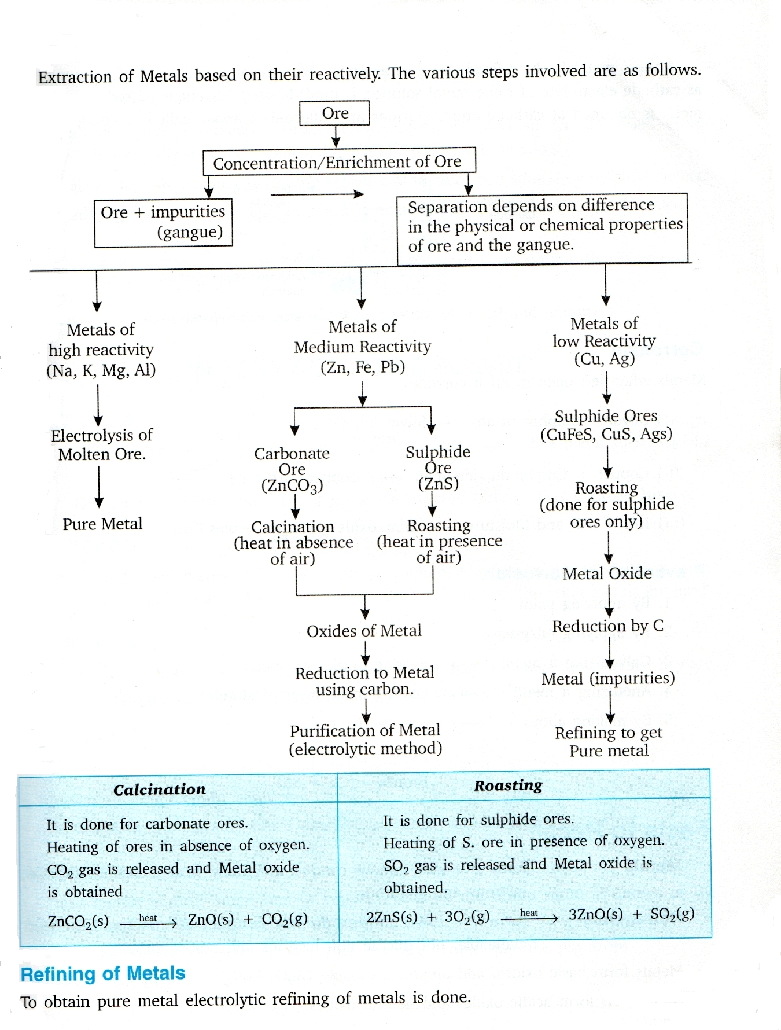

SUGGESTED ACTIVITIES

- Testing physical properties of metals
- Metals are good conductor of heat
- Metals are good conductor of electricity
- Testing chemical properties of metals
- To show properties of ionic compound
- Investigating the conditions under which iron rusted

HOTS QUESTIONS (SOLVED / UNSOLVED)

Q.1 | - What are amphoteric oxides? Choose the amphoteric oxides from amongst the following:  Na₂O, ZnO, Al₂O₃, CO₂, H₂O  - Why is it that non metals do not displace hydrogen from dilute acid?
Ans. | - The oxides which are acidic as well as basic in nature are called amphoteric oxides. ZnO and Al₂O₃are amphoteric oxides.  - Non metals can not loose electrons so that H⁺ ions become hydrogen gas.
Q.2. | What is anodizing? What is its use?
Ans. | The process of forming thick oxide layer of aluminium oxide that makes it resistant to further corrosion.
Q.3. | What is Aqua regia? What is its use?
Ans. | It is a mixture of concentrated HCl and concentrated HNO₃ in the ratio 3:1. It can dissolve gold and platinum.
Q.4. | Give reason: Aluminium is highly reactive metal, but it is used to make utensils for cooking.
Q.5. | Explain why (a) Iron articles are frequently painted. (b) Iron sheets are coated with Zinc layer.
Q.6 | On adding dilute HCl acid to copper oxide powder, the solution formed is blue – green. Predict the new compound formed which imparts a blue – green colour to the solution? Write its equation.
Q.7. | Name the property of metal used in the following cases- (i) Aluminium foil (ii) Meta jewellery (iii) Cable wires (iv) Bells
Q.8. | How can you prove that Zinc is more reactive than Copper?
Q.9. | Draw and explain the electrolytic refining of impure Copper.
Q.10. | Why is Aluminium extracted from Alumina by electrolytic reduction and not by reducing it with Carbon?
Q.11 | Write 3 points of difference between Calcination & Roasting?
Q.12 | Write 5 points of difference between Ionic compound and covalent compound.
Q.13 | What is thermit reaction? Give its one use.
Q.14 | What is amalgam?
Q. 15 | Magnesium when reacts with hot water, starts floating. Why?

CHAPTER 6 -LIFE PROCESSES

KEY CONCEPTS & GIST OF THE LESSON
- Life processes – The processes that are necessary for an organism to stay alive. Eg. Nutrition, respiration, etc.
- Criteria of life- (i) Growth (ii) Movement
- Nutrition- The process in which an organism takes in food, utilizes it to get energy, for growth, repair and maintenance, etc. and excretes the waste materials from the body.
- Types of nutrition
- Autotrophic nutrition (Auto =self: trophos = nourishment) E.g. Plants, Algae, blue green bacteria.
  - Process – Photosynthesis(Photo=light; Synthesis= to combine)
  - Raw materials- (i) Carbon dioxide (ii)Water
  - Equation- sunlight
  - 6CO₂ + 6H₂O C₆H₁₂O₆ + 6O₂
Chlorophyll
  - Energy conversion- Light/Solar energy to Chemical energy
  - Role off Chlorophyll- To trap the sun’s energy for photosynthesis
  - Factors- (i) Carbon dioxide (ii) Water(iii) Light (iv) Temperature
  - Events/ Steps of photosynthesis-
    - Absorption of light energy by chlorophyll
    - Conversion of light energy to chemical energy & Splitting of water molecule into Hydrogen & oxygen
    - Reduction of Carbon dioxide to Carbohydrate
  - Gaseous exchange- (i) Gas used- Carbon dioxide
(ii) By product - Oxygen
  - Source of raw materials-
    - Carbon dioxide –Land plants- Air, Aquatic plants- Water
    - Water & Minerals - Soil

- Heterotrophic nutrition (Hetero =others: trophos = nourishment) Eg. Animals, plants lacking chlorophyll like fungi.
- Saprophytic nutrition: Organisms feeds on dead decaying plants or animals material. E.g. Fungi, Bacteria

(b) Parasitic nutrition: Organisms obtain food from the body of another living (host)
  - Endoparasite : Parasite lives inside the body of the host e.g. tapeworm, roundworm.
  - Exoparasite : Parasite lives on the body of the host. E.g. lice, leech.
Note- The parasite benefits while the host is usually harmed e.g. Cuscutta-plant parasite (amar bel), plasmodium (malarial parasite).

(c) Holozoic nutrition: Organism (mostly animals) take in whole food and then digest it into smaller particles with enzyme. Eg. Amoeba, Paramoecium. Animals, human beings.
  - Steps in Holozoic nutrition
    - Ingestion: taking in of food.
    - Digestion: breaking down of complex food into simpler, absorbable form.
    - Assimilation: Utilization of digested food from the body.
    - Egestion: Removing undigested food from the body

  - Nutrition in human beings
    - Alimentary canal-
Mouth → Oesophagus → Stomach → Small intestine → Large intestine
    - Important gland/juices
(Refer to figure 6.6 page no.97 of N.C.E.R.T Text book)

Organ | Gland | Enzyme/Juice | Function
Mouth | Salivary glands | Salivary Amylase | Converts starch into sugar
Stomach | Gastric glands | Gastric juice-  (i) Hydrochloric  acid →  (ii) Pepsin →  (iii) Mucus → | (a) Kills harmful bacteria that  enters with the food.  - Makes the medium alkaline  for the action of Pepsin  Digests proteins  Protects the inner lining of the stomach from the corrosive action of Hydrochloric acid.
Small intestine | 1) Liver  2) Pancreas | (i) Bile juice →  (ii) Pancreatic  Juice  - Amylase →  - Trypsin →  - Lipase → | (a) Makes the medium acidic  for the action of Pancreatic  enzymes.  (b) Breaks down large fat  molecules into smaller globules  so that enzymes can act upon  them.  Converts Carbohydrates to glucose  Converts Proteins to Amino acids  Converts Fats into Fatty acids & Glycerol

- Peristaltic movements- Rhythmic contraction of muscles of the lining of Alimentary canal to push the food forward.
- Sphincter muscle- Helps in the exit of food from the stomach.

- Villi- Small finger like projections on the walls of-
    - Small intestine- To increase the surface area for the absorption of food.
    - Large intestine- For absorption of water.

- Respiration- The process by which digested food is broken down with the help of Oxygen to release energy.

  - Types of respiration- (i) Aerobic respiration (ii) Anaerobic respiration

Aerobic respiration | Anaerobic respiration
1. Takes place in presence of Oxygen.  2. End products- Carbon dioxide & Water  3. More energy is released.  4. Takes place in Cytoplasm & Mitochondria  5. Complete oxidation of glucose takes place.  6. It occurs in most organisms.  7. Equation-  Glucose→ Pyruvate→ CO₂ + H₂O + Energy | 1. Takes place in absence of Oxygen.  2. End products- Ethanol & Carbon dioxide  3. Less energy is released.  4. Takes place in only in Cytoplasm.  5. Incomplete oxidation of glucose takes place.  6. It occurs in certain bacteria, yeast & certain tissues of higher organisms. E.g. In humans during vigorous exercise, when the demand for Oxygen is more than the supply, muscle cells respire anaerobically for some time.  7. Equation-  In Yeast-  Glucose→ Pyruvate→ Ethanol + H₂O + Energy  In muscle cells -  Glucose→ Pyruvate→ Lactic acid + Energy

- Some common features of Respiratory organs- (i) Large surface area- for greater rate of diffusion of respiratory gases. (ii) Thin permeable walls – to ensure easy diffusion & exchange of gases. (iii) Extensive blood supply- Respiratory organs are richly supplied with blood vessels for quick transport of gases.
- Gaseous exchange in plants-
  - Process – Diffusion
  - Direction of diffusion depends on- (i) Environmental conditions
(ii) Requirement of the plant.
- Day time- Carbon dioxide given out during respiration is used for photosynthesis. Therefore only Oxygen is released, which is a major activity during the day.
- Night time – Only respiration takes place. Therefore only Carbon dioxide is released, which is a major activity during the night.

- Gaseous exchange in animals-
- Terrestrial animals- take Oxygen from the atmosphere.
- Aquatic animals- take Oxygen dissolved in water. (Oxygen content is low in water, therefore they breathe faster.
- Human Respiratory system- External nostrils → Nasal cavity → Trachea→ Bronchi → Bronchioles →Alveoli
- Rings of cartilage present in the throat ensure that the trachea (air passage) does not collapse when there is less air in it.
- Lungs – (i) Present in the thoracic cavity.
(ii) They are spongy, elastic bags consisting of Bronchi,
Bronchioles and Alveoli
Refer to figure 6.9 page no. 104 of N.C.E.R.T Text book)

- Respiration occurs in two phases-
- (i) External-Breathing, which is a mechanical process. (ii) Internal - Cellular respiration
- Mechanism of breathing – It includes : (i)Inhalation (ii) Exhalation
- Exchange of gases-
- Unicellular organisms- By Diffusion
- Animals- (i) As the body size is large, diffusion alone is not enough.
(ii) Respiratory pigments also required.
(iii) Respiratory pigment in human beings is Haemoglobin,
which is present in red blood corpuscles.
(iv) It has very high affinity for Oxygen.
(iv) Carbon dioxide is more soluble in water than Oxygen, so it
Gets dissolves in blood and is thus transported.
- Transportation
- Transportation in human beings-
- Blood- (i) It is a fluid connective tissue.
(ii) Components- (1) Fluid medium- Plasma
(2) Red blood corpuscles
(3) White blood corpuscles
(4) Platelets suspended in plasma
(iii) Plasma transports food, Oxygen, Carbon dioxide,
Nitrogenous wastes, etc.
- Functions of blood- (i) Transport of respiratory gases.
(ii) Transport of nutrients.
(iii) Transport of waste products.
(iv) Defence against infection
- Blood vessels- (i) Arteries (ii) Veins (iii) Capillaries
Arteries | Veins
1. Thick walled.  2. Deep seated.  3. Carry blood away from the heart.  4. Carry Oxygenated blood.  5. Valves absent. | 1. Thin walled.  2. Superficial.  3. Carry blood to the heart.  4. Carry Deoxygenated blood.  5. Valves present

- Heart- (Refer to figure 6.10 page no. 106 of N.C.E.R.T Text book)
(i) It is a muscular organ, which works as a pump in the circulatory system.
(ii) It is the size of our fist.
(iii) It has two sides, which are separated by a partition so that the oxygenated and
deoxygenated blood do not get mixed up.
(iv) It has four chambers-
Two upper chambers called Atria.
Two lower chambers called Ventricles.
- Working of heart-
Left side- (i) Left atrium relaxes & the Oxygenated blood enters it from
the lungs through the pulmonary vein.
(ii) Left atrium contracts & the blood enters the left ventricle
through the valve.
(iii) Left Ventricle contracts and the blood is pumped into the
largest artery ‘Aorta’ and is carried to all parts of the body.
Right side- (i) Right atrium relaxes & the deoxygenated blood from the body enters it
through superior and inferior Vena cava.
(ii) Right atrium contracts & the blood enters the right Ventricle through
the valve.
(iii) Right Ventricle contracts and the blood is pumped into the Pulmonary
artery and is carried to lungs.
- Valves- Unidirectional to prevent the backward flow of blood.
- Pulmonary vein is the only vein that carries Oxygenated blood.
- Aorta is the only artery that carries Deoxygenated blood.
- Double circulation in man- because the blood passes through the heart twice in one complete cycle of the circulation.
- Capillaries- (i) Form the connection between arteries & veins.
(ii) Walls are one cell thick only for easy exchange of
blood.
- Platelets- Plug the leaks of arteries and veins by clotting the blood.
- Lymph- Extracellular fluid similar to plasma but colourless with lesser protein.
- Function of lymph- (i) Transportation of digested & absorbed fats from
the small intestine.
(ii) Drains excess fluid from the intercellular spaces
back in the blood.
- Higher animals- E.g., birds, mammals.
- Oxygenated blood & Deoxygenated blood are completely separate for efficient Oxygen supply.
- This is to fulfil higher energy needs and to maintain body temperature (warm blooded animals).
- Amphibians & reptiles- have 3 chambered heat where little mixing of Oxygenated blood & Deoxygenated blood takes place. Therefore their body temperature varies with the temperature of the environment. (cold blooded animals)
- Transportation in plants-
- Plants need less energy needs- because they do not move and therefore have a slow transport system
- Transport of water-
- Takes place by xylem tissue present in roots, stem, leaves and is therefore interconnected.
- Root cells take up ions from the soil, which creates a concentration difference between root and soil. Column of water therefore rises upwards.
- In very tall plants- transpiration creates a suction pressure, which pulls the water upwards.
- Importance of transpiration-
- Helps in upward movement of water in plants.
- It regulates the temperature in plants.
- Transport of food-
- Takes place by phloem tissue.
- Movement of prepared food in plants is called translocation.
- Excretion- The biological process of removal of harmful metabolic wastes in living organisms.
- Excretion in human beings-
(Refer to figure 6.13 page no. 110 of N.C.E.R.T Text book)

- Organs of excretory system- (i) Kidneys (iii) Urinary bladder
(ii) Ureters (iv) Urethra
- Kidneys-
- Two in number
- Bean shaped
- Present in abdomen on either side of the backbone
- Basic unit is nephron.
  - Glomerulus- Group of capillaries (cluster) present in Bowman’s capsule to receive blood from renal artery and filters it.
  - Bowman’s capsule- Cup shaped structure, which contains glomerulus.
  - Convoluted tubule- is long and reabsorbs vital nutrients like glucose, amino acids, salts, urea and water.

Note-Vital functions of kidneys- (a) Filtration & removal of Nitrogenous wastes
(b) Reabsorption of vital nutrients
- Ureters- Transport the urine formed in the kidneys to the urinary bladder.
- Urinary bladder- Muscular bag like structure to store urine.
- Urethra- Helps in removal of urine when the Urinary bladder is full.
- Artificial kidney- Principle: Dialysis
- Excretion in plants-
  - Gaseous wastes- CO₂ in respiration & O₂ in photosynthesis are removed by the process of diffusion.
  - Excess water- is removed by transpiration.
  - Other wastes- (i) Stored in cellular vacuoles or in leaves, which fall off or as
gums, resins, etc. in old xylem.
(ii) Excreted in soil.
- Important diagrams-
- Open & close stomata
- Steps of nutrition in Amoeba
- Alimentary canal of human beings/ Digestive system of human beings
- Respiratory system of human beings
- Structure of heart.
- Excretory system of human beings
- Structure of nephron
- Important activities-
- To prove that chlorophyll is necessary for photosynthesis.
- To prove that Carbon dioxide is necessary for photosynthesis.
- To prove that light is necessary for photosynthesis.
- To prove that product of fermentation is Carbon dioxide.
- To prove that leaves lose water by transpiration.
- To study the action of salivary amylase on starch.
- To demonstrate that Carbon dioxide is present in exhaled air.
- To demonstrate the process of transpiration in plants.

CHAPTER 7 – CONTROL & COORDINATION

KEY CONCEPTS & GIST OF THE LESSON

- Coordination-The working together of various organs of the body of an organism in a proper manner to produce appropriate reaction to a stimulus is called coordination.

- Stimulus- The changes in the environment to which an organism responds and reacts is called Stimulus

- Control & coordination in animals- takes place by (i) Nervous system & (ii) Endocrine system

- Nervous system
Stimulus → Receptor organ → Sensory nerve → Brain/Spinal cord
↓
Response ← Effector organ ← Motor nerve

- Endocrine system
Stimulus → Endocrine organ → Secrete hormone → Hormone in blood
↓
Response ← Target organ
- Parts of the Nervous system – (i) Brain (ii) Spinal cord (iii) Nerves (Neurons)

- A Neuron is the structural & functional unit of Nervous system

- Parts of a neuron- (i) Dendrites (ii) Cell body (iii) Axon

- Synapse- Space/junction between two adjacent nerves is called Synapse.

- Passing of information takes place –(i) By Electric impulse (inside the neuron) and (ii) In the form of chemicals (At synapse)

- Reflex action- Spontaneous, involuntary and automatic response to a stimulus to protect us from harmful situations. Eg. On touching a hot object unknowingly we instantly withdraw our hand.

- Reflex arc- The pathway of the reflex action is called Reflex arc.
Stimulus → Receptor organ → Sensory nerve → Spinal cord →→Effector organ→ Response
Refer to figure 7.2 page no. 117 of N.C.E.R.T Text book)

- Nervous system- (1) Central Nervous system (CNS) (2) Peripheral Nervous system
(PNS)
(i) Brain (i) Autonomic Nervous system
(ii) Spinal cord (ii) Voluntary Nervous system

- Brain (i) Centre of coordination of all activities (ii) Thinking is involved (iii) Complex process

- Parts of brain- Refer to figure 7.3 page no. 118 of N.C.E.R.T Text book

Fore brain | Mid brain | Hind brain
(i) Cerebrum  (ii) Thalamus (iii) Hypothallamus | ---------- | (i) Cerebellum (ii) Pons (iii) Medulla oblongata

- Fore brain
Cerebrum- (i) Main thinking and largest part of the brain.
(ii) It has 3 main areas-
        - Sensory area- to receive impulses from sense organs via Receptors
        - Motor area- control voluntary movements.
        - Association areas- Reasoning, learning & intelligence.
Thalamus – It relays sensory information to the Cerebrum
Hypothallamus- It forms the link between Nervous system & Endocrine system

- Mid brain- It connects Fore brain and Hind brain. Controls reflex of eyes & ears

- Hind brain- Connects the Fore brain & Hind brain
Cerebellum – Controls & coordinates muscular movements, maintaining body posture and
equilibrium.
Pons- Acts as a bridge between brain & spinal cord
Medulla oblongata- Controls involuntary actions like blood pressure, salivation, vomiting, etc.

- Spinal cord- Cylindrical or tubular structure extending downwards from the Medulla oblongata.

- Protection of the brain & the spinal cord- (i) Bony outer covering: skull for the brain & vertebral column for the spinal cord.
(ii) Cerebrospinal fluid present in between the three membranes.

- Action caused by Nervous tissue Information → Nervous tissue → Brain Muscles → Causes action
- Path or action- Nerve impulse → Muscle cell → Changes shape due to special proteins
↓
Action caused ← Shorter form of muscles ← Change shape & arrangement of cell
- Chemical communication by hormones- (advantages)
  - Electrical impulses have their limitations because they reach only those cells connected to the nervous tissue.
  - Also the nerve cells cannot generate & transmit impulses continuously.
  - Electrical communication is slower.
- Hormones- (i) are chemical messengers secreted by endocrine glands
(ii) Are secreted in small amounts & may act in nearby places or distant places.
(iii) Do not take part in the reaction & are destroyed immediately.
- Hormones are secreted by- Endocrine glands & Exocrine glands

S. No. | Endocrine glands | Exocrine glands
1. | Ducts absent | Ducts present
2. | Secrete hormones | Secrete enzymes
3. | Secreted in blood | Secreted in ducts of glands
4. | Situated away from the site of action | Situated near the site of action

- Some glands which act as both endocrine & exocrine

Gland | Endocrine function | Exocrine function
Pancreas | Produces insulin & Glucagon hormone. | Produces digestive enzyme. (pancreatic amylase)
Testes | Produces hormone Testosterone | Produces male gametes (reproductive cells)
Ovaries | Produces hormone Oestrogen | Produces female gametes (reproductive cells)
- Important Endocrine glands, the hormone they secrete & their function
Refer to figure 7.7 page no. 124 of N.C.E.R.T Text book)

Endocrine gland | Hormone | Function
Pituitary gland | Growth hormone | Body growth, development of bones & muscles  (If excess- Gigantism)  (If less- Dwarfism)
Thyroid gland | Thyroxine | Regulates carbohydrate, protein & fat metabolism( If less- Goitre_
Pancreas | Produces insulin & Glucagon hormone | Regulates blood sugar levels (if less diabetes is caused)
Testes in males | Produces hormone Testosterone | Development of secondary male characters like deep voice, beard, etc.
Ovaries in females | Produces hormone Oestrogen | Development of secondary female characters like mammary glands, menstrual cycle, maintenance of pregnancy.

- Coordination in plants- Only chemical coordination is present in plants.
- Tropic movements- The movements of plants in the direction of stimulus (positive) or away from it (negative) are called tropic movements. E.g. Phototropism, Geotropism. Chemotropism.
Refer to figure 7.4 & 7.5 page no. 121 of N.C.E.R.T Text book)

- Nastic movements -The movements of plants independent of stimuli are called nastic movements. E.g.- Touch me not plant leaves close when touched.
- Plant hormones (Phytohormones)
Examples- 1. Auxins- Help in growth of root & shoot tips.
2. Gibberellins- Help in vegetative growth
3. Cytokinins- Promote cell division
4. Abscissic acid - Inhibits growth & causes wilting (falling) of leaves

- Important diagrams-
  - Structure of neuron (nerve cell)
  - Reflex arc
  - Human brain
  - Endocrine glands in human beings
- Important activities-
- To compare taste of sugar and food with open & blocked nostrils.
- To demonstrate the response of a plant to the direction of light.
- To demonstrate hydrotropism.

CHAPTER -12

ELECTRICITY
GIST OF THE LESSON
- Positive and negative charges: The charge acquired by a glass rod when rubbed with silk is called positive charge and the charge acquired by an ebonite rod when rubbed with wool is called negative charge.
- Coulomb: It is the S.I. unit of charge. One coulomb is defined as that amount of charge which repels an equal and similar charge with a force of 9 x 10⁹ N when placed in vacuum at a distance of 1 meter from it. Charge on an electron = -1.6 x 10⁻¹⁹ coulomb.
- Static and current electricities: Static electricity deals with the electric charges at rest while the current electricity deals with the electric charges in motion.
- Conductor: A substance which allows passage of electric charges through it easily is called a ‘conductor’. A conductor offers very low resistance to the flow of current. For example copper, silver, aluminium etc.
- Insulator: A substance that has infinitely high resistance does not allow electric current to flow through it. It is called an ‘insulator’. For example rubber, glass, plastic, ebonite etc.
- Electric current: The flow of electric charges across a cross-section of a conductor constitutes an electric current. It is defined as the rate of flow of the electric charge through any section of a conductor.
Electric current = Charge/Time or I = Q/t Electric current is a scalar quantity.
- Ampere: It is the S.I. unit of current. If one coulomb of charge flows through any section of a conductor in one second, then current through it is said to be one ampere. 1 ampere = 1 coulomb/1 second or 1 A = 1C/1s = 1Cs⁻¹ 1 milliampere = 1 mA = 10⁻³ A 1 microampere = 1µA = 10⁻⁶ A
- Electric circuit: The closed path along which electric current flows is called an ‘electric circuit’.
- Conventional current: Conventionally, the direction of motion of positive charges is taken as the direction of current. The direction of conventional current is opposite to that of the negatively charged electrons.
- Electric field: It is the region around a charged body within which its influence can be experienced.
- Electrostatic potential: Electrostatic potential at any point in an electric field is defined as the amount of work done in bringing a unit positive charge from infinity to that point. Its unit is volt. Positive charges move from higher to lower potential regions. Electrons, being negatively charged, move from lower to higher potential regions.
- Potential difference between two points: The Potential difference between two points in an electric field is the amount of work done in bringing a unit positive charge from one to another. Potential difference = Work done/Charge or V = W/Q
- One volt potential difference: The Potential difference between two points in an electric field is said to one volt if one joule of work has to be done in bringing a positive charge of one coulomb from one point to another. 1 volt = 1 joule/1 coulomb or 1 V = 1J/1C
- Galvanometer: It is device to detect current in an electric circuit.
- Ammeter: It is device to measure current in a circuit. It is always connected in series in a circuit.
- Voltmeter: It is a device to measure potential difference. It is always connected in parallel to the component across which the potential difference is to be measured.
- Ohm’s law: This law states that the current passing through a conductor is directly proportional to the potential difference cross its ends, provided the physical conditions like temperature, density etc. remains unchanged.
V α I or V = RI
The proportionality constant R is called resistance of conductor.
- Resistance: It is a property of a conductor by virtue of which it opposes the flow of current through it. It is equal to the ratio of the potential difference applied across its ends and the current flowing through it.
Resistance = Potential difference/Current or R = V/I
- Ohm: It is the S.I. unit of resistance. A conductor has a resistance of one ohm if a current of one ampere flows through it on applying a potential difference of one volt across its ends. 1 ohm = 1 volt/1 ampere or 1Ω = 1V/1A
- Factors on which resistance of a conductor depends: The resistance R of a conductor depends
i) Directly on its length L i.e. R α L. ii) inversely on its area of cross-section A i.e. R α 1/A iii) on the nature of material of the conductor on. On combining the above factors, we get R α L/A R = ρ * L/A The proportionality constant ρ is called resistivity of conductor.
- Resistivity: It is defined as the resistance offered by a cube of a material of side 1 m when current flows perpendicular to its opposite faces. Its S.I. unit is ohm-meter (Ωm). Resistivity, ρ = RA/L
- Equivalent resistance: If a single resistance can replace the combination of resistances in such a manner that the current in the circuit remains unchanged, then that single resistance is called the equivalent resistance.
- Laws of resistances in series: i) Current through each resistance is same. ii) Total voltage across the combination = Sum of the voltage drops. V= V₁ + V₂ + V₃ iii) Voltage drops across any resistor is proportional to its resistance. V₁ = IR₁, V₂ = IR₂, V₃ = IR₃ iv) Equivalent resistance = Sum of the individual resistances. R_{s} = R₁ + R₂ + R₃ v) Equivalent resistance is larger than the largest individual resistance.
- Laws of resistances in parallel: i) Voltage across each resistance is same and is equal to the applied voltage. ii) Total current = Sum of the currents through the individual resistances. I = I₁ + I₂ + I₃ iii) Currents through various resistances are inversely proportional to the individual resistances. I₁ = V/R₁, I₂ = V/R₂, I₃ = V/R₃ iv) Reciprocal of equivalent resistance = Sum of reciprocals of individual resistances. 1/R_{p} = 1/R₁ + 1/R₂ + 1/R₃ v) Equivalent resistance is less than the smallest individual resistance.
- Joule’s law of heating: It states that the heat produced in a conductor is directly proportional to (i) the square of the current I through it (ii) proportional to its resistances R and (iii) the time t for which current is passed. Mathematically, it can be expressed as H = I²Rt joule = I²Rt/4.18 cal or H = VIt joule = VIt/4.18cal
- Electric energy: It is the total work done in maintaining an electric current in an electric circuit for given time.
Electric energy, W = VIt = I²Rt joule
- Electrical power: Electrical power is the rate at which electric energy is consumed by an appliance.
P = W/t = VI = I²R = V²/R
- Watt: It is the S.I. unit of power. The power of an appliance is 1 watt if one ampere of current flows through it on applying a potential differences of 1 volt across its ends. 1 watt = 1 joule/1 second =1 volt x 1 ampere or 1 W = 1 Js⁻¹ = 1 VA 1 kilowatt = 1000 W 1Mega watt= 10⁶ watt 1Gigawatt=10⁹ watt

- Kilowatt hour: It is the commercial unit of electrical energy. One kilowatt hour is the electric energy consumed by an appliance of 1000 watts when used for one hour. 1 kilowatt hour (kWh) = 3.6 x 10⁶ J
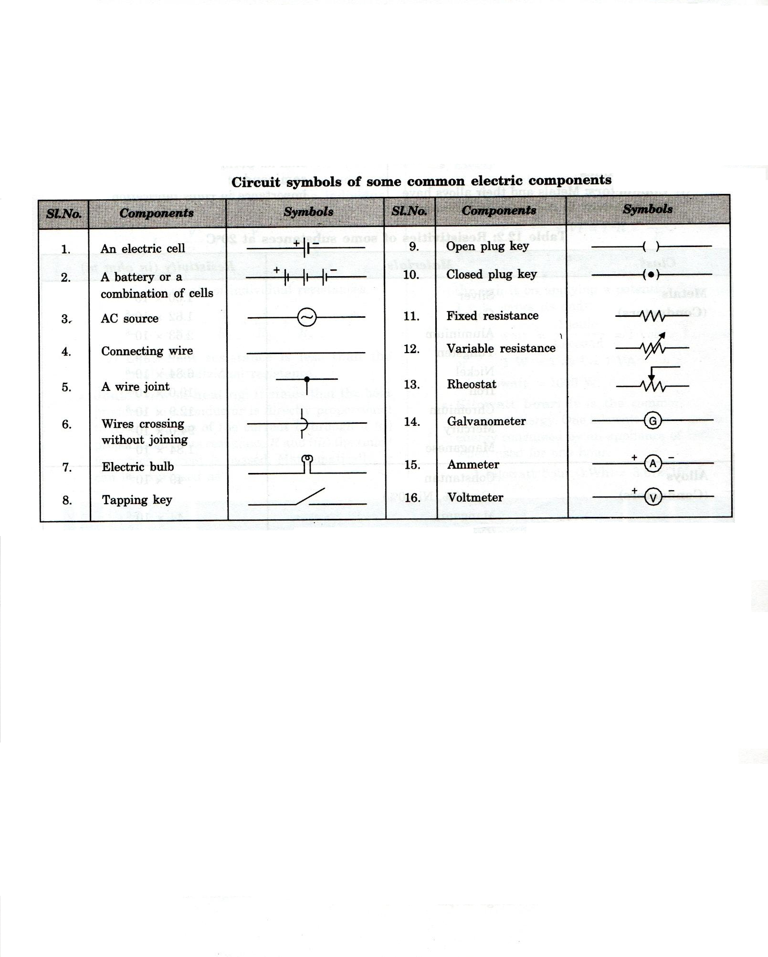

SUGGESTED ACTIVITIES

- To verify ohm’s law.
- To observe the flow of current is different for different components.
- To study the factors on which the resistance of conducting wire depends.
- Resistors in series and resistors in parallel

HOTS QUESTIONS (SOLVED / UNSOLVED)
Q.1. | Why is the tungsten metal more coiled in the bulb and not installed in straight parallel wire form?
Ans. | The coiled wire of tungsten increases the surface area of the wire in very less space so as to emit more light and helps in glowing with more intensity.
Q.2. | Why are fairy decorative lights always connected in parallel?
Ans. | When the fairy lights are connected in series the resistance offered will be greater and brightness of the bulbs will be affected. But in parallel connection all the bulbs will glow with same intensity and if any more bulbs gets fused the other bulbs will continue to glow.
Q.3. | What will happen when -  - Voltmeter is connected in series?  - Ammeter is connected in parallel?
Ans. | - Negligible current will pass through the circuit because the voltmeter has a very high resistance.  - Ammeter will get damaged due to flow of large amount of current through it, because it has low resistance.

CHAPTER -13
MAGNETIC EFFECTS OF ELECTRIC CURRENT

KEY CONCEPTS & GIST OF THE LESSON
- Magnet: (i) is an object that attracts objects made of iron, cobalt & nickel. (ii) Comes to rest in North-South direction, when suspended freely.

- Magnets are used: (i) In radio & stereo speakers, (ii) In refrigerator doors, (iii) in audio & video cassettes players, (iv) On hard discs & floppies of computers & (v) in children’s toys.

- Magnetic field: The area around a magnet where a magnetic force is experienced is called a magnetic field. It is a quantity that has both direction & magnitude.

- Magnetic field lines: Magnetic field is represented by field lines. They are lines drawn in a Magnetic field along which a North magnetic pole moves. Magnetic field lines are called as Magnetic lines of force.
Refer to figure 13.3 & 13.4 page no. 225 of N.C.E.R.T Text book)

- Properties of Magnetic field lines:
      - They do not intersect each other.
(ii) It is taken by convention that magnetic field lines emerge from
North pole and merge at the South pole. Inside the magnet, their
direction is from South pole to North pole. Therefore magnetic field
lines are closed curves.
- Magnetic field lines due to a current through a straight conductor (wire)- consist of series of concentric circles whose direction is given by the Right hand thumb rule.
- Right hand thumb rule: If a current carrying straight conductor is held in your right hand such that the thumb points towards the direction of current, then the wrapped fingers show the direction of magnetic field lines.
(Refer to figure 13.7, page no. 228 of N.C.E.R.T Text book)
- Magnetic field lines due to a current through a circular loop
(Refer to figure 13.8, page no. 228 of N.C.E.R.T Text book)
- The strength of the magnetic field at he centre of the loop(coil)depends on:
    - The radius of the coil- The strength of the magnetic field is inversely proportional to the radius of the coil. If the radius increases, the magnetic strength at the centre decreases.
    - The number of turns in the coil: As the number of turns in the coil increase, the magnetic strength at the centre increases, because the current in each circular turn is having the same direction, thus the field due to each turn adds up.
    - The strength of the current flowing in the coil: as the strength of the current increases, the strength of thee magnetic fields also increases.

- Solenoid: (Refer to figure 13.10, page no. 229 of N.C.E.R.T Text book)
- (i) A coil of many turns of insulated copper wire wrapped in the shape of a cylinder is called a Solenoid. (ii) Magnetic field produced by a Solenoid is similar to a bar magnet.
(iii) The strength of magnetic field is proportional to the number of turns & magnitude of current.
- Electromagnet: An electromagnet consists of a long coil of insulated copper wire wrapped on a soft iron core.
(Refer to figure 13.11, page no. 229 of N.C.E.R.T Text book)

- Fleming’s Left hand rule: Stretch the thumb, forefinger and middle finger of left hand such that they are mutually perpendicular. Forefinger points in the direction of magnetic field and centre finger in the direction of current, then the thumb gives the direction of force acting on the conductor.
(Refer to figure13.13, page no. 231 13.13 of N.C.E.R.T Text book)

- Electric motor: A device that converts electric energy to mechanical energy.
(Refer to figure 13.15, page no. 232 of N.C.E.R.T Text book)

- Principle of Electric motor: When a rectangular coil is placed in a magnetic field and a current is passed through it, force acts on the coil, which rotates it continuously. With the rotation of the coil, the shaft attached to it also rotates.

- Electromagnetic induction: Electricity production as a result of magnetism (induced current) is called Electromagnetic induction.

- Fleming’s Right hand rule: gives the direction of induced current.
Stretch the thumb, forefinger and middle finger of right hand such that they are mutually
perpendicular. Forefinger points in the direction of magnetic field and centre finger in the
direction of induced current, then the thumb gives the direction of motion of the conductor.

- Electric generator: A devise that converts mechanical energy to electric energy.
(Refer to figure 13.19, page no. 236 of N.C.E.R.T Text book)
Electric generator is of two types- (i) A.C generator (ii) D. C generator

- Principle of Electric generator: Electromagnetic induction

- Domestic electric circuits: (Refer to figure 13.20, page 238 of N.C.E.R.T Text book)
- We receive electric supply through mains supported through the poles or cables. In our houses we receive AC electric power of 220V with a frequency of 50Hz.
The 3 wires are as follows- (i) Live wire- (Red insulated, Positive)
(ii) Neutral wire- (Black insulated, Negative)
(iii) Earth wire- (Green insulated) for safety measure to ensure
that any leakage of current to a metallic body does not give
any serious shock to a user.
- Short circuit: is caused by touching of live wires and neutral wire
- Fuse: is a protective device used for protecting the circuits from short circuiting and over loading

- Important diagrams-
- Magnetic field lines around a bar magnet.
- Right hand thumb rule
- Magnetic field lines through and around a current carrying solenoid.
- An electromagnet.
- A simple electric motor
- Electric generator

- Important activities-
- Magnetic field lines around a bar magnet
- Direction of electric current in a simple electric circuit.
- Direction of Magnetic field lines depends on the direction of electric current.

HOTS QUESTIONS (SOLVED)
- On what effect of an electric current does an electromagnet work?
A. Magnetic effect of electric current
- What is the frequency of AC (Alternating Current) in India?
- 50 Hz
- On what effect of an electric current does a fuse work?
A. Heating effect of electric current
- An Alternating Current has a frequency of 50 Hz. How many times it changes direction in one second?
A. Since Alternating Current changes its direction twicw in a cycle, it will change its direction 100 times (50x2) in one second as its frequency is 50Hz.
- What is short circuiting in an electric circuit?
A. Short circuiting in an electric circuit is a situation in which the live wire touches the neutral wire.
- What kind of quantity is magnetic field?
A. It is a vector quantity as it has both direction & magnitude.
- How is Solenoid different from a circular coil?
A. Solenoid is different from a circular coil in the sense that the length of the solenoid is much greater than its diameter
- On what factor the strength of magnetic field of a solenoid depends?
A The strength of magnetic field of a solenoid is proportional to the number of turns of the coil and the magnitude of the current.
10. What kind of motor is used in: (i) A fan (ii) A battery operated toy
A. (i) A fan has AC motor (ii) A battery operated toy has DC motor.

HOTS QUESTIONS (UNSOLVED)
- Name the sources of direct current.
- Why don’t two magnetic lines intersect each other?
- What is the role of split ring in an electric motor?
- What is an earth wire?
- Why do we use power of two different current ratings at our homes?
- What would be the frequency of an Alternating Current, it its direction changes after every 0.01 second?
- Which of the two requires a thin fuse wire to draw: 5A or 15A of current?
- It is advised to keep magnets away form computers, T.V. Give reason
- In a domestic circuit, MCB (Miniature Circuit Breaker) of one room trips again and again. What could be the reason for this?
- What is the application of a solenoid?
- What is the application of a solenoid?

CHAPTER-14
SOURCES OF ENERGY

KEY CONCEPTS & GIST OF THE LESSON

- Characteristics of a good fuel:
    - High calorific value
    - Less smoke
    - Less residue after burning
    - Easy availability
    - Inexpensive
    - Easy to store and transport

- Fossil fuels: were formed millions of years ago, when plants and animal remains got buried under the earth and were subjected to high temperature and pressure conditions. E.g.: Coal, Petroleum, etc. These fossil fuels are non renewable sources of energy and cause environmental problems due to pollution.
- Thermal power plants:
- Use coal, petroleum and natural gas to produce thermal electricity.
- Electricity transmission is very efficient.
- The steam produced by burning the fossil fuels runs the turbine to produce electricity

- Hydro power plant:
(Refer to figure 14.3, page no. 246 of N.C.E.R.T Text book)
- It is the most conventional renewable energy source obtained from water falling from a great height.
- It is clean & non polluting source of energy.
- Dams are constructed to collect water flowing in high altitude rivers. The stored water has a lot of potential energy.
- When water is allowed to fall from a height, potential energy changes to kinetic energy, which rotates the turbines to produce electricity.
- Disadvantages of Hydro power plant:
- Highly expensive to construct.
- Dams cannot be constructed on all river sites.
- Large areas o human habitation and agricultural fields get submerged.
- People face social and environmental problems.

- Non conventional sources:
(1) Bio mass:
    - It is the source of the conventionally used fuels that are used in our
country. E.g.: Cow dung cakes, fire-wood, coal, charcoal
    - Bio gas: It is a mixture of gases produced during decomposition of bio mass in the absence of Oxygen. (Anaerobic Respiration). Methane is the major component of bio gas.
    - Bio gas plants: Animal dung, sewage, crop residues, vegetable wastes, poultry droppings, etc. are used to produce Bio gas in Bio gas plants.
    - (Refer to figure 14.4, page no. 247 of N.C.E.R.T Text book)
  - Wind energy:
    - It can be converted into mechanical and electrical energy.
    - Kinetic energy of the wind is used in running of wind mills, which are used to lift water, grind grains, etc.
    - Wind mill-(Refer to figure 14.5, page no. 247 of N.C.E.R.T Text book)
    - Advantages: (i) Eco friendly (ii) Renewable
    - Disadvantages: (i) Wind speed not uniform always.
(ii) Needs a large area to erect series of wind mills.
(iii) Big amount of investment is needed.
(iv) Out put is less as compared to investment
  - Solar energy:
    - Solar radiations can be converted electricity through solar cells (photovoltaic cells).
    - Photovoltaic cells convert solar radiations directly into electricity through silicon solar cells.
    - Solar cells arrange on a large flat sheets form a solar panel.
    - Solar cookers are painted black from outside and a large glass plate to trap solar radiations by green house effect.
    - (Refer to figure 14.6, page no. 249 of N.C.E.R.T Text book)
    - Advantages of Solar cookers:
(i) Eco friendly
(ii) Renewable
(iii) Used in rural areas.
(iv) Retains all the nutrients in food due to slow cooking.
    - Disadvantages of solar cooker:
(i) Silicon cells are expensive.
(ii) Solar radiations are not uniform over earth’s surface.
(iii) Cannot be used at night or on cloudy days.
(iv) Cannot be used to make chapattis for frying as these
require a temperature of 140⁰C or more.
(Maximum temperature of 100⁰C only can be
achieved in a solar cooker)
    - Other solar devices- Solar water heater, Solar furnace
  - Geo thermal energy:
  - Energy harnessed from the heat of the sun is called Geo thermal energy.
  - Magma is formed when this heat melts the rocks. The molten rocks and hot gases are called magma
  - The magma gets collected at some depths below the earth’s surfaces. These places are called ‘Hot spots”
  - When underground water comes in contact these hot spots, it changes into steam, which can be used to generate electricity.
    - Advantages of Geo thermal energy:
- Renewable
(ii) Inexpensive
    - Disadvantages of Geo thermal energy:
- Only few sites available for harnessing energy.
- Expensive
  - Nuclear energy:
(i) Energy released when some changes take place in the nucleus of the atom of a
substance, is called Nuclear energy.
(ii) It is used for heat generation, fuel for marine vessels.
    - Advantages of Nuclear energy:
    - Alternative source of energy due to depletion of fossil fuels.
    - From a small amount of fuel, a large amount of energy is released.
    - Disadvantages of Nuclear energy:
- Risk of nuclear waste leakage
- High cost of setting up of nuclear plant
    - Pollution of environment.
  - Energy from the sea-
(A) Tidal energy: Locations in India – Gulf of Kutch, Gujrat & W. Bengal
(i) Depends upon harnessing the rise and fall of sea level due to tidal action.
(ii) Dams are constructed across a narrow part of sea and turbine converts tidal
energy into electrical energy.
Disadvantages: Uniform tidal action is not seen
(B) Wave energy:
(i) Kinetic energy of the waves of sea are used to rotate turbines..
(ii) These turbines generate electrical energy

- Important diagrams-
- Hydro power plant
- Bio gas plant
- A wind mill
- A solar cooker

HOTS QUESTIONS (SOLVED)

- Name the materials used for making solar cells.
A. Silicon, Germanium and Selenium
- What fraction of solar energy reaches the earth’s surface?
A. 47%
- Name the process that produces a large amount of energy in the sun.
A. Nuclear fusion
- Why is biogas called a clean fuel?
A. Because it- (i) leaves no ash (ii) does not cause pollution (iii) does not produce any
poisonous gas.
- Why Hydrogen cannot be used as a domestic fuel?
AHydrogen cannot be used as a domestic fuel, in spite of its high calorific value, because it is explosive in nature and difficult to store & transport.
- What are OTEC power plants? How do they operate?
- (i) It is Ocean Thermal Energy Conversion.
(ii) These plants can operate if the temperature difference between water at the surface and
water at depths up to 2 km is 293K (20⁰C) or more.
(iii) The warm surface water is used to boil a volatile liquid like Ammonia. The vapour of the
liquid is used to turn the turbine.
(iv) The cold water from the depth is pumped up and condensed water again changes into
vapour.
- Though wood is renewable source of energy, but the use of wood as a fuel is not wise decision. Explain.
A. Wood is obtained by cutting trees. A newly plant sapling usually takes about 10-15 years to grow and mature into a tree. Cutting of trees on a large scale cases depletion of forests leading to disturbance of balance in nature. The balance between Oxygen & Carbon dioxide is also disturbed. Therefore the use of wood as a fuel is not wise decision
- Explain, why a sheet of glass is used in solar heating devices?
A. Glass has a property that allows the infra red rays of short wavelength from the sun to get in the device but does not allow infra red rays of long wavelength to leave the solar heating device. Therefore, heat is trapped inside the heating device. A kind of green house effect is produced, which helps to increase the temperature inside the heating device.
- Explain, why is a reflector used in a solar cooker?
A. The reflector is used to increase the area over which the solar energy is collected so that more and more heat rays of the sun enter the solar cooker. It increases the efficiency of solar cooker.

HOTS QUESTIONS (UNSOLVED)
- What is the use of black painted surface in solar heating devises.
- Why are bio gas plants considered to be boon to the farmers? Give reason.
- Hydroelectricity generated at a dam may be considered another form of solar energy. Why?
- How is the slurry left over after the generation of biogas in biogas plant used?
- Why is charcoal considered to be a better fuel than wood?
- Why a solar cooker cannot be used for frying or making chapattis?
- In parabolic reflector type coolers, even temperature up to 180⁰C- 200⁰C can be attained. How?
- Modern chulahs are more efficient than traditional chulahs. Why?
- How is hydro energy converted into electrical energy?
- Explain, why only a part of the solar energy that strikes the upper regions of atmosphere reaches the surface of the earth?

CHEMICAL REACTIONS AND EQUATIONS
FORMATIVE ASSESSMENT I
Q. PAPER I

MARKS-30 TIME- 70 MINUTES

Instructions:
- Questions : 1 to 5 – 1 Mark each
- Questions : 6 to 9 – 2 Marks each
- Questions : 10 to 13 – 3 Marks each
- Question 14 – 5 Marks

- On what chemical law, balancing of chemical equation is based?
- Identify the compound oxidized in the following reaction:
H₂S _{(g)} + Cl₂ → S _{(s)} + HCl _{(g)}
- Give an example of photochemical reaction.
- Name the reaction which forms insoluble salts.
- Name the product obtained and type of reaction given below:
Na₂SO₄ + BaCl₂ → _________ + ________
- Explain the following in terms of gain or loss of oxygen with one example:
  - Oxidation
  - Reduction
- A copper coin is kept in a solution of silver nitrate for some time, what will happen to the coin and the colour of the solution?
- Why do we apply paint on iron articles?
- What happens chemically when quicklime is added to water?
- What is rancidity? Write the common methods to prevent it.
- What is corrosion? State the conditions necessary for rusting of iron. How rusting is harmful?
- Name the type of reactions in the following cases:
  - Garbage producing foul smell
  - Burning of natural gas.
  - Carbon dioxide gas passed through lime water.
- Blue crystals of copper sulphate on heating in a dry test tube become colourless. Give reasons.

  - Why can not a chemical change be normally reversed?
  - Why is it always essential to balance a chemical equation?
  - What happens when CO₂ gas is passed through lime water and why does it disappear on passing excess CO₂?
  - Can rusting of iron take place in distilled water?

FORMATIVE ASSESSMENT I
Q. PAPER II
MARKS-30 TIME- 70 MINUTES

Instructions:
- Questions : 1 to 5 – 1 Mark each
- Questions : 6 to 9 – 2 Marks each
- Questions : 10 to 13 – 3 Marks each
- Question 14 – 5 Marks

- Burning of a candle is a chemical change; where as melting of a candle wax is a chemical change. Why?
- What is a reducing agent?
- What is the chemical formula of rust?
- What is the role of catalyst in a chemical change?
- Why does stale food give a bad smell and bad taste?
- What are the 2 important conditions of a balanced ionic equation?
- Why does the blue colour of Copper sulphate solution start fading when a Zinc rod is dipped in it. Write its equation.
- Give 2 examples from everyday life situations, where redox reactions are taking place.
- Can we place Silver nitrate in an iron vessel? Why or why not?
- What types of reactions are represented by the following? Also give reason the same. (i) A + B → C
(ii) A + BC → AC + B
(iii) AB + CD → AD + CB
- What is the relationship between oxidation and oxidising agent in a redox reaction? Write an example to show this relationship.
- What is corrosion? Why do aluminium sheets not corrode easily? Name any 2 methods to prevent corrosion.
- Discuss the importance of decomposition reactions in metal industry.
- (i) Give one example where corrosion is an advantage rather than disadvantage.
(ii) What is the difference between displacement reaction and double displacement reaction with suitable example?
(iii) Write 2 limitations of a chemical reaction.

ACID, BASES AND SALTS
FORMATIVE ASSESSMENT I
Q.PAPER I

MARKS-30 TIME- 70 MINUTES

Instructions:
- Questions : 1 to 5 – 1 Mark each
- Questions : 6 to 9 – 2 Marks each
- Questions : 10 to 13 – 3 Marks each
- Question 14 – 5 Marks
- Write the chemical name of baking soda.
- What happens when gypsum is heated at 373K?
- Which has a higher pH value 1M HCl or 1M NaOH solution?
- Hydrogen ion concentration of an acid is 1 x 10⁻² mol/l. what is its pH?
- Name the gas formed when Sodium hydroxide reacts with Zinc
- What is meant by ‘Water of Crystallisation’ of a substance? Describe an activity to show that.
- Why does tooth decay start when the pH of mouth is lower than 5.5?
- What is baking powder? How does it make the cake soft and spongy?
- Give Arrhenius definition of an acid and a base. Choose strong acid and strong base from the following:
CH₃COOH, NH₄OH, KOH, HCl
- What happens when nitric acid is added to egg shell? Give the chemical equation.
- A student prepared solutions of an acid and a base in two separate beakers. She forgot to label the solutions and litmus paper is not available in the laboratory. Since both the solutions are colourless, how will she distinguish between the two?
- Identify the compound ‘X’ on the basis of the reactions given below. Write the names and chemical formulae of A, B, C
 | + Zn | - + H_{2 (g)}
Compound X |  | - + H_{2 (g)}
Compound X | +HCl | - + H₂O
Compound X | + CH₃COOH | - + H₂O
- How is plaster of Paris prepared? What is its chemical formula? Write is chemical name.

  - Define strong acid and weak acid.
  - A student working in the laboratory added some water to a syrupy liquid taken in tube. The tube immediately cracked and the liquid escaped out, that produced blisters on the skin of the student. Why?
FORMATIVE ASSESSMENT I
Q. PAPER II
MARKS-30 TIME- 70 MINUTES
Instructions:
- Questions : 1 to 5 – 1 Mark each
- Questions : 6 to 9 – 2 Marks each
- Questions : 10 to 13 – 3 Marks each
- Question 14 – 5 Marks
1. Why solution of HCl in water conducts electricity, but that of glucose in water does not?
2. Write the chemical name of Plaster of Paris.
3.What happens when chlorine is passed through slaked lime?
4. What happens when salt and ice are mixed together?
- What is the difference between washing soda and soda ash?
- If someone is suffering from acidity after over eating. Suggest a remedy for this. Why?
- What is an acid-base indicator? Give 2 examples of synthetic acid-base indicator.
- What is the difference between a strong acid and a weak acid? Give 2 examples of each of them.
- With the help of a chemical equation, explain how a soda acid fire extinguisher helps in putting out a fire.
- Why does a stain of a curry on a white clothe become reddish brown, when soap is scrubbed on it and turns yellow again, when the cloth is washed with plenty of water.
- Why should curd be not kept in copper or brass vessels? What is done to protect it?
- A tarnished copper vessel begins to shine again when rubbed with lemon. Why?
- (a) What is the action of litmus on (i) dry ammonia gas (ii) Solution of ammonia gas in water
(b) State the observations you would make on adding Ammonium hydroxide to aqueous solution of (i) Ferrous sulphate (ii) Aluminium chloride
- Write the chemical name, preparation, 2 properties and 2 uses of Baking powder or plaster of Paris.
METALS AND NON – METALS
FORMATIVE ASSESSMENT I
Q.PAPER I

MARKS-30 TIME- 70 MINUTES

Instructions:
- Questions : 1 to 5 – 1 Mark each
- Questions : 6 to 9 – 2 Marks each
- Questions : 10 to 13 – 3 Marks each
- Question 14 – 5 Marks
- Which metal other than mercury is liquid at room temperature?
- Why the item made of silver turns black when exposed to air?
- Which non – metal is lustrous?
- What is an amalgam?
- What is the nature of oxides of metal?
- Give reasons for the following:
  - Na, K and Ca metals form hydrides by combination with hydrogen gas, but most other metals do not.
  - Metals conduct electricity.
- Write the equations for the reactions of:
  - Iron with steam.
  - Calcium and potassium with water.
- What is activity series? How does it help us in predicting the relative reactivities of various metals?
- What is the difference between sodium atom and sodium ion?

  - Write electron dot structure for sodium and oxygen.
  - Show the formation of Na₂O by electron transfer.
  - What are the ions present in these compounds?
- Write three properties of ionic compounds.
- Explain how a metal low in the activity series can be extracted. Write suitable example.
- Give reasons:
  - Platinum, gold and silver are used to make jewellery.
  - Sodium, potassium and lithium are stored under oil.
  - Aluminium is a highly reactive metal; still it is used to make utensils for cooking.
- Name the following:
  - A non – metal that is a good conductor of electricity.
  - A metallic oxide which can not be reduced by coke.
  - A metallic oxide which is amphoteric in nature.
  - A non – metallic oxide which is neutral.
  - Principal ore of aluminium.

FORMATIVE ASSESSMENT I
Q.PAPER II

MARKS-30 TIME- 70 MINUTES

Instructions:
- Questions : 1 to 5 – 1 Mark each
- Questions : 6 to 9 – 2 Marks each
- Questions : 10 to 13 – 3 Marks each
- Question 14 – 5 Marks
1.Give 2 examples of amphoteric oxides.
2. Why Sodium chloride has high melting point?
3. How do metals & non metals combine?
4. What is aqua-regia?
5.What is the nature of oxides of non metal?
6. Give reasons for the following:
  - Why Aluminium cannot be obtained by reduction of its oxide with coke?
  - Metals can be beaten into sheets whereas non metals cannot.
7. Write the equations for the reactions of:
  - Magnesium with Zinc sulphate.
  - Sodium with water.
- Out of copper and iron, which one is more is more reactive? How can you test it?
- What is the difference between roasting and calcination process? Give an example of each
- Draw a labelled diagram of – Electrolytic refining of Copper
- Write three properties of covalent compounds.
- Explain how a metal high in the activity series can be extracted. Write suitable example.
- Give reasons:
  - Copper is used to make electrical wires.
  - Silver is used to make jewellery.
  - Metals are considered electropositive.
14. (i) A metal ‘M’ has the electronic configuration 2,8,3 and occurs in nature as M₂O₃. It is more reactive than Zinc. Answer the following questions-(a) Name the metal ‘M’. (b) Name the ore from which it is extracted. (c) How is the metal oxide converted to metal?
(ii) Why do Gallium and Caesium melt in our palms?

LIFE PROCESS
FORMATIVE ASSESSMENT I
Q.PAPER I
MARKS-30 TIME- 70 MINUTES

Instructions:
- Questions : 1 to 5 – 1 Mark each
- Questions : 6 to 9 – 2 Marks each
- Questions : 10 to 13 – 3 Marks each
- Question 14 – 5 Marks

- Name the site of photosynthesis.
- What is osmoregulation?
- Name the excretory unit of kidney.
- What is neuron?
- Name the term for transport of food from leave to other parts of the plant.
- Draw the diagram of cross – section of a lead and label the following in it:
  - Chloroplast
  - Guard cell
  - Lower epidermis
  - Upper epidermis
- What do you mean by double circulation of blood?
- Explain why Bile juice does not contain any digestive enzymes, yet it is essential for digestion.
- How would non – secretion of hydrochloric acid in our stomach affect food digestion? Explain.
- How does nutrition takes place in Amoeba?
- Draw a diagram of cross section of human heart. Show the path of flow of blood with the help of arrows.
- How water is transported upwards in plants?
- Descried the functioning of nephrons.

  - Draw a diagram of human alimentary canal.
  - Label the following – oesophagus, liver, gall bladder, and duodenum.
  - What is the function of liver in human body?

FORMATIVE ASSESSMENT I
Q.PAPER II

MARKS-30 TIME- 70 MINUTES

Instructions:
- Questions : 1 to 5 – 1 Mark each
- Questions : 6 to 9 – 2 Marks each
- Questions : 10 to 13 – 3 Marks each
- Question 14 – 5 Marks

- Why do fishes breathe faster than land animals?
- Why is circulation in man known as “double circulation?
- What is the source of (i) Carbon dioxide & (ii) Water in autotrophs .
- Name the two tissues in plants, which are involved in transportation of materials.
- What is the basic, functional unit of kidneys known as?
- What is the function of (i) Salivary amylase (ii) Lipase in digestion in humans.
- How does opening and closing of stomata occur?
- What is trachea? Why does trachea not collapse when it has less air in it?
- What do the following transport?
(i) Xylem (ii) Pulmonary artery (iii) Pulmonary vein (iv) Vena cava
- Write 2 differences between aerobic and anaerobic respiration. Name 2 organisms that use anaerobic mode of respiration.
- Draw a neat and well labelled diagram of digestive system of human beings.
- Explain the three events that take place during photosynthesis.
- Explain three requirements of all respiratory surfaces.
- (i) Explain three requirements of all respiratory surfaces
(ii) Draw a neat and well labelled diagram of human respiratory system.
OR
(i) Explain, how urine is formed in the human body?
(ii) Draw a neat and well labelled diagram of human excretory system.

CONTROL AND CO – ORDINATION
FORMATIVE ASSESSMENT I
Q. PAPER I

MARKS-30 TIME- 70 MINUTES

Instructions:
- Questions : 1 to 5 – 1 Mark each
- Questions : 6 to 9 – 2 Marks each
- Questions : 10 to 13 – 3 Marks each
- Question 14 – 5 Marks

- Which endocrine gland is unpaired?
- Which part of the brain controlled posture and balance of the body?
- Where in a neuron, conversions of electrical signal to a chemical signal occur?
- Which gland secretes digestive enzyme as well as hormones?
- We suddenly withdraw our hand when a pin pricks. Name the type of response involved in this action.
- What is a tropic movement? Explain with an example.
- What will happen if intake of iodine in our diet is low?
- Draw the structure of neuron and label the following on it:
  - Nucleus
  - Dendrite
  - Cell body
  - Axon
- Why are some patients of diabetes treated by giving injections of insulin?
- Why is the flow of signals in a synapse from axonal end of one neuron but not the reverse?
- What are reflex actions? Explain reflex arc.
- What are the major parts of the brains? Mention the functions of each.
- How does chemical co – ordination take place in animals?

  - Name the various plant hormones.
  - Give physiological effects of hormones on plant growth and development.

Formative assessment-I
Q. PAPER II
MARKS-30 TIME- 70 MINUTES

Instructions:
- Questions : 1 to 5 – 1 Mark each
- Questions : 6 to 9 – 2 Marks each
- Questions : 10 to 13 – 3 Marks each
- Question 14 – 5 Marks

MARKS-30 TIME- 70 MINUTES
- What is a synapse?
- Name one growth promoting & one growth inhibiting plant hormone.
- Which part of the brain is responsible for: (i) thinking (ii) Voluntary action?
- What could be the disadvantage if reflex action were to be controlled by the brain?
- Name any 2 stimuli that act on plants.
- Give 2 differences between tropic and nastic movements in plants.
- Explain 2 ways by which the brain and the spinal cord protected?
- Write 2 differences between sensory and motor nerves.
- Draw a neat & well labeled diagram of nerve cell.
- Name the disorder that may occur if the following hormones are not secreted properly?
(a) Insulin (b) Thyroxine (c) Growth hormone
11. What is reflex arc? Draw schematic pathway of a typical reflex action.
12. Give one point of difference between the following:
(a) Spinal nerve & cranial nerve
(b) Central nervous system & Peripheral nervous system.
(c) Dendrite & Axon
13. What is hydrotropism? Explain an activity to show hydrotropism.
14. Draw a diagram of human brain and label on it the following parts:
(i) Cerebrum (ii) Pons (iii) Medulla oblongata (iv) Cerebellum
OR
(i) How do neurons transmit information?
(ii) Explain the action of adrenaline hormone that is released in the blood.

ELECTRICITY
FORMATIVE ASSESSMENT I
Q. PAPER I
MARKS-30 TIME- 70 MINUTES
Instructions:
- Questions : 1 to 5 – 1 Mark each
- Questions : 6 to 9 – 2 Marks each
- Questions : 10 to 13 – 3 Marks each
- Question 14 – 5 Marks
 | Define resistivity of material.
 | What is the power of torch bulb rated at 2.5V and 500mA?
 | Why series arrangement not used for connecting domestic electrical appliances in a circuit?
 | Which has higher resistance – a 50W bulb or a 2.5W bulb and how many times?
 | What is the direction of flow of conventional current?
 | Why is it not advisable to handle electrical appliances with wet hands?
 | Two electric bulbs marked 100W 220V and 200W 200V have tungsten filament of same length. Which of the two bulbs will have thicker filament?
 | How does the resistance of a wire vary with its area of cross section?
 | Draw the following symbols
 | - Battery | - Switch closed
 | - Resistor of resistance R | - Voltmeter
A geyser is rated 1500W, 250V. This geyser is connected to 250V mains. Calculate –
    - The current drawn
    - The energy consumed in 50hrs.
    - The cost of energy consumed at Rs. 2.20 per kWh.
 | What is the function of an electric fuse? Name the material used for making fuse. In household circuit where is fuse connected?
 | Write one important advantage of using alternative current. How alternating current differ from direct current?
 | What is the difference between short circuiting and overloading?
- Draw diagram showing three resistors R₁, R₂ and R₃ in series.
- Two resistors of resistance 4Ω and 12Ω
- In parallel
- In series
Calculate the values of effective resistance in each case.

FORMATIVE ASSESSMENT I
Q. PAPER II
MARKS-30 TIME- 70 MINUTES

Instructions:
- Questions : 1 to 5 – 1 Mark each
- Questions : 6 to 9 – 2 Marks each
- Questions : 10 to 13 – 3 Marks each
- Question 14 – 5 Marks
 | Name the instrument used to measure electric current.
 | What is the mathematical form of Ohm’s law?
 | Name a metal which is the best conductor electricity.
 | Why resistance become more in series combination?
 | What is electrical power? Write its unit.
 | Why does resistance of a conductor increase with increase in temperature?
 | Current in a circuit is doubles by changing resistance. What will be the change in power loss?
 | Why are the conductors of electric heating devices such as bread toaster and electric iron made of alloy rather than pure metal?
 | Draw the following symbols
 | - Electric cell | - Switch open | - Electric bulb | - Ammeter
 | A 100 watt electric bulb is lighted for 2 hours daily and four 40 watt bulbs are lighted for 4 hours daily. Calculate the energy consumed (in kWh) in 30 days.
 | Resistance of a conductor depends on which three factors. Explain with mathematical expression.
 | What is the effect of temperature on resistance of – pure metals, insulators and semi – conductors.
 | Write 3 points of difference between direct and alternate current.
- Draw diagram showing three resistors R₁, R₂ and R₃ in parallel.
- Two identical resistors, each of resistance 2 ohms, are connected in turn
- In series and
- In parallel
To a battery of 12 volts. Calculate the ratio of power consumed in two cases.

MAGNETIC EFFECTS OF ELECTRIC CURRENT
FORMATIVE ASSESSMENT I
Q. PAPER I
MARKS-30 TIME- 70 MINUTES

Instructions:
- Questions : 1 to 5 – 1 Mark each
- Questions : 6 to 9 – 2 Marks each
- Questions : 10 to 13 – 3 Marks each
- Question 14 – 5 Marks
 | State two uses of permanent magnets.
 | Does a neutron moving in a magnetic field experience a force. Why?
 | State Fleming’s right hand rule.
 | What are the functions of live and neutral wire in domestic circuit?
 | Electricians wear rubber shoes while working. Why?
 | Give four basic properties of magnets.
Define SI unit of magnetic field. Under what condition does a moving charge experience
- Maximum force ii) Minimum force
 | Draw toe field line around the bar magnet along its length on its two sides and mark the field directions on them by arrow marks.
 | Why do we use power supply of two different current rating at our home?
 | Write an activity to show that current carrying wire behaves like a magnet.
 | Match the following
 | A | B
 | - Electromagnet | - Convert electric energy to mechanical energy
 | - Electric motor | - Convert mechanical energy to electrical energy
 | - Electric generator | - Strong magnet
 | Name three factors on which force produced due to magnetic field depends.
 | What is an electric fuse? What material is used for fuse wire?
- Write the principle of electric motor.
- Explain the construction and working of electric motor briefly.
- Draw a labelled diagram of electric motor.

FORMATIVE ASSESSMENT I
Q. PAPER II
MARKS-30 TIME- 70 MINUTES

Instructions:
- Questions : 1 to 5 – 1 Mark each
- Questions : 6 to 9 – 2 Marks each
- Questions : 10 to 13 – 3 Marks each
- Question 14 – 5 Marks
 | State two uses of electromagnet.
 | An electron moving along X – axis in a magnetic field along Y – axis. In which direction will the electron deflected.
 | State Fleming’s left hand rule.
 | What is the importance of earth wire?
 | Should a copper wire be used as a fuse wire? If not, why?
 | Give two points of difference between and electromagnet and permanent magnet.
Draw the lines of force indicating field direction of the magnetic field through and around
- Single loop of wire carrying electric current.
- A solenoid carrying electric current.
 | What id magnetic field? How is the direction of magnetic field at a point determined?
 | Give four features of domestic electric wiring.
 | Draw a schematic diagram of domestic wiring system and write its main features.
 | Match the following:
 | A | B
 | - Right hand thumb rule | - Force on a conductor in a magnetic field
 | - Fleming’s left hand rule | - Direction of magnetic field of straight conductor
 | - Fleming’s right hand rule | - Direction of induced current in conductor
 |  | - Polarity of any end of a solenoid.
- Draw a labelled diagram to show how electro – magnet is made.
- What is the purpose of soft iron core in making electromagnet?
 | Write two differences between AC and DC current and draw diagram also.
- Write principle of electric generator.
- Explain construction and working of generator.
- Draw labelled diagram of electric generator.

ENERGY
FORMATIVE ASSESSMENT I
Q.PAPER I
MARKS-30 TIME- 70 MINUTES

Instructions:
- Questions : 1 to 5 – 1 Mark each
- Questions : 6 to 9 – 2 Marks each
- Questions : 10 to 13 – 3 Marks each
- Question 14 – 5 Marks
Which component of sunlight helps in drying of cloths?
In what form energy stored in water in high raised dams?
Name two places of our country where nuclear power plants are located.
What is a solar cell?
What type of energy transformation takes place when electric bulb glows?
Write two differences between hydroelectricity and thermal electricity.
Explain two reasons biogas is called as clean fuel.
State two limitations of using hydrogen as a common fuel.
How is nuclear energy employed for peaceful purposes?
What is the principle of wind mill?
Name the three forms in which energy from ocean is made available for use. What are OTEC power plants? How do they operate?
Give three reasons why the uses of cow dung in biogas plants are preferred than burning dry cow dung cakes for cooking.
Explain why
- Charcoal is considered better fuel that wood.
- Use of wood as fuel is not advised although forest can be replenished.
- Fossil fuels are classified as non – renewable sources of energy.
- What is a principle of solar cooker?
- Explain its working in brief.
- Draw a labelled diagram of solar cooker.

FORMATIVE ASSESSMENT I
Q.PAPER II
MARKS-30 TIME- 70 MINUTES

Instructions:
- Questions : 1 to 5 – 1 Mark each
- Questions : 6 to 9 – 2 Marks each
- Questions : 10 to 13 – 3 Marks each
- Question 14 – 5 Marks
Name the component of sunlight, exposure to which may cause skin cancer.
Flowing water possess which type of energy.
Name one place in India where wind energy power station is installed.
What is a solar panel?
What type of energy transformation takes place during winding of spring of a clock?
Write two differences between renewable and non – renewable sources of energy.
What is the principle of solar cooker? Name two types of solar cooker.
Name any two types of harmful nuclear radiations emitted during nuclear fission.
What is thermal power plant? Where it is preferably situated?
What is the principle of solar cooker? Give two limitations and two advantages of solar cooker.
Name the fuel for hydro power plant. Mention two advantages and disadvantages of producing electricity at the hydro power plant.
Explain why:
- It is difficult to burn a piece of wood fresh from a tree.
- Pouring dry sand over the fire extinguishes it.
- It is difficult to use hydrogen as source of energy.
What are the different types of energies obtained from sea? Explain.
- What is a principle of Biogas?
- Explain it working in brief.
- Draw a labelled diagram of biogas.

SUMMATIVE ASSESSMENT I
TIME: 3-3^{1/2} HOURS M.M: 80
General Instructions:
- The question paper comprises of two sections, A and B, you are to attempt both the sections.
- All the questions are compulsory.
- There is no overall choice. However internal choice has been provided in all the three questions of five marks category. Only one option in each question is to be attempted.
- All questions of section A and all questions of Section B are to attempted separately.
- Question numbers 1 to 4 in Section A are one mark question. These are to be answered in one word or one sentence.
- Question numbers 5 to 13 are two marks questions, to be answered in about 30 words.
- Question numbers 14 to 22 are three marks questions, to be answered in about 50 words.
- Question numbers 23 to 25 are five marks questions, to be answered in about 70 words.
- Question numbers 26 to 41 in section B are multiple choice questions based on practical skills. Each question is a one mark question. You are to choose one most appropriate response out of the four provided to you.

SECTION – A
- Identify the compound which is oxidized in the following reaction:
H₂S + Br₂ → 2HBr + S
- Why are titanium and chromium classified as strategic element?
- Name the largest constituent of biogas.
- Which has a higher resistance: a 50W lamp or 25W lamp bulb and how many times?
- Identify the most reactive and least reactive metal among the following. Define reactivity series.
Al, K, Cu, Au
- A drop of litmus solution is added to each of the four solutions give below. State the colour of litmus solution observed in each.
Soap solution, Sodium bicarbonate solution, Acetic acid, Tomato juice
- Translate the following statements into chemical equations and then balance the equations:
  - Aluminium metal replaces iron from ferric oxide. Fe₂O₃, giving aluminium oxide and iron.
  - Barium chloride reacts with zinc sulphate to give zinc chloride and a precipitate of barium sulphate.
- What is the chemical name of washing soda? Name the three chief raw materials used for making washing soda.
- Write four differences between arteries and vein.
- Write four characteristics used for selecting a suitable fuel.
- How many 176Ω resistors (in parallel) are required to carry 5A on a 220V line?
- What is solenoid? Draw field lines of the magnetic field through and around a current carrying solenoid.
- In a house hold, 5 tube lights of 40W each are used for 5 hours and electric press of 500W for 4 hours everyday. Calculate the total electrical energy consumed by the tube lights and press in a month of 30 days.
- Given the following reaction
2Al + Fe₂O₃ → 2Fe + Al₂O₃ + Heat
Answer the following with reason.
  - Name the oxidising agent.
  - Name the reducing agent.
  - Name the substance oxidised.
- A compound which is prepared from gypsum has the property of hardening when mixed with a proper quantity of water. Identify the compound. Write the chemical equation for its preparation. For what purpose is it used in hospital?

  - Show the formation of NaCl from sodium and chlorine atoms by the transfer of electrons.
  - Why has sodium chloride, a high melting point?
  - Name the anode and the cathode used in electrolytic refining of impure copper metal.
- What are the functions of
  - Gibberellins
  - Cytokinins
  - Abscisic acid
- Define ‘nerve impulse’ which structure in a neuron helps to conduct a nerve impulse.
- State three advantages associated with using solar cells to produce electricity.

  - State Ohm’s law.
  - Draw the circuit diagram of Ohm’s law.
  - What is the nature of graph in terms of relation between V and I.

  - An electric bulb is rated as 50W, 220V. Calculate the energy consumed by the bulb in 20 minutes. Express your answer in commercial units of electricity.
  - Distinguish between Overloading and Short Circuiting in a domestic circuit.
  - Why is it essential to earth electrical appliances having metallic body?
- What are the environmental consequences of the increasing element for energy? What steps would you suggest to reduce energy consumption?

  - State and explain two vital functions of kidney.
  - Draw neat and labelled diagram of excretory system of human
OR
- Draw neat and labelled diagram of digestive system.
- Write the functions of the following glands.
  - Salivary gland
  - Liver
  - Pancreas

  - Why should curd and sour substances not be kept in brass and copper vessels?
  - Why does an aqueous solution of acid conduct electricity?
  - Why plaster of Paris should be stored in a moisture proof container?
  - What is efflorescence?
  - Why is baking soda used as an antacid?
OR

- State reasons for the following.
    - Metals are good conductor of heat.
    - Addition of some silver to pure gold for making ornaments.
    - Inability of non – metals for displacing hydrogen from dilute sulphuric acid.
- Balance the following equations
    - CaO + H₂O → Ca(OH)₂
    - NaOH + H₂SO₄ → Na₂SO₄ + H₂O

  - Why is pure iron not used for making permanent magnets?
  - Name one material used for making permanent magnets.
  - Describe how permanent magnets are made electrically.
  - State two examples of electrical instruments made by using permanent magnets.
OR
Explain the meaning of the word ‘Electromagnetic’ and ‘Induction’ in the term ‘Electromagnetic Induction’. On what factors does the value of induced current produced in a circuit depend? Name and state the rule used of determination of direction of induced current. State one practical application of this phenomenon in everyday life.

SECTION – B
 | Absorption of light energy by mesophyll cells of leaf causes.
 | - Oxidation of chlorophyll |  | - Excitation of chlorophyll
 | - Reduction of chlorophyll |  | - Evolution of O₂
 | Which of the following does not secrete any hormone?
 | - Testis |  | - Spleen
 | - Ovary |  | - Pancreas
 | Which part of sunlight is used in making solar cell?
 | - Infrared radiation |  | - Ultraviolet radiation
 | - Visible radiation |  | - All of these
 | Which one of the following reaction can be a non – redox reaction?
 | - Combination |  | - Decomposition
 | - Displacement |  | - Double displacement.
 | Which of the following metal does not react with dilute sulphuric acid to liberate H₂ gas?
 | - Calcium |  | - Sodium
 | - Iron |  | - Silver
 | Sodium carbonate is not used as:
 | - Ingredient in antacids |  | - As a cleaning agent
 | - For removing permanent hardness of water |  | - For manufacturing of glass
 | Which one of the following compounds is not an ionic compound?
 | - Sodium chloride |  | - Calcium chloride
 | - Carbon tetrachloride |  | - Magnesium chloride
 | Which among the following reactions are endothermic in nature?
 | - Decomposition of lead nitrate |  | - Burning of methane
 | - Dilution of sulphuric acid |  | - Dissolution of ammonium chloride in water.
 | - i. and ii. | - ii. and iii. | - iii. and iv | - i. and iv
 | Seeds which are kept in the conical flask during the experiment that CO₂ is released during respiration must be.
 | - Dry |  | - Wet
 | - Germinated |  | - Boiled
 | The end products of aerobic respiration are
 | - CO₂ energy and hydrogen |  | - CO₂ and water
 | - CO₂, H₂O and ATP |  | - ADP and CO₂
The correct set up of for studying the dependence of the current on the potential difference across a resistor is
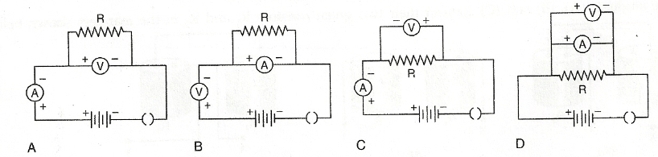
 | - A | - B | - C | - D
The normal positions of the pointers of the two ammeters A₁ and A₂ and two voltmeters V₁ and V₂ available in the laboratory are shown below:
For an experiment to study the dependence of the current on the potential difference across a resistor, the student should select.
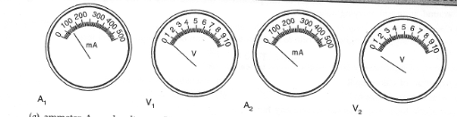
 | - Ammeter A₁ and voltmeter V₁ |  | - Ammeter A₂ and voltmeter V₂
 | - Ammeter A₁ and voltmeter V₂ |  | - Ammeter A₂ and voltmeter V₂
The given circuit diagram shows the experiment arrangement of different circuit components for determination of equivalent resistance of two resistors connected in series. The components X, Y and Z shown in the circuit, respectively represent
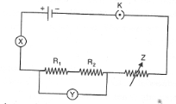
 | - Rheostat, Resistor, Ammeter |  | - Ammeter, Voltmeter, Rheostat
 | - Voltmeter, Ammeter, Rheostat |  | - Rheostat, Ammeter, Voltmeter
In the experiment on finding the equivalent resistance of two resistors, connected in parallel, the voltmeter has been correctly connected in
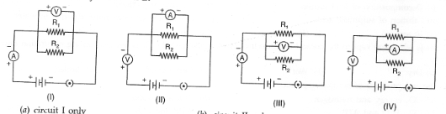
 | - Circuit I only |  | - Circuit II only
 | - Both circuits I and III |  | - Both circuits II and IV
The three students (A), (B) and (C) connected their two given resistors R₁ and R₂ in the manner shown below.
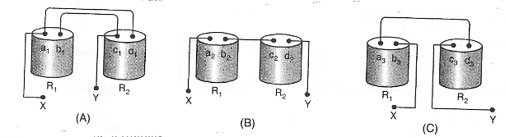
They connect the terminals marked X and Y above to the terminals marked X and Y in the given circuit. They record the ammeter readings (I) for different positions of the rheostat and the corresponding voltmeter readings (V).
The average value of the ratio V/I in their observations would be minimum for:
 | - Students (A) and (B) only |  | - Students (B) and (C) only
 | - Students (C) and (A) only |  | - Student (A) only
41.
For testing the presence of starch an illuminated leaf is first
- Boiled in alcohol | - Dipped in iodide solution
- Boiled in water | - Placed in safranin solution
===========

SUMMATIVE ASSESSMENT II
TIME: 3-3^{1/2} HOURS M.M: 80

General Instructions:
- The question paper comprises of two sections, A and B, you are to attempt both the sections.
- All the questions are compulsory.
- There is no overall choice. However internal choice has been provided in all the three questions of five marks category. Only one option in each question is to be attempted.
- All questions of section A and all questions of Section B are to attempted separately.
- Question numbers 1 to 4 in Section A are one mark question. These are to be answered in one word or one sentence.
- Question numbers 5 to 13 are two marks questions, to be answered in about 30 words.
- Question numbers 14 to 22 are three marks questions, to be answered in about 50 words.
- Question numbers 23 to 25 are five marks questions, to be answered in about 70 words.
- Question numbers 26 to 41 in section B are multiple choice questions based on practical skills. Each question is a one mark question. You are to choose one most appropriate response out of the four provided to you.

SECTION – A
  - Arrange the following metals in decreasing order of reactivity
Cu, Ca, Mg, Na, Zn
2 What is the chemical name of washing soda? Name the three raw materials used in making washing soda by Solvay process.
3.What is the range of calorific value of gaseous fuels?
4.Two magnets are lying side by side as shown in the figure. Draw lines of magnetic field between poles of P and Q.
S | N |  | S | N
P |  |  | Q
5.Solid calcium oxide was taken in a container and water was slowly added to it.
  - State two observations made in the experiment.
  - Write the name of the chemical formula of the product.
6.A student prepared solutions of (i) an acid and (ii) a base in two separate beakers. She forgot to label the solutions and litmus paper is not available in the laboratory. Since both the solutions are colourless, how will she distinguish between the two?
7.Match the important chemicals given in Column (A) with the chemical formulae given in Column (B).
Column (A) | Column (B)
- Plaster of Paris | - CaSO₄
- Gypsum | - CaSO₄, ½ H₂O
- Bleaching Powder | - CaSO₄, 2H₂O
- Slaked Lime | - NaHCO₃
- Baking Soda | - Ca(OH)₂
- Dead burnt plaster | - CaOCl₂
8.
  - You are provided with three metals: sodium, magnesium and silver. Using only water as the reactant, how will you identify each of them?
  - Which metal listed is most likely to occur in the free state?
9.What role does saliva play in digestion of food?
10 Draw the lines of magnetic field through and around a single loop of wire carrying current.
11.
  - What type of electric current is generated by most of power stations in India?
  - What is the frequency of supply generated in India?
12.Differentiate box type solar cooker with plane mirror and box type solar cooker with spherical reflector.
13.A 6V battery is applies across a piece of heater wire, a torch cell and a 6V bulb one by one with an ammeter in series every time. What do you observe in general and why?
14.On heating blue coloured powder of copper (II) nitrate in a boiling tube, copper oxide (black), oxygen gas and a brown gas X is formed.
  - Write a balance equation of the reaction.
  - Identify the brown gas X evolved.
  - Identify the type of reaction.
  - What could be the pH range of aqueous solution of the gas X?
15.A metal carbonate X on reacting with an acid gives a gas which when passed through a solution Y gives carbonate back. On the other hand, a gas G that is obtained at anode during electrolysis of brine is passed on a dry substance Y, it gives a compound Z, used for disinfecting drinking water. Identify X, Y, G and Z.
16.Explain why:
  - Calcium salt becomes sticky during rainy season.
  - Blue vitriol changes to white upon heating.
  - Ammonia does not have and OH⁻ ion. Still is blue.
17.Name and describe the hormones produced by posterior lobe of pituitary.
18.What is the mechanism of ascent of sap?
19.How does the strength of magnetic field at the centre of a circular coil of wire depend upon
  - The radius of coil
  - The number of turn on wire in coil
  - Strength of current flowing in coil?
20.
  - List the factors on which value of induced e.m.f. depends.
  - Name the rule used for determining direction of induced e.m.f.
  - State on practical application of this phenomenon in everyday life.
21.What is VI graph and what is its importance. Give V vs I graph for Ohmic and nonohmic materials.
22.
  - What do you understand by series combination of resistors?
  - Define equivalent resistance of series combination of resistors.
23.Explain the following:
  - Reactivity of Al decreases if it is dipped in HNO₃
  - Carbon cannot reduce the oxides of Na or Mg.
  - NaCl is not a conductor of electricity in solid state whereas it does conduct electricity aqueous solution as well as in molten state.
  - Iron articles are galvanised.
OR
- Distinguish between ‘roasting’ and ‘calcination’. Which of the two is used for sulphuric ore and why?
- Write the chemical equation to illustrate the use of aluminium for joining cracked railway lines.
- Name the anode, the cathode and the electrolyte in the electrolytic refining of impure copper.
24.Describe the various steps in aerobic respiration.
OR
What is photo periodism? Describe the types of flowering plants on the basis of their photo periodic response.
25.What do you understand by ‘magnet’? What is meant by natural and artificial magnets? Show that like poles and unlike poles repel or attract. Define magnetic field and field line.
OR
Describe an activity to draw magnetic field line due to a bar magnet. Give and explain any three properties of magnetic field. What do magnet field lines represent?

SECTION – B
26. | Which of the following is not a mineral acid?
 | - Hydrochloric acid | - Citric acid
 | - Sulphuric acid | - Nitric acid
27 | Which among the following is not a base?
 | - NaOH | - KOH
 | - NH₄OH | - C₂H₅OH
28 | Which of the following statements is not correct?
 | - All metal carbonates react with acid to give a salt, water and carbon dioxide.
 | - All metal oxides react with water to give salt and acid.
 | - Some metals react with acids to give salt and hydrogen.
 | - Some non – metal oxides react with water to form an acid.
29 | Solid calcium oxide reacts vigorously with water to form calcium hydroxide accompanied by liberation of heat. This process is called slaking of lime. Calcium hydroxide dissolves in water to form its solution called lime water. Which among the following is (are) true about slaking of lime and the solution formed?  - It is an endothermic reaction.  - It is an exothermic reaction.  - The pH of the resulting solution will be more than seven.  - The pH of the resulting solution will be less than seven.
 | - i. and ii. | - ii. and iii.
 | - i. and iv. | - iii. and iv.
30 | In the double displacement reaction between aqueous potassium iodide and aqueous lead nitrate, a yellow precipitate of lead iodide is formed. While performing the activity, if lead nitrate is not available, which of the following can be used in place of lead nitrate?
 | - Lead sulphate (insoluble) | - Lead acetate
 | - Ammonium nitrate | - Potassium sulphate
31 | Out of the four circuits shown for studying the dependence of the current on the potential difference across a resistor, the correct circuit is:  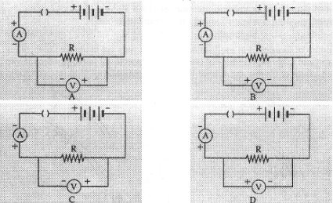
 | - A | - B
 | - C | - D
32 | A student has to connect 4 cells of 1.5V each, to form a battery of 6V.  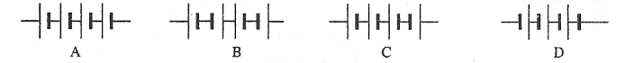  The correct way of connecting these cells in shown in figure.
 | - A | - B
 | - C | - D
33 | In an experiment to determine equivalent resistance of two resistors R₁ and R₂ in series, which one of the following circuit diagrams shows the correct way of connecting the voltmeter in the circuit?  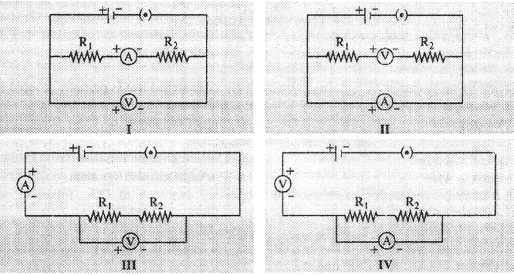
 | - I | - II
 | - III | - IV
34 | A student uses a battery of adjustable voltage 0 – 6V. She has to perform an experiment to determine the equivalent resistance of two resistors when connected in parallel using two resistors of value 3ohm and 6ohm. The best choice of combinations of voltmeter and ammeter to be used in the experiment is:
 | - Ammeter of range 0 – 5A and voltmeter of range 0 – 10 V.
 | - Ammeter of range 0 – 5A and voltmeter of range 0 – 5 V.
 | - Ammeter of range 0 – 2A and voltmeter of range 0 – 10 V.
 | - Ammeter of range 0 – 5A and voltmeter of range 0 – 2 V.
35 | The rest positions of the needles in a milliammeter and voltmeter not in use are as shown in Fig. A. When a student uses these in his experiment, the readings of the needles are in the positions shown in Fig. B. The corrected values of current and voltage in the experiment are:  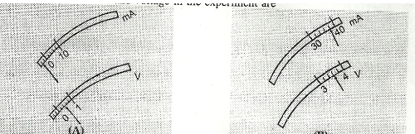
 | - 42 mA and 3.2 V | - 42 mA and 4.0 V
 | - 34 mA and 3.2 V | - 34 mA and 4.0V
36 | Temporary leaf peel is mounted in
 | - Canada balsam | - Water
 | - Dilute alcohol | - Dilute glycerine
37 | In the given diagram, nuclei should be shown in parts  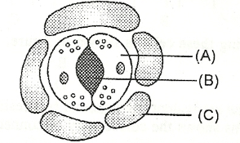
 | - A and B | - B and C
 | - A and C | - A, B, and C
38 | For studying the necessity of light in photosynthesis, a de-starched leaf is partially covered with
 | - Black paper | - Blue paper
 | - Red paper | - Any of the above
39 | For testing the presence of starch an illuminated leaf is first
 | - Boiled in alcohol | - Dipped in iodide solution
 | - Boiled in water | - Placed in safranin solution
40 | Student while performing experiment on respiratory evolution of CO₂ forgot to pour KOH solution in the small hanging test tube. There was
 | - A rise of water in delivery tube | - A fall in water level in delivery tube
 | - Evolution of bubbles from delivery tube | - No change in water level in delivery tube
41 | On absorption of CO₂, KOH solution shall
 | - Turn pink | - Become transparent
 | - Become milky | - Turn blue.

======================

DIAGNOSTIC TOOLS FOR FORMATIVE ASSESSMENT

CHEMICAL REACTION AND EQUATIONS
Oral questions (Conversation type)
- How do you represent chemical changes in chemistry?
- What should you know to write a chemical equation?
- How are reactants and products separated in a chemical equation?
- Is it essential to write balanced chemical equation?
- What will happen if it is not balance?
- How do you know that the equation is not balance?
- What happens when calcium carbonate is heated?
- What is this reaction called?
- Does decomposition take place only on heating?
- What is oxidation?
- Can we call a chemical reaction an oxidation reaction in which hydrogen is removed?
- Give an example of everyday life where redox reaction takes place.
- What is corrosion?
- Give an example.
- What are the requirements for corrosion?
Oral questions:
 | What is opposite to combination reaction?
 | To pack food articles, why do manufacturers flush out oxygen with nitrogen?
 | What is spoiling of food called when kept for a long time?
 | What is the chemical reaction called in which heat is evolved?
 | Silver articles get black coating. Name the phenomenon.
 | Which gas is evolved when acid is added to lime water?
 | When a more reactive metal displaces a less reactive metal in solution, what is the reaction called?
 | What sign (+ or -) is given to exothermic reaction?
Which of the two is a redox reaction?
- Displacement
- Double displacement
 | What is one important similarity between rusting and burning?
Quiz (Who am I?)
 | I am symbolic representation of a chemical change.
 | I am a metal which go on losing weight when constantly exposed to air and moisture.
 | I conduct electric current and get a green coating when exposed to humid atmosphere for long.
 | My blue colour starts fading when zinc metal is added to my aqueous solution.
 | I get reduced in a redox reaction.
 | I am formed during a chemical change.
 | I separate reactants from products when a chemical reaction is represented by a chemical equation.
 | I give a name to the reaction between acids and bases.
 | I am a chemical reaction which represents digestion of food in our body/
 | I am a process which is used to prevent rusting of iron objects / articles.
PUZZLES
⇓ Down
- Result of a chemical change (8)
- Particles lost (9) on oxidation
⇒Across
- A reaction in which oxidation and reduction takes place (5)
- An unbalanced equation (8)
- Substance add up on reduction (8)
 |  |  |  |  |  |  | ¹
 |  | ⁴ H |  |  |  |  |  |  |  | G
 |  |  |  | ² R |  | ⁵ | D
 |  |  |  |  |  |  | ³ S |  |  |  |  |  |  | L
 |  |  |  |  |  | S
2. ⇓ Down
- Phenomenon in which iron vessels get damaged on adding copper sulphate solution (12)
- Phenomenon in which food material starts to smell badly on keeping (9)
⇒Across
- A reaction between acids and bases (14)
- A process in which one of the products become insoluble (13)

 |  |  |  |  |  |  |  |  |  |  | ¹
 |  |  |  |  |  |  |  |  |  |  | I
 |  |  |  |  |  |  |  |  |  |  |  |  |  |  |  |  |  | ³
 |  |  |  |  | ² |  |  |  |  |  | L |  |  |  |  |  |  | N
 |  |  |  |  |  |  |  | ⁴P |  |  | C |  |  |  |  |  |  | I
SUGGESTED PROJECTS / ACTIVITIES
 | Find out how food materials are packed and supplied to us so that these are kept for long time.
 | Find out how galvanization process is carried out.
 | Find out how goldsmiths prevent silver articles from corrosion. How do they clear them once these are corroded?
 | Find out how the process of electrolytic decomposition is employed in refining metals.
 | See that both air and water are a must for iron to get rusted.
SEMINAR – Suggested Topics
 | Students may be divided into a number of groups and each group may be asked to study one type of chemical reaction thoroughly. They may be asked to explore more examples of reactions of the type assigned to them. Each group may then be asked to present their findings to all the students.

ACIDS, BASES AND SALTS
ORAL QUESTIONS – (Conversation Type)
- Acids are sour in taste. Is it a way to find whether a substance is an acid or a base?
- What is other physical test?
- Any test with solid acid?
- Can you check the evolution of CO₂ chemically?
- What are acids?
- Can presence of H⁺ ion in water be estimated? How?
- How is pH related to strength of an acid?
- Name one strong acid and one weak acid.
- What are salts?
- How many types of salts are formed?
- What are neutral salts?
- What do you mean by acidic salts?
- Define basic salts.
- Give the corresponding acid and base from which sodium carbonate is formed.
- What is common salt?
- Why does common salt become moist in rainy season?
- How is it used as a freezing mixture?
- Name two important laboratory chemicals prepared from common salt on large scale.
- What is washing soda?
- Name the process by which sodium carbonate is manufacture.
- What are the raw materials used in the preparation of washing soda?
- Sodium carbonate is obtained from another carbonate on heating. Name it.
- Name the substance used for bleaching cotton and wood pulp in textiles.
- What is its chemical name?
- How is it manufactured?
- What is slaked lime?
- Why does bleaching powder smell of chlorine?
ORAL QUESTIONS
 | Name the acid present in lemon juice.
 | What is the chemical difference between washing soda and baking powder?
 | Name the acid present in ant sting.
 | What is the ideal pH of the soil for the healthy growth of a plant?
 | At what pH the mouth teeth start decaying?
 | How is pH of an acid solution affected when it is diluted?
 | Name the gas responsible for extinguishing fire in a soda – acid fire extinguisher.
 | Out of glucose and acetic acid which one will conduct electricity in water?
 | What is the pH of blood?
 | What is the chemical name of the compound which has the property of hardening when mixed with water?
QUIZ – WHO AM I
 | I can roughly measure pH value from 0 – 14.
 | I am called antichlor and am used to remove excess chlorine from clothes when treated with bleaching powder.
 | I am a product of gypsum and am used to making chalks and fire proof materials.
 | I am a compound of calcium and can be used for disinfecting drinking water as well as for decolourisation.
 | I give different smell in acid and base solution.
 | I am an oxide capable of showing properties for both acids and bases.
 | I am a covalent compound and conducts electricity in aqueous medium.
 | I am a salt of potassium hydroxide and nitric acid.
 | I am the term used when a solid becomes liquid when exposed to moist air.
 | I am derived from tomato and turn blue litmus into red.
PUZZLES
⇒ Across
- Known as vinegar (6)
- A mineral acid (12)
⇓ Down
- Acid obtained from milk (6)
- An acid obtained from lemon (6)
 |  |  |  |  | ⁴ |  |  |  |  | C |  | ²L |  |  |  | ³C
 |  |  |  |  |  |  |  |  |  |  |  | ¹ | C |  |  |  | C
 |  |  |  |  |  |  |  |  |  |  |  | C |  |  |  | C
⇒ Across
- A stone used for manufacture of sodium carbonate (9)
- A substance that changes colour in acid – base solution (9)
⇓ Down
- A gas obtained in the electrolysis of sodium chloride (8)
- A substance that gives relief from acidity (7)
 |  |  |  |  |  |  | ²C
 |  |  |  |  |  |  |  |  |  |  | ⁴
 |  |  |  |  |  | ¹ | I |  |  |  | T
 |  |  |  |  |  | ³ | N |  |  |  | A
SUGGESTED PROJECTS / ACTIVITIES
 | Prepare extract of natural materials like red cabbage leaves, flower petals, tea petals etc. and test with acid – base solutions to find which can act as indicator.
 | Different students may check pH of their urine, blood, cough etc. and compare with their diet on that day and summarise what diet suits human body best.
 | Prepare extracts of different masala at home and check their pH with pH paper and draw a conclusion.
 | Compare the reaction of different acids with carbonate / bicarbonate and suggest which combination is best to construct a fire extinguisher.
GROUP ACTIVITY
 | Study of Acid – Base indicators.
 | Test solutions suggested – lemon juice, orange juice, vinegar, milk of magnesia, baking soda, lime water, sugar, common salt, dilute shampoo.
 | Indicators: Red litmus, Blue litmus, phenolphthalein, methyl orange.
 | The students must tabulate their observation and conclusion.
SEMINAR
 | Students may be asked to study the ‘Acid and Bases’ in ‘Human Body’. They may then present a paper on this topic in the class.
Effect of acid rain on the environment.

3. Effect of pollution on the environment.

NAMES OF COMPOUNDS

Cut out all the boxes. Match one box from the left column with one box from the right column. Glue the matching boxes into your notebooks.

Calcium carbonate | Zn Cl₂
Hydrochloric acid | Cu Cl₂
Sodium hydroxide | Ca CO₃
Sodium chloride | Na OH
Silver oxide | Ca SO₄
Calcium hydroxide | Mg O
Nitric acid | HCl
Sulphuric acid | NaCl
Silver bromide | H NO₃
Magnesium oxide | H₂ SO₄
Copper chloride | Ca (OH)₂
Copper oxide | Ag Br
Silver nitrate | Ag₂ O
Calcium sulphate | Cu O
Sodium sulphate | Ag NO₃
Zinc chloride | Na₂ SO₄

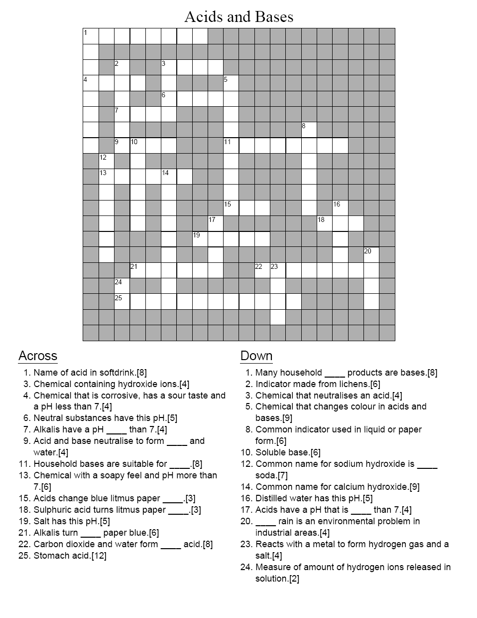

METALS AND NON – METALS
ORAL QUESTIONS
 | Name the metal which is a liquid.
 | Name the non – metal which shows lustre.
 | Name the lightest metal.
 | Name the metal with highest density.
 | Name the property of the metals by virtue of which these can be beaten into sheets
 | Name the property of the metals by virtue of which these can be drawn into wires.
 | Name the material which is kept in water.
 | Name the metal used for galvanisation of iron.
 | Mercury is liquid and a good conductor of heat. How is this property utilized?
QUIZ – WHO AM I
 | I am a property of metals which appears at lower temperatures.
 | I am noble conductor of heat and electricity.
 | Though I get corroded in atmosphere but still find wide applications for making kitchen utensils.
 | I am a metal but very soft and cannot be kept in the open.
 | I am called a series and play a significant role when a metal reacts with solutions of other metal salts.
 | Scientists / Industrialists use me to extract metals profitably and economically.
 | I am a process to refine metals of high reactivity.
 | I am a process associated with wasting away of metals by the action of atmospheric gases and moisture
 | I am homogenous and not a compound though my formation least to altering the properties of metals involved.
 | We belong to the same category of elements but still combine to form molecules / compounds.
PUZZLES
⇒ Across
- Property of metals to give long wires. (9)
- Solid solution of metal (6)
⇓ Down
- Three dimensional networks of ionic compounds (7).
- Process of heating concentrated ores in the absence of air (11)
 |  |  |  |  |  |  |  |  | ⁴
 |  |  |  |  |  |  |  | ²
 |  |  |  |  |  |  |  | ³A | L
 |  |  |  |  |  |  |  |  | C
 |  |  |  |  | ¹ |  |  | T | I |  |  |  | Y
 |  |  |  |  |  |  |  | E
 |  |  |  |  |  |  |  |  | N
⇒ Across
- Property of metals to give sheets. (12)
- Refined naturally occurring inorganic solid from which metal is extracted economically(3)
⇓ Down
- Property of metals to allow passage of heat or electricity (12).
- A series determined by electropositive character of metals (10)
 |  |  |  |  |  |  |  |  | ² |  | ⁴
 |  |  |  |  |  |  |  |  | ³O |  | E
 |  |  |  |  |  |  |  |  | N |  | A
 |  |  |  |  |  |  |  |  |  |  | C
 |  |  |  |  |  |  |  |  | C
 |  | ¹ |  | L |  |  |  |  | I |  | I |  | Y
 |  |  |  |  |  |  |  |  | V
 |  |  |  |  |  |  |  |  | Y
 | SEMINAR
 | Significance of alloys in modern life.
 | Harmful effects of corrosion in industry and method by which it can be prevented.
PROJECT
 | Students may collect different small articles which are made of different alloys (such as stainless steel, brass, bronze, solder, and duralumin). They may also use pictures of articles made of different alloys and paste in the project file.

LIFE PROCESSES
ORAL QUESTIONS
 | Do plants also need oxygen?
 | How does food passes through alimentary canal?
 | What regulate the exit of food from the stomach into small intestine?
 | In which part of the alimentary canal food is completely digested absorbed?
 | In which cell organelle breakdown of pyruvate takes place using oxygen?
 | Which structures stop backward flow of blood in atria and ventricles?
 | The filtered urine is collected in which part of nephron?
 | Which part of the plant excretes some waste substances into the soil?
 | Name the process used to remove urea from the blood.
 | The process by which evaporation of water from the plants mainly through the stomata.
QUIZ
 | Digestion of starch in humans takes from which organ?
 | Absorption of energy takes place in sunlight by the pigment.
 | Is chloroplast is non – lining structure?
 | What is the function of amylase?
 | Name the organ responsible for respiration in fish.
 | Which is more harmful urea or ammonia?
 | Which contains less nitrogenous wastes, the renal vein or renal artery?
PUZZLES
⇒ Across
- Aerial part which eliminates waste from the plant body
- Unicellular plant that carryout fermentation.
⇓ Down
- Transports oxygen in the body.
- Carry impure blood.
 |  |  |  |  |  |  |  |  |  |  | ⁴
 |  |  |  |  |  | ¹
 |  |  |  |  |  | ² |  |  | ³
⇒ Across
- Help in respiration in water.
- Removed through urine.
⇓ Down
- Help to breath in air
- The process by nitrogenous waste is removed.
- Organism that takes in food with the help of pseudopodia.
 |  |  |  |  |  |  | ¹ |  | ²
 |  |  |  |  |  |  |  |  | ³ |  | ⁴ | ⁵

Label The Diagram Of Respiratory System

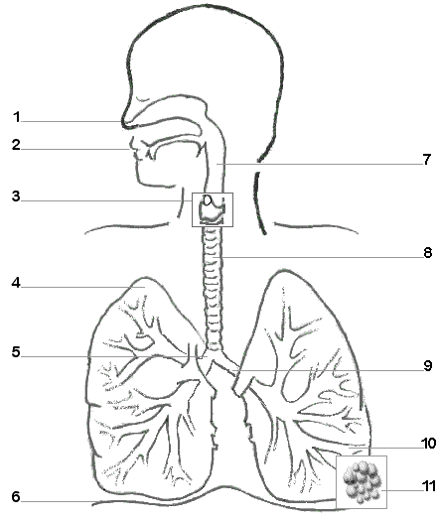

- Cross word puzzle- Circulatory system

 | ¹ |  |  |  |  |  |  |  |  |  | ²
³
⁴ |  |  |  |  |  |  |  | ⁵
 |  |  |  | ⁶
 |  |  | ⁷
⁸ |  |  |  |  |  |  |  |  |  | ⁹
¹⁰
¹¹

Clues for solving the cross word puzzle

ACROSS  3. The only vein that carries oxygenated blood to the heart  4. The organ which beats continously to act as a pump for the transport of blood.  5. The number of chambers in the human heart.  6. A doctor uses this instrument to amplify the sound of the heart.  8. The two upper chambers of the heart.  9. The heart is located on this side of the chest cavity.  10. The only artery that carries deoxygenated blood from the heart.  11. They form the connection between the arteries and veins | DOWN  1. The number of heart beats per minute.  2. The two lower chambers of the heart.  7. The heart is roughly the size of your ______.

- To understand the structure of heart the students can the following jig-saw puzzle.

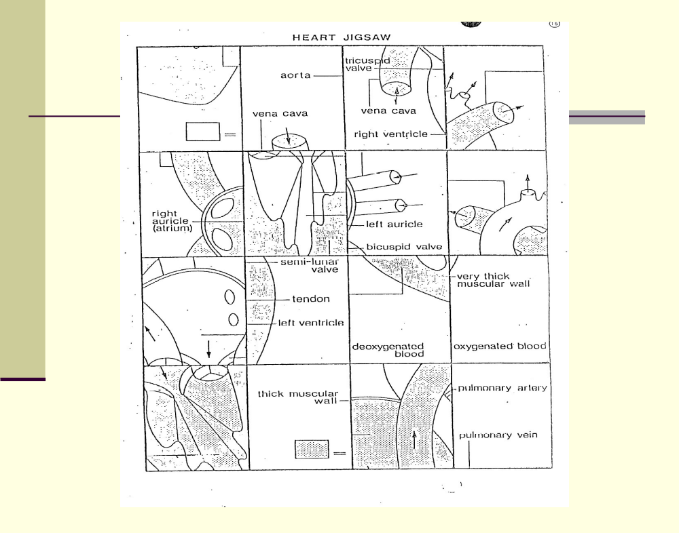

Photosynthesis – Crossword puzzle

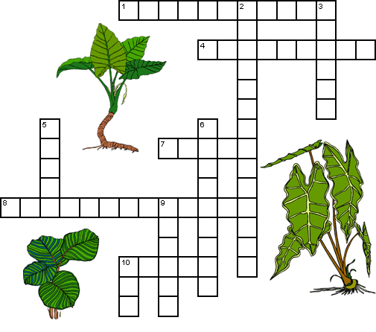

Across  1 A plant pigment that absorbs sunlight. (11)  4 The links between the energy that carnivores get from eating to the energy captured by photosynthesis. (4,5)  7 Chlorophyll absorbs every color of sunlight except this. (5)  8 A compound needed for photosynthesis. (6,7)  10 The product of photosynthesis. (5) | Down  2 The process by which plants and some bacteria use the energy from sunlight to produce sugar. (14)  3 Part of the plant where photosynthesis generally occurs. (6)  5 A compound needed for photosynthesis. (5)  6 An animal that eats plants. (9)  9 A by-product of photosynthesis. (6)  10 Number of molecules of oxygen produced along with one molecule of sugar. (3)

SEMINAR
Balanced diet from different regions of India.
Reason for kidney failure and remedy for it.
Modes of nutrition in different types of organism.
PROJECT
Prepare project on glands, their location (pictures) functions and various abnormalities of digestive system.
Food pyramid-
- Cut a large triangle using chart paper and divide it into sections that represent the nutrients required by our body.
- Ask students to bring pictures of foods from news papers, magazines, etc.
- Ask the students to paste the pictures in the appropriate section of the Pyramid.
Students can be asked to work on the project on various respiratory diseases.
Students can identify the heart sounds using a Stethoscope.
Collection of data on haemoglobin levels in men, women and children.
Collection of data on blood pressure. (Instrument used - normal range of blood pressure, causes of low or high blood pressure, prevention & control of high blood pressure.)

CONTROL AND CO – ORDINATION
ORAL QUESTIONS
What is the basic unit of nervous system?
How do neuron conduct message from brain to other parts?
What do you mean by CNS?
What are its main parts?
Which part controls reflex action?
What are endocrine glands?
What is the secretion of endocrine gland called?
Name a gland of human body which secretes both enzymes and hormone.
Which plant hormone helps in cell division?
Which hormones help on stem elongation?
QUIZ
Which system of our body is made of organised network for conducting information in the body?
Which part of the neuron receives information?
What is the name of the neuron which remains between the sensory neuron and the motor neuron? Where is it located?
Which part of the brain helps us to do activities like riding a cycle and walking in a straight line?
What are two major types of muscles we have?
What causes change in leave of ‘touch me not’ plant?
Which hormone helps us to prepare to combat adverse condition?
Name a female sex organ which produces gametes as well as female hormone.

Cross word puzzle: Nervous system

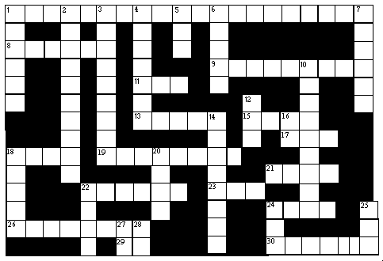

Clues
ACROSS
1. Composed of the brain and spinal cord (3 words).
8. Contains photoreceptors; on the inner posterior portion of eye.
9. "Inside the mouth"
11. Electrical brain activity recorded with scalp or brain electrodes
(abbreviation).
13. Necessary for hearin
17. Neurotransmitter in brain, spinal cord and peripheral nervous system
(abbreviation).
18. Outermost layer of meninges.
19. Neurotransmitter lacking in patients with Parkinson's disease.
21. Supportive cells of the nervous system; "glue".
22. Nerve cell.
23. Photoreceptor that is not used for color vision.
24. Photoreceptor that is used for color vision.
26. The sense of hearing.
29. Opposite of "Yes"
30. Junction between two neurons.

DOWN
1. In the brain, it is the outermost layer of the gray matter.
2. The fifth cranial nerve.
3. The middle layer of the meninges.
4. The part of the cell containing chromosomes.
5. Period of sleep when dreams occur (abbreviation).
6. The second cranial nerve.
7. Fat-like substance that surrounds some axons.
10. The first cranial nerve.
12. Fluid that fills the ventricles (abbreviation).
14. Part of neuron that takes information TO the cell body.
16. Short for "mother".
18. Electrical brain activity between 2 and 4 Hz.
20. Part of neuron that takes information AWAY from the cell body.
22. A short written letter.
24. Abbreviation for 1 across.
25. Organ for vision.
27. Opposite of "off".
28. Opposite of "yes".

ANSWERS: Cross word puzzle: Nervous system

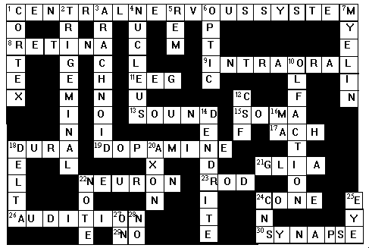

ACTIVITIES / PROJECT
Make a project on various endocrine glands, their functions and related disorders.
SEMINAR
Diabetes – a silent killer.
Causes and prevention of this life style disease.

ELECTRICITY
ORAL QUESTIONS (CONVERSATION TYPE)
- Why is electricity more useful than other forms of energy?
- How is static electricity different from current electricity?
- What are conductors? Give examples.
- What are insulators? Give examples.
- What constitutes an electric current?
- Name the SI unit of electric charge.
- Which is bigger – c coulomb of charge or a charge of an electron?
- How much is the charge on an electron? Can a charge less than this value exist?
- What is the number of electrons constituting one coulomb of charge?
- Define electric current.
- Name the SI unit of current.
- Define one ampere.
- Is electric current a scalar of vector quantity?
- What does an electric circuit mean?
- When does the current flow in an electric circuit?
- How can the current be kept continuous in a conductor?
- Which particles constitute current in a metallic conductor?
- Define potential difference.
- Name the SI unit of potential difference.
- What is meant by saying that a potential difference between two points in 1volt?
- What is the relationship between work done, potential difference and charge moved?
ORAL QUESTIONS
Which unit is equivalent of joule / coulomb?
How does the resistance of a wire depend on its length?
How does the resistance of a wire depend on its area of cross – section?
When are resistors said to be connected in series?
When are resistors said to be connected in parallel?
Why is tungsten suitable for making the filament of a bulb?
Why is tungsten not used as a fuse wire?
Alloys are preferred over metals for making the heating elements of heaters. Why?
How is the direction of electric current related to the direction of flow of electrons in a wire?
Should the heating element of an electric iron be made of iron, silver or nichrome wire?
QUIZ – WHO AM I
I am equal to the charge carried by 6.25 x 10¹⁸ electrons.
I am the rate of flow of charge through any section of a conductor.
I am same as coulomb/second.
I am closed path along which electric charges can flow.
I am equal to the work done per unit charge from point to another.
I am same as joule/coulomb.
I oppose the flow of charges through any conductor.
I am same as volt/ampere.
I relate potential difference with current for a given resistance.
I am used to measure potential difference between two points of a circuit.

CROSSWORD PUZZLE- ELECTRICITY
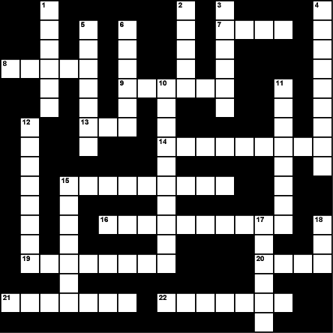

Across  7. Unit of electrical power, named after the Scottish inventor of the steam engine  8. a rotating machine that transforms electrical energy into mechanical energy  9. The kind of electricity you create by rubbing a balloon on your head  13. Atom or group of atoms that carries a positive or negative electric charge as a result of having lost or gained one or more electrons  14. Emission of radiant energy in the form of waves or particles  15. It transmits electricity, like copper  16. Opposition to the passage of an electric current  19. Elementary particle consisting of a charge of negative electricity  20. Smallest particle of an element that can exist either alone or in combination  21. Uncharged elementary particle  22. Electric potential or potential difference | Down  1. Elementary particle that carries a positive charge  2. Electromagnetic radiation in the wavelength range including infrared, visible, ultraviolet, and X-rays  3. Device for making, breaking, or changing the connections in an electrical circuit  4. Flash produced by a discharge of atmospheric electricity  5. Complete path of an electric current including the source of electric energy  6. Inventor of the electric light bulb  10. Force acting on particles of matter, tending to draw them together  11. Electrical charge with more protons than electrons  12. Electrical charge with more electrons than protons  15. Electrical flow through a conductor  17. Definite quantity of electricity  18. Unit of electrical resistance

ANSWERS - ELECTRICITY CROSSWORD

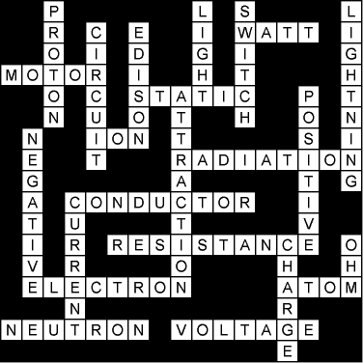

SUGGESTED PROJECT / ACTIVITIES
Make a study of electrical conductivity of different materials or components.
Study the factors on which the resistance of a conducting wire depends.
Show experimentally that current thought each resistor when connected in series is same.
SEMINAR
Why in domestic electric circuits, electric appliances are connected in parallel and not it series? Explain.
Precautions to be taken while handling electrical appliances.
Working of lightning conductor in tall buildings.
Describe the practical applications of heating effect of current.
ACTION PLAN
From newspapers find out the accidents caused by electricity of lightening and suggest some preventions to be taken.
HAVE FUN THROUGH RESEARCH
Surf the internet and write the life story of the great scientist Thomas Alva Edison who invented electric bulb.

MAGNETIC EFFECT
ORAL QUESTIONS
- What are magnets?
- What are natural magnets?
- What is the meaning of the word lodestone?
- What is the origin of the word magnetism?
- State the law of magnetic poles.
- What is the surer test of magnetism?
- What happens if we break a magnet into two pieces?
- Is it possible to obtain isolated north and south poles?
- What is magnetic line of force?
- Can two magnetic lines of force intersect? Give reason.
- Magnetic lines of force are endless. Comment.
- How do the field lines of the regions of strong field different from those of weak field?
- What is a solenoid?
- Is the magnetic field of a solenoid similar to that of a bar magnet?
- State the two factors by which the strength of magnetic field inside a solenoid can be increased.
- How will you determine the direction of the magnetic field due to a current – carrying solenoid?
- What is an electromagnet?
- What is the effect of placing an iron core in a solenoid?
- What type of core should be used inside a solenoid to make an electromagnet?
- Give two advantages of electromagnets.
ORAL QUESTIONS
 |  | What important observation did Oersted make in his experiments with current carrying conductors?
 |  | How can you locate a current – carrying wire concealed in a wall?
 |  | A freely suspended magnet always points along north – south direction. Why?
 |  | What type of core should be used inside a solenoid to make an electromagnet?
 |  | Name the SI unit of magnetic field.
 |  | What is the principle of an electric motor?
 |  | A generator converts energy from one form to another. What is this energy conversion?
 |  | Which wire (live, neutral or earth) goes through the switch?
 |  | Are different appliances connected in series or parallel in a house?
 |  | What is the colour convention for live, neutral and earth wires?
PUZZLE
⇒ Across
- A method preventing electric shock due to touching of live wire with the metallic body of an appliance.
- A device to convert electrical energy into mechanical energy.
- A device to convert mechanical energy into electrical energy.
- SI unit of magnetic field.
⇓ Down
- A material having attractive and directive properties.
- A temporary magnet.
- A device to protect a circuit from overloading.

 |  |  |  |  |  |  |  |  | ²M₅
 |  |  |  |  | ¹E₆ |  |  |  |  |  |  |  |  |  | ³G |  | ⁴
 |  |  |  |  |  |  |  |  |  |  |  | ⁷
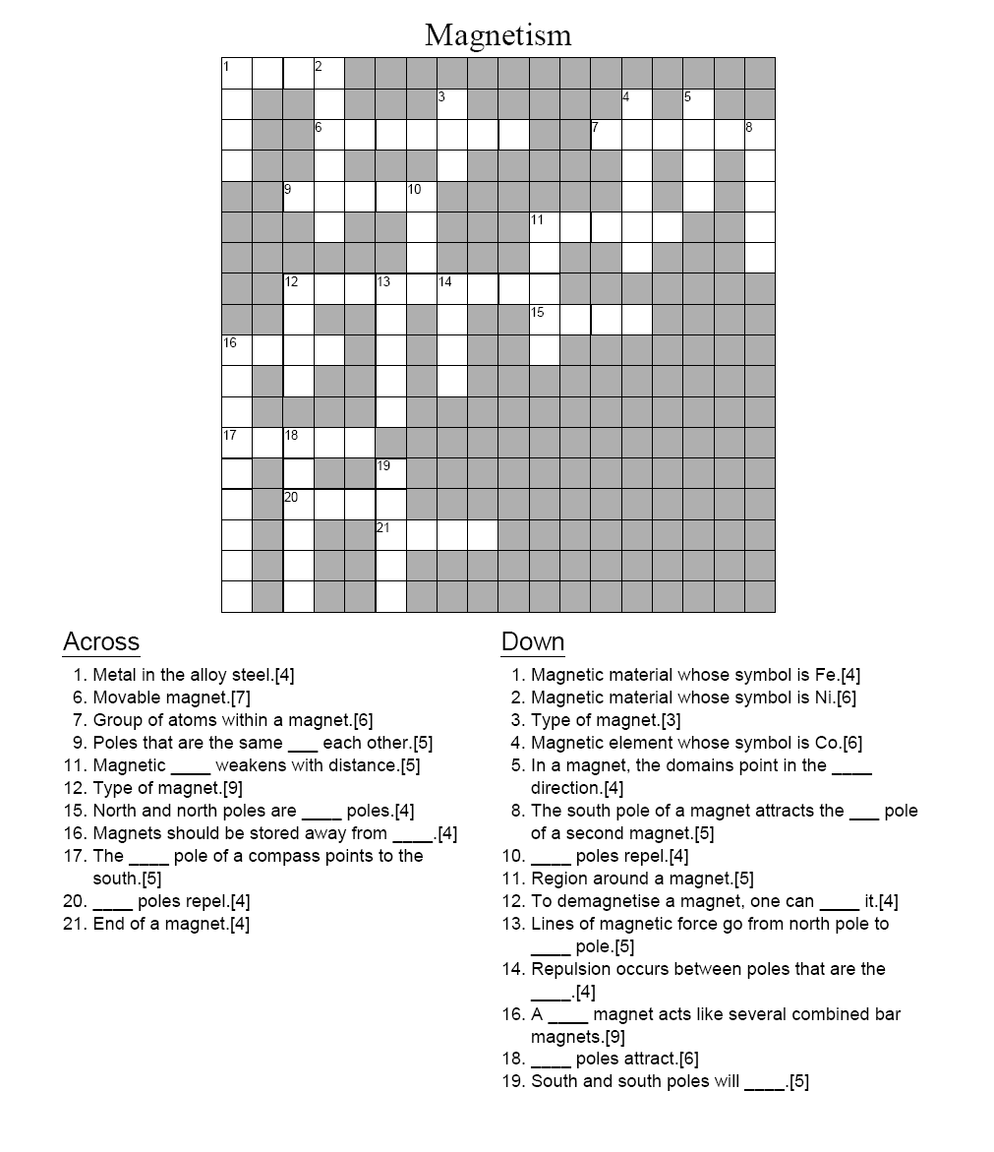
ANSWERS-MAGNETISM

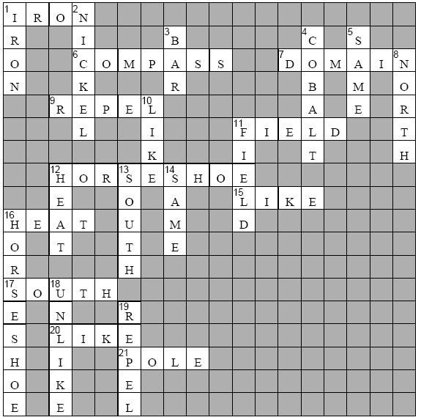

ELECTRICITY AND MAGNETISM WORD SCRAMBLE
Scrambled Words | Answer Pattern
1. ciicettlyer | ___ ___ ___ ___ ___ ___ ___ ___ ___ ___ ___
2. iiirctslaetttcecy | ___ ___ ___ ___ ___ ___ ___ ___ ___ ___ ___ ___ ___ ___ ___ ___ ___
3. map | ___ ___ ___
4. lvto | ___ ___ ___ ___
5. octucrndo | ___ ___ ___ ___ ___ ___ ___ ___ ___
6. noluarsti | ___ ___ ___ ___ ___ ___ ___ ___ ___
7. csirciiretsue | ___ ___ ___ ___ ___ ___ ___ ___ ___ ___ ___ ___ ___
8. aarltlirpeilcuc | ___ ___ ___ ___ ___ ___ ___ ___ ___ ___ ___ ___ ___ ___ ___
9. cnpiieocrtu | ___ ___ ___ ___ ___ ___ ___ ___ ___ ___ ___
10. uetcrcildsoic | ___ ___ ___ ___ ___ ___ ___ ___ ___ ___ ___ ___ ___
11. ceurcilerttcrne | ___ ___ ___ ___ ___ ___ ___ ___ ___ ___ ___ ___ ___ ___ ___
12. eulcttcicrcirie | ___ ___ ___ ___ ___ ___ ___ ___ ___ ___ ___ ___ ___ ___ ___
13. facinedeilgtm | ___ ___ ___ ___ ___ ___ ___ ___ ___ ___ ___ ___ ___
14. mtgerneteloac | ___ ___ ___ ___ ___ ___ ___ ___ ___ ___ ___ ___ ___
15. aegrreotn | ___ ___ ___ ___ ___ ___ ___ ___ ___

ANSWERS- ELECTRICITY AND MAGNETISM WORD SCRAMBLE

1. electricity 2. static electricity 3. amp 4. volt 5. conductor 6. insulator
7. series circuit 8. parallel circuit 9. open circuit 10. closed circuit 11.electric current 12. electric circuit 13. magnetic field 14. electromagnet 15.generator

ACTIVITY
Perform an activity to show that current flows through a coil when a bar magnet is pushed towards the coil towards the coil or pulled away form the coil.
Take a cell, an iron nail and some copper wire and demonstrate how nail can be converted into an electromagnet.
Perform an activity to show that a current carrying conductor placed perpendicular to the magnetic field experienced a force.
SEMINAR (SUGGESTED TOPICS)
Electric current passing through a straight conductor gives rise to a magnetic field around the conductor.
Current can be induced in a closed coil without connecting it to a battery.
Demonstrate the house hold electric circuit.
Why is it necessary to earth the outer metallic appliance? Explain.
SYMPOSIUM
Safety measures to adopted to while using electricity.
ACTION PLAN
Find out the birthday of Michael Faraday and arrange a meeting to honour him.
HAVE FUNE THROUGH RESEARCH
Write a short article on
“World without Magnet”
(Take help from internet.)

ENERGY
ORAL QUESTIONS (CONVERSATION TYPE)
 | - What is a good source of energy?
 | - Name one good source of energy.
 | - It is a renewable source of energy?
 | - Is it conventional or non – conventional source of energy?
 | - What other name is give to it?
 | - What is a fossil fuel?
 | - Name any other two fossil fuels.
 | - Which is the ultimate source of all forms of energy?
 | - Can you explain?
 | - Name some renewable source of energy arising due to sun.
 | - Name some non – renewable source of energy arising due to sun.
 | - Why is the energy contained in fossil fuels considered due to sun’s energy?
 | - Name any source of energy not influenced by sun’s energy.
 | - What is the principle of nuclear energy?
 | - What are the kinds of nuclear reaction?
 | - Which of these can be used for destructive purposes?
 | - Which of these can be used to produce energy for common use?
 | - What is nuclear fission?
 | - Name two substances which are easily fissionable.
 | - What are these substances called?
 | - What is this phenomenon of breaking up of radioactive isotopes called?
 | - Name the rays emitted.
ORAL QUESTIONS
 | Which component of solar radiations produces heat?
 | Name a form of energy that can be harnessed from the oceans.
 | Name the main component of biogas.
 | Name a fuel which is considered cleaner that CNG.
 | What is common between an atom bomb and a nuclear reactor?
 | What is the main transformation of energy during working of a windmill?
 | What are the conditions to achieve nuclear fusion?
 | Name the device which converts the energy of wind into electric energy.
QUIZ
 | I am a force that cannot be created but my form may be changed.
 | I am an important part of the system that transforms that transforms K.E. / P.E. into electrical energy.
 | I have been used to produce energy for a long time and my origin is in the remains of plants and animals.
 | I used to thrown as a waste material for centuries. But I am given an honourable name and a useful work to perform.
 | I have a huge body capable of eating water from any source with a decorative head called Hydro electric power station.
 | I resemble a fossil fuel but find use as self sustained source of energy especially in rural areas.
 | I produce a chain of reactions each step capable of producing tremendous amount of energy.
 | I am associated with nuclear reactions but deliver heat in critical conditions.
 | I am the lightest fuel with a large potential as a source of energy.
 | I deliver hot springs with taking any energy from man – made sources or sun.
PUZZLES
⇒ Across
- A type of metal that allows only partial current to pass (13)
- A device to harness kinetic energy of wind (8)
⇓ Down
- Vegetable and animal waste (7)
- Process to increase percentage of fissionable material (10)
 |  |  |  |  |  |  |  |  | B²
 |  |  |  |  |  |  |  |  |  | ⁴
 |  |  |  | ¹ |  |  |  |  | O | N |  |  |  |  | O | R
 |  |  |  |  |  |  |  |  |  | R
 |  |  |  |  |  |  |  |  | A
 |  |  |  |  |  | ³ |  |  | D | M
 |  |  |  |  |  |  |  |  |  | T
⇒ Across
- Trapped energy inside earth (10)
- A substance which slows down the speed of neutrons in nuclear reactor (9)
⇓ Down
- Liquid fossil fuel (9)
- Isotope commonly used in nuclear reactor (7)
 |  |  |  |  |  |  |  |  |  |  |  | ³
 |  |  |  |  |  |  |  |  |  |  |  |  |  | ⁴
 |  |  |  |  |  | ² |  | D |  |  |  | T |  | R
 |  |  |  |  |  | ¹ |  |  |  |  |  | R | M | A
 |  |  |  |  |  |  |  |  |  |  |  | M

ENERGY CROSSWORD PUZZLE-CLUES

- Down
  - 2 A poisonous, odourless gas
  - 5 A plant's pollen that causes air pollution
  - 6 Pollution created by natural sources
  - 7 An opening in the Earth's crust which throws hot gases, magma and ashes
  - 9 Humans that make the land, water and air dirty and harmful to living things
  - 10 Land, air and water that gets dirty and is harmful to living things naturally
  - 17 This makes windmills turn
  - 18 Energy created from the earth

- Across
  - 1 Any kind of power
  - 3 Precipitation combined with sulphur dioxide
  - 4 Where nuclear energy is produced
  - 8 Something in air, water, land that makes it dirty
  - 10 Land, air and water that gets dirty and is harmful to living things
  - 11 The type of energy that comes from the sun
  - 12 Power or energy than can be released from the nucleus of an atom
  - 13 Coal, oil and gas
  - 14 Biological mass
  - 15 Lightning, batteries, light bulbs and plugs
  - 16 Clear liquid that is cold

ENERGY CROSSWORD PUZZLE

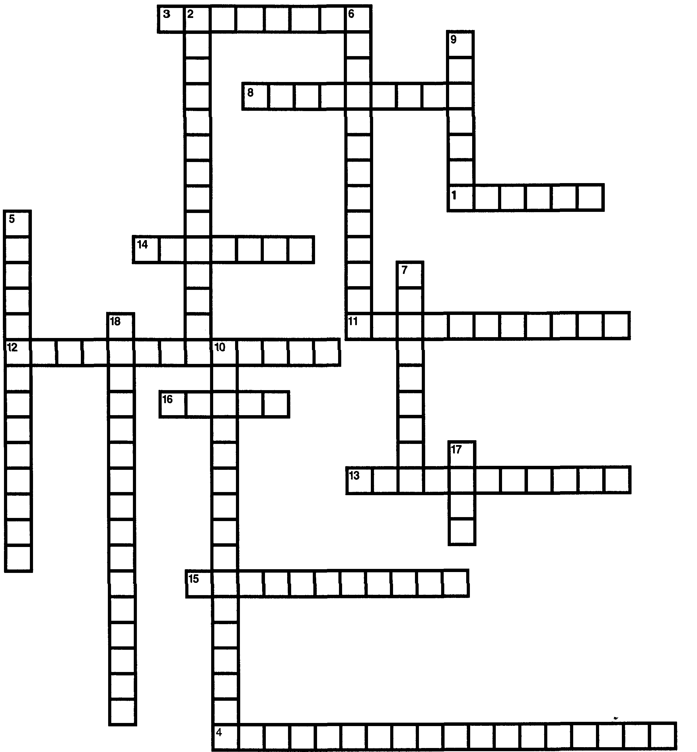

Energy Crossword Puzzle Answers

- Down
  - 2 carbon monoxide
  - 5 goldenrod weeds
  - 6 natural wastes
  - 7 volcanoes
  - 9 manmade
  - 10 natural pollution
  - 17 wind
  - 18 geothermal energy
- Across
  - 1 energy
  - 3 acid rain
  - 4 nuclear power plants
  - 8 pollution
  - 11 solar
  - 12 nuclear energy
  - 13 fossil fuels
  - 14 biomass

SEMINAR (SUGGESTED TOPICS)
Sun is the ultimate source of energy.
Harnessing of solar energy.
Wind energy and its application
Use of solar energy in overcoming the persisting energy crisis.
Burning of fossil fuel is harmful to the humanity.
Why are we looking at alternate source of energy?
ACTION PLAN
1945 August 6th and 9th …………. The Black Terrible Days in …………………… the world history………..
Germany put atomic bomb in Hiroshima and Nagasaki………. The whore world wept for days……….

Arrange a meeting to overview the Rising Up of Japan from the complete destruction. Can we adopt the hardworking and determined nature of Japanese?
Have s survey on it and be inspired by them.
HAVE FUN THROUGH RESEARCH
The ultimate source of energy is sun. Imagine the world without sun and develop a story based on it.

SUGGESTED WEBSITES

- For Reference and Content Enrichment
  - www.meritnation.com
  - www.fullmarks.org
  - www.xamidea.in
  - www.extramarks.com
  - www.learnnext.com
  - www.edurite.com
- For Activities, Worksheets, Puzzles, etc.
  - http://www.surfnetkids.com
  - http://www.ntscience.co.uk/scienc
  - http://qldscienceteachers.tripod.com
  - http://edubakery.com/
  - http://www.seai.ie/Schools/Secondary_Schools/Subjects/Physics/
  - http://library.thinkquest.org
  - https://www.lessonplanet.com

  - http://www.songsforteaching.com/sciencesongs.htm

SECOND TERM

Prepared by :

Smt. Geetha B.,
Principal,
Kendriya Vidyalaya,
No.3 Colaba, Mumbai
(Second Term)

CONTENTS: Page nos.
- Carbon and its compounds 4 - 14

- Periodic classification of elements 15 - 24

- How do organisms Reproduction? 25 - 33

- Heredity and Evolution 34 - 39

- Light – Reflection and Refraction 40 - 44

- The Human eye and the colourful world 45 - 47

- Management of natural resources 48 - 52

- Our Environment 53 - 62

*****

COURSE STRUCTURE
Class X
Second Term
Marks:-80
Units | Marks
I. Chemical Substances-Nature and Behavior  II. World of living  III. Natural Phenomena  IV. Natural Resources | 21  27  26  06
Total | 80

THEME: MATERIALS (25 Periods)
Units: Chemical Substances-Nature and Behavior
- Carbon compounds
- Periodic classification of elements.
THEME:-THE WORLD OF THE LIVING (30 Periods)
Unit: World of living
- How do organisms Reproduction
- Heredity and evolution:
THEME: NATURAL PHENOMENA (23 Periods)
Unit: Reflection & Refraction
- Light – Reflection & Refraction
- Human eye and colourful world
THEME: NATURAL RESOURCES (12 Periods)
Unit: Conservation of natural resources
- Management of natural resources
- Our environment

*****

Topic 1: CARBON AND ITS COMPOUNDS

Important Terms & Conditions:
Versatility of carbon: Carbon is a non metal and occurs in free as well combined state in nature.
Free State: Diamond, graphite and coal.
Combined state: 1. Solid State-All animals and plants products.
2. Liquid state-Petroleum and vegetable oils.
3. Gaseous state: In air as CO_{3.}
Carbon has 4 valance electrons carbon can form an anion C-4 by gain of electrons. It can also form cations C+4 by loss of electron.IT can share its balanced electrons with other carbon atoms or atoms of non metals and forms covalent bonding.
Compounds of carbon: Simplest compound of carbon are hydrocarbons, and simplest hydro carbon is methane.
Classification of hydro carbon:
Saturated Hydro carbons Unsaturated Hydro carbons
(C_{n}H_{2n+2})
COMPOUNDS HAVING SINGLE COVALENT BOND COMPOUNDS HAVING DOUBLE OR TRIPLE BONDS.
ALKANES. ALKENES AND ALKYNES
e.g., ethane (C₂H₆) alkenes (C_{n}H_{2n}) alkynes
H H H H (C_{n}H_{2n-2})
| | | |
H-C-C-H C========C H-C=C-H
| | | | -
H H H H

Sr.No. | Hydro carbons | Definitions | Examples
1. | Straight chain | All carbons atoms are in the form of straight chain | Butane
2. | Branched chain | One or more carbon atoms are attached to main straight chain | Isobutane
3.  a.  b. | Ring or cyclic hydro carbon  Saturated  Unsaturated | Carbon atoms are in the form of ring and bonded by single covalent bond  Carbon atoms are bonded by one or more doubled covalent bond | Cyclohexane  Benzene

Isomerism: The phenomenon of existence of compounds in two or more forms with same molecular formula but different structure.

Functional group: An atom or groups of atoms which makes a carbon compound reactive and decide its properties.

Sr.No. | Hetro Atoms | Functional groups | Formula of functional groups | Example
1. | Cl/Br | Halo-Chloro/Bromo | -Cl, -Br | Chloromethane  (CH₃Cl)
2. | Oxygen | 1.Alcohol  2.Aldehyde  3.Ketone  4.Caboxylic acid | -OH  -CHO  >C=O  -COOH | Ethanol  C₂H₅OH  Methanal  HCHO  Propanone  CH₃COCH₃  Ethanoic acid  CH₃COOH

HOMOLOGOUS SERIES: A series of compounds in which the same functional group substitute for hydrogen in a carbon chain, such that successive compounds differ by CH₂ group,e.g.,CH₄, C₂H₆, C₃H₈, etc.

NOMENCLATURE OF CARBON COMPOUNDS:
Prefix + word root + Suffix + Functional group.

CARBON COMPOUNDS:
- ETHANOL-C₂H₅OH, common name ethyl alcohol
- ETHANOIC ACID-CH₃COOH , Common name acetic acid.
- ESTERIFICATION REACTION: The reaction between carboxylic acid and an alcohol in the presence of conc. Sulphuric acid to form a sweet smelling substance ester is called esterification. e.g.,
Conc. H₂SO₄
CH₃COOH+C₂H₅OH -------------------- CH₃COOC₂H₅ + H₂O
- SPONIFICATION REACTION: Alkaline hydrolysis of ester produces soaps.

Heat
CH₃COOC₂H₅ + NaOH ------------------------ CH₃COONa + C₂ H₅OH

- Reaction with carbonates and hydrogen carbonates: reaction of ethanoic acid with carbonates or bi carbonates evolves carbon di oxide gas.
2CH₃COOH + Na₂Co₃ 2CH₃COONa + CO₂ + H₂O
SOAPS AND DETERGENTS. Soap is sodium and potassium salt of long chains of carboxylic acids. They foam lather with soft water only.

Detergent are ammonium or sulphonate salts of long chain of carboxylic acids. They even remain effective in hard water and foam lather.

---
Topic 1: CARBON AND ITS COMPOUNDS
F.A. - III
(PAPER-PEN TEST)

TIME: 40 min. Max. Marks. - 40.
1. Name the compound formed on heating ethanol at 443 K with excess of conc. H₂SO₄. 1
2. What happens when a small piece of sodium is dropped into ethanol? 1
3. Write the chemical equation for the decarboxylation reaction of ethanoic acid. 1
4. Give an example of esterification reaction. 1
5. Name the product obtained when ethanol is oxidized by either chromic anhydride or alkaline
Potassium permanganate. 1
6. Write the chemical equation representing the preparation reaction of ethanol from ethene. 1
7. Name the two elements which are present both in CNG and petroleum. 2.
8. Draw the electronic dot structure of ethane molecule (C₂H₆). 2
9. Write the IUPAC name of the next homologue of CH₃OHCH ₂ CH₃ 2
10. Define homologous series of organic compounds. Mention any two characteristics of
homologous series. 2
11. Describe a chemical test to distinguish between ethanol and ethanoic acid. 2 12. Give the name of functional groups.
(i) –CHO (ii) –C = 0 2
13. Why does carbon form compounds mainly by covalent bonding? 2

14. Give a chemical test to distinguish ethanol from ethanoic acid. 2

15. Allotropy is a property shown by which class: Substances, elements, compounds or
Mixtures? Give one example of allotropy. 2

16. How may be the following be obtained from ethanol? Express giving chemical equations.
(i) Ethyl ethanoate (ii) Sodium ethoxide. 2

17. Describe with chemical equation how ethanoic acid may be obtained from:
(i) Ethanol (ii) methanol 2
18. Explain the cleansing action of soap. 3
19. Distinguish between esterification and saponification reactions of organic compounds. 3
20. Explain the structure of graphite in terms of bonding and give one property based on this
Structure. 3
21. Name the organic acid present in vinegar. Write a chemical equation which represents the
Commercial method for the preparation of this acid from methanol. 3
---

Topic 1: CARBON AND ITS COMPOUNDS
F.A. - IV

QUIZ
- Name the simplest hydrocarbon.
- What is the general formula of alkynes?
- Name the carboxylic acid used as preservative.
- Name the product other than water formed on burning of ethanol in air.
- Give the IUPAC name of the following compounds:
- An aldehyde derived from ethane
- A ketone derived from butane.
- A chloride derived from propane.
- An alcohol derived from pentane.
M.C.Qs.
- Dilute acetic acid was added to the four test tubes containing the following chemical:
(i) KOH (ii) NaHCO₃ (iii) K₂CO₃ (iv) NaCl

Brisk effervescence was observed in test tubes:
- I & ii (b) ii &iii (c) i & iv (d) ii &iii.

- Which of the following solutions of acetic acid in water can be used as vinegar used in pickles?
- 5-10% (b) 10-15% (c) 20-30% (d) 100%

- The suffix used for naming an aldehyde is
(a). ol (b). al (c). One (d). ene

- When acetic acid reacts with ethyl alcohol, we add conc. H₂SO₄. Its acts as…… and the process is called …………………………………………………………

- Oxidizing agent, saponification
- Dehydrating agent , esterification
- Reducing agent , esterification
- Acid, esterification.

- 2ml of ethanoic acid was taken in each of the three test tubes A, B, and C, and 2ml, 4 ml and 8ml water was added to them, respectively. A clear solution is obtained in:

- Test tube A only
- Test tubes A and B only
- Test tubes B and C only
- All the test tubes.

- 2 ml of acetic acid was added in drops to 5 ml of water it was noticed that:

- The acid formed a separate layer on the top of water
- Water formed a separate layer on the top of the acid.
- A clear and homogenous solution was formed.
- A pink and clear solution was formed.

- A few drops of ethanoic acid were added to solid sodium carbonate. The observation made was that:

- A hissing sound was produced.
- Brown fumes evolved.
- Brisk effervescence occurred.
- A pungent smelling gas evolved.

- Acetic acid, when dissolved in water , it dissociates into ions reversibly because it is a:

(a) Weak acid (b) strong acid (c) weak base (d) strong base.

- Which of the following hydrocarbon can show isomerism?
(a)C₂H₄ (B) C₂H₆ (c) C₃H₈ (d) C₄H₁₀.
10. Combustion of hydrocarbon is generally accompanied by evolution of
(a) Heat (b) Light (c) both heat and light (d) Electric current.

11. The suffix used for naming an aldehyde is
(a). ol (b). al (c). One (d). ene

PUZZLE:. COLLECT THE LETTERS FROM THE TABLE AND MAKE APPROPRIATE WORDS USING FOLLOWING CLUES:
The answers have been provided in the puzzle you can look for the answer horizontally, (left to right), vertically (upwards and downwards) or diagonally.
- Compounds containing double and triple bonds.
- A compound which is basic constituent of many cough syrups.
- Very dilute solution of ethanoic acid.
- A sweet smelling substance formed by the reaction of alcohol and carboxylic acids.
- Gas released when sodium metal is dropped in ethanol.
- The functional group present in methanol.
- IUPAC name of alkene containing 3 carbon atoms.
- The number of single covalent compounds present in pentane.
- First member of homologous series alkyne.
- Simplest ketone.
- Self linking property of carbon.
- Product formed by dehydration of ethanol in conc. Sulphuric acid.
- Alcohol whose intake in small quantities can be lethal.
- Number of single covalent bonds in ammonia.
- Type of reactions shown by alkanes.

M | N | G | K |  | L | O | N | A | H | T | E |  | M | M | B
P | Q | R | S |  | A | C | I | D | P | I | E |  | O | N | A
N | C | U | N |  | S | A | T | U | R | A | T |  | E | D | S
O | A | P | E |  | T | R | O | L | O | L | H |  | T | P | E
I | T | E | N |  | Y | H | T | E | P | C | Y |  | H | Q | E
T | E | N | E |  | P | O | R | P | A | O | N |  | A | R | D
V | N | V | I |  | V | I | D | R | N | H | E |  | N | S | Y
T | A | S | R |  | I | S | E | Y | O | O | K |  | O | T | H
I | T | I | A | I |  | T | H | F | N | L |  | J | L | X | E
S | I | R | G | S |  | I | L | U | E | S |  | L | O | N | D
B | O | N | E | G |  | O | R | D | Y | H |  | M | E | N | L
U | N | X | N | E |  | E | T | X | I | S |  | H | P | Q | A
S | C | I | I | B |  | E | A | U | T | T |  | H | R | E | E
M | A | G | V | F |  | R | A | G | E | R |  | A | N | C | E

ACTIVITY:
To study the saponification reaction reaction for the preparation of soap in the laboratory using any vegetable oils.
Prepare soaps of different colours and fragrances.

PROJECTS:
To prepare models of methane, ethane, ethyne and benzene molecules using thermocols, ball and match sticks.

TOPICS FOR DEBATE:
- Role of esters in everyday life.
- Condemning the use of alcohol as a social practice.
- Use of biodegradable synthetic detergents for cleansing purpose.

HIGH ORDER THINKING SKILLS (HOTS) QUESTIONS:
1. Why the colour of potassium permanganate disappears if it is added to warm solution of ethanol?

2. An organic compound with molecular formula C₂H₄O₂ produces brisk effervescence on addition of sodium carbonate /bicarbonate.

(a). Identify the organic compound.
(b) Name the gas evolved.
(c) How will you test the gas evolved?
(d) Write the chemical equation for the above reaction.
(e) List two important uses of the above compound.

3. (a) what are the various possible structural formulae of a compound having molecular formula C₃H₆O?
(b). Also, give the IUPAC names of the above possible compounds.
(c) . What is the similarity in these compounds?

4. A mixture of oxygen and ethyne is burnt for welding. Can you tell why a mixture of ethyne and air is not used?

5. Two carbon compound A and B have molecular formula C₃H₈ and C₃H₆ respectively. Which one of the two is most likely to show addition? Justify your answer. Explain with the help of a chemical equation, how an addition reaction is vegetable ghee industry.

6. 1 ml glacial acetic acid and 1ml of ethanol are mixed together in a test tube. Few drops of concentrated sulphuric acid is added in the mixture are warmed in a water –bath 5 minutes.
(a) Name the resultant compound formed.
(b) Represent the above change by a chemical equation.
(c) What term is given to such reaction?
(d) What are the special characteristics of the compound formed?

7. An organic compound ‘X’ with a molecular formula C₂H₆O undergoes oxidation in the presence of alkaline KMnO₄ and forms the compound ‘Y’.
(a) Identify ‘X’ and ‘Y’.
(b)Write your observation when the compound ’X’ is made to react with compound ‘Y’ which is used as a preservative for pickles.
---

Topic 2 : PERIODIC CLASSIFICATION OF ELEMENTS
Important terms & condition:
Classification of elements: the arrangement of elements in such a manner that elements with similar properties are grouped together while elements with dissimilar properties are separated.
Early attempts to classify elements:
Dobereiner’s triads:
He arranged the elements with similar properties in a group of three known as triad in such a manner that the atomic mass of the middle element was approximately the average of the other two elements.
Limitations:
Only three triads were identified from the element known at that time. Hence, this classification was not useful.
Newland’s law of octaves:
He arranged the elements in the order of increasing atomic masses starting with hydrogen (least atomic mass) and ended with thorium having atomic mass 56.
Acc. To him, the properties of every eighth element are similar to the first element. It was compared to music notations Sa, Re, Ga, Ma, Pa, Da, Ni, Sa, and thus the name Newland’s law of octaves (note of music).
Limitations:
- It was applicable only for lighter elements having atomic mass up to 40 amu, i.e.upto calcium.
- He believed that only 56 elements existed in nature but later on more elements were discovered whose properties did not fit into Newland’s law of octaves.
- Some elements having different properties were grouped together like cobalt and nickel have been placed with halogens.
Due to above limitations, Newlands law of octaves was rejected.
Mendeleev’s periodic table:
He arranged the elements in order of increasing atomic masses, similarity in physical and chemical properties of elements. Properties of hydrides and oxides of different elements were studied and elements with similar properties were grouped together
He classified the elements in table Consisted of vertical columns called groups and horizontal rows called periods. There were 7 groups in table and group is subdivided into subgroups A and B except group 7 which has three sets of elements in 4th, 5th and 6th period.
Limitations of Mendeleev, periodic table:
- Position of hydrogen was not assigned correctly.
- No separate position has been given to isotopes of an element.
- Some elements having higher atomic mass are placed before the elements with lower atomic mass.

Modern periodic table :
Moseley modified the Mendeleev’s periodic table by taking atomic number as the fundamental property instead of atomic mass.
Modern periodic table consists of 18 vertical columns known as groups, and 7 horizontal rows known as periods.

Groups:
Elements in group 1 are called alkali metals.
Elements in group 2 are called alkaline earth metals.
Elements in group 17 are called halogens.
Group 18 elements are called inert gases or noble gases.
Significance of group in the periodic table is that an element in a group has same no. of valence electrons, valency and thus identical chemical properties.

Periods :
1st period – 2 elements and is called very short period.
2nd period – 8 elements and is called short period.
3rd period - 8 elements and is called short period.
4th period – 18 elements and is called long period.
5th period – 18 elements and is called long period.
6th period – 32 elements and is called very long period.
7th period – incomplete period.

The number of shells present in the element indicates the period to which it belongs.

Valency: it is defined as the combing capacity of an atom of an element to acquire noble gas configuration. It is equal to the number of electrons lost, gained or shared during the formation of a chemical compound.

Atomic size / Atomic radii: It is defined as the distance from the Centre of nucleus to the outermost shell of the atom. It is generally expressed in Pico meter (Pm).

On moving down the group the group the atomic radii increases. Because on moving down the group a new energy shell is added which increases the distance between the outermost electrons and the nucleus. Although the nuclear charge also increases, but it is compensated by the additional shell being added thus, increasing the size of the atom.

Across the period the atomic radii decrease. Due to the increased nuclear charge, the pull on the electrons increases and hence, they are pulled closer to the nucleus thus, decreasing the atomic size.

Oxides and its nature: Metals react with oxygen to form oxides by loss of electrons. These oxides on dissolution in water form bases.

Reactivity of elements:
Down the group reactivity of metals increases as the tendency to lose electrons increases due to increased atomic size.

Reactivity of non- metals decreases down the group because of the increased atomic size and the tendency to gain electrons decreases.

On moving across the period, the reactivity first increases due to the decrease in the metallic character and increase in non metallic character.

---

Topic 2: PERIODIC CLASSIFICTION OF ELEMENTS

F.A.- III
(PAPER-PEN TEST)
TIME: 1 hrs. M.M.:30
- What is the position of Hydrogen in the Modern periodic table? 1

- Where are the isotopes of the same elements having different atomic masses placed in the periodic table? 1

- An element M is in third group of the periodic table. Write the formula of its oxide. 1

- What is the valency of Magnesium with atomic number 12 and chlorine with atomic number 17? 1

- What is the difference in number of shells in magnesium and sulphur? 1

- On the basis of electronic configuration, how will you select:
- The terminating member in a period.
- The chemically similar elements. 1

- Give reason as to why the atomic radii of elements increase in a group while moving from top to bottom? 2

- Elements in a group of the periodic table have similar chemical properties. Why? 2

- Explain why atomic number is more important than atomic weight in determining chemical properties? 2

- Where in period 2 of the periodic table do we find:
- Elements classified as non metals.
- Elements forming negative ions
- Elements with high melting points
- Elements forming positive ions 2

- In a group reactivity of metals increases while those of non metals decreases when we going a group. Explain. 2

- Elements in a group of the periodic table have similar chemical properties. Why? 2

- Elements of group 18 are called zero group .why? 2

- Write the electronic configuration of atoms of
- Potassium (K) (b) Argon (Ar), (c) Lithium (Li), (d) Fluorine (F), (e) Chlorine (Cl).

These have atomic numbers as 19, 18, 3, 9 and17 respectively. Uses the electronic configuration to explain.
(i). Why is potassium more reactive than lithium?
(ii).Why is fluorine more reactive than chlorine?
(iii).Which is smaller in size Cl or Ar?
(iv).Which is smaller in size Li or F?
(v).Which is more electronegative F or Cl? 5

11. The atomic number of an element is 17.
(i)What is its valency?
(ii)Whether it is a metal or non metal?
(iii).Whether it is bigger or smaller in size than an element of atomic number 18?
(iv).What type of bonds it will form with elements of group 18?
(v). How would its oxide behave with litmus solution? 5

HIGH ORDER THINKING SKILLS (HOTS) QUESTIONS:
- An element has two electrons in its M shell:
- Identify the element. (b) What type of ion will it form? (c) What will be the formula of its chloride? (d) Predict the solubility of its chloride?

- Which among the following elements whose atomic numbers are given below belong to the same period? Give the reason. 17, 10, 20, 12, 19, 15.

- Element X with atomic 12 and element Y with atomic number 17 reacts with hydrogen to form hydrides. Which of them is expected to have high melting points?

- Why the position of hydrogen is not justified in the Modern periodic table?

- Table given below shows a part of the periodic table.
H |  |  |  |  |  |  | He
Li | Be | B | C | N | O | F | Ne
Na | Mg | Al | Si | P | S | Cl | Ar
Using this table, explain why: (a) Li and Na are considered as active metals. (b) Atomic size of Mg is less than that of Na. (c) Fluorine is more active than chlorine

---

Topic 2: PERIODIC CLASSIFICATION OF ELEMENTS

F.A.- IV

QUIZ:
- Name the element with atomic number 12.
- Name a metal in making cans and member of group 14.
- The most electronegative element in the periodic table.
- The horizontal rows in the periodic table.
- On moving across the period, atomic size of the element increase or decreases.
- Who gave the classification on basis of musical notes?
- Name two elements belonging to group 1 which can be cut with the help of knife.
- What name is given to the elements belonging to group 2 of the periodic table and why?
9. A lustrous non metal having 7 valence electrons.
10. Highly reactive metal gives violet colour to flame.
11. A gas used in coloured advertising lights having 2 valence electrons

M.C.Qs.
- Which of the following are the characteristics of isotopes of an element?
- Isotopes of an element have same atomic masses.
- Isotopes of an element have same atomic numbers.
- Isotopes of an element show same physical properties.
- Isotopes of an element have same chemical properties. (a) (i),(iii)and(iv) (b) (ii),(iii)and(iv)
(c) (Ii) and (iii) (d) (ii) and (iv)
2. Where would you locate an element with electronic configuration 2, 8, 7 in the modern periodic table?
(a). Group 7and period 2
(b) Group 17 and period 3
(c) Group 7 and period 3
(d) Group 17 and period 2
3. Which of the following elements will form acidic oxide?
(a) An element with atomic number 7
(b) An element with atomic number 12
(c) An element with atomic number 20
(d) An element with atomic number 18.
4. Which of the given elements A, B, C, D and E with atomic number 2, 4,8,10 and 18 respectively belong to same period?
(a) A, B, C (b) B, C, D (c) A,C,E (d) B, D, E.
PROJECTS:
Power point presentation on the following topics:
- Modern periodic table based on the similarity of properties of elements.
(b) Contribution by various scientists towards the development of periodic table.

DEBATE &DISCUSSION:
(a). Drawbacks of Mendeleev’s and modern periodic table.
(b). Achievements of Mendeleev’s and modern periodic table.
(c). Advantages of modern periodic table in understanding chemistry.
----

TOPIC 3: HOW DO ORGANISMS REPRODUCE

IMPORTANT POINTS :
- Reproduction-- Process by which living organisms produce new individual of their own kind.

- Creation of DNA copy--When the cell divides into two, each new cell gets a copy of each DNA or chromosomes.

- Importance of variations-- Variations are created by DNA copying mechanisms during sexual reproduction.

- Asexual modes of reproduction ---
  - Fission--- Binary & multiple fission
  - Fragmentation
  - Regeneration
  - Budding
  - Vegetative Propagation
  - Spore formation

- Sexual Reproduction---
  - In flowering plants
  - In human beings

- Parts of flower

- Pollination—Self and cross pollination

- Fertilization—Male and Female germ cells fuse to form zygote.

- Puberty-- Age, when reproductive organs become functional, (In female 10 - 12 years, in male 13-14 years).

- Male reproductive system in human beings.

- Female reproductive system in human beings.

- Reproductive health—
  - To have awareness about STDs,
(Sexually transmitted diseases).
b) Some common STDs are gonorrhea, syphilis & HIV-AIDS.
- Contraceptive methods to avoid pregnancy---
  - Barrier method
  - Chemical method
  - Surgical method

---

HIGHER ORDER THINKING SKILLS (HOTS) QUESTIONS

- Give two reasons for the appearance or variations among the progeny formed by sexual reproduction.

- Colonies of yeast fail to multiply in water but multiply in sugar solution. Give one reason.

- The type of reproduction seen in the figure is :-

a) Budding
b) Grafting
c) Fragmentation
d) Vegetative Propagation.
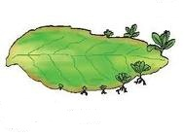
- Malarial parasite divides into many daughter individual simultaneously through multiple fission. State an advantage the parasite gets because of this type of reproduction.

- If a woman is using copper-T, will it help in protecting her from sexually transmitted diseases

- What is the importance of DNA copying in reproduction?

- Why is vegetative propagation practiced for growing some types of plants?

- How does reproduction help in providing stability to population of species?

- Why are the testes extra abdominal in location?

- What would be the reason for adopting contraceptive methods?

- Name those parts of flower, which serve the same function as the following do in the animals?
a) Testis c) Eggs
b) Ovary d) Sperms

- Label any 6 parts in the given figure. What are the functions performed by them in human beings? What is the role of 2 and 4?
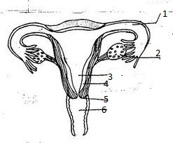

FORMATIVE ASSESSMENT-III

Very Short Answer Type Questions: -
Note: - Each question carries 1 Mark.
1) What is reproduction?
2) Have you seen seeds of rose or potato? Name some plants whose seeds you may have seen.
3) Can an Amoeba and Hydra reproduce like human beings?
4) What changes are observed in the uterus if fertilization occurs?
5) Define fertilization.

Short Answer Type Questions

Note: Each question carries two marks: -

(6) In the human body, what is the role of (a) seminal vesicle (b) prostate gland?
(7) State the difference between Menarch and Menopause?
(8) What is variation? Mention the importance of DNA copying in reproduction.

Answer the Following Questions: -
Note: --Each question carries 3 marks each.
9) Name three types of asexual reproduction with example for each.

10) Label the diagram according to the numbers given.
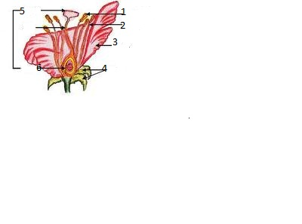

11) Practical skill based MCQs. (Each question carries one mark.)
I) The following figures illustrate budding in yeast. Which is the correct sequence?
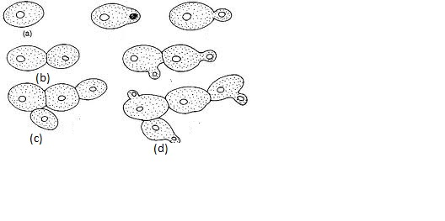
II) The following figures illustrate binary fission in Amoeba in an incorrect
Sequence:

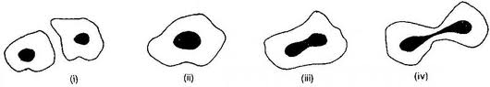

The correct sequence is:
(a) (i),(iii),(iv),(ii) (b)(ii),(iii),(iv),(i) (c)(iv),(iii),(ii),(i) (d)(iii),(iv),(ii),(i)

III) Which of the following shows spore formation? 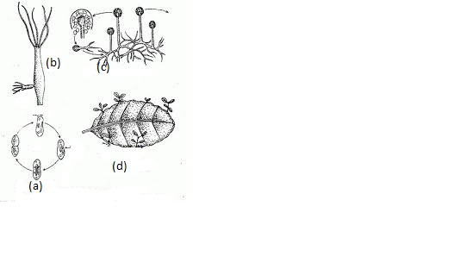
LONG ANSWERS TYPE QUESTION:--
(FIVE MARKS)
- How is sexual reproduction better than asexual reproduction? What is the role of ovaries in female reproductory system? Where does the fertilization take place in female body?(2,I,2 marks)

---

FORMATIVE ASSESMENT- IV

- PICTURE BASED QUIZ.

1. The figure given below shows the male reproductive system.

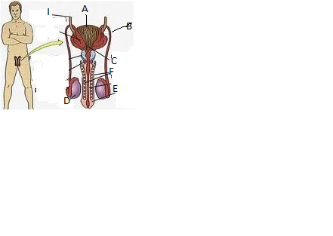
(A) Label B ……………. (B) Label D………………………

2. What is the function of D given in above figure?
- Activity—To grow Rhizopus & prepare its temporary slide.
Aim: To show asexual reproduction in an organism.
App: Slice of bread, water, box, slide, cover slip.
Procedure: Children grow Rhizopus on slice of bread and make a temporary slide.
- Project: a) To study manner of vegetative reproduction in some commercially useful plants.
b) To study the seeds during sprouting period.
- Seminar: Reproductive health and sexually transmitted diseases: Children form the groups and discuss.

- Symposium: Gender related problems: female infanticide.

- Group discussion: If there was no sexual reproduction.

- Debate: Is it necessary to learn about reproductive health from class VII?

----

TOPIC 4: HEREDITY AND EVOLUTION
POINTS TO REMEMBER:
- HEREDITY – Transmission of features or characters from one generation to another or from parents to offspring through their genes.
- VARIATION – It occurs due to sexual reproduction, inaccuracies during DNA replication (mutation) and due to environmental factors.
- GENETICS --- Branch of biology dealing with the study of heredity and variations.
- ALLELES – There is one pair of alleles which can express itself whether present in homozygous or heterozygous state. e.g. – T (tallness in pea plant), R (round seed in pea plant)
- GREGOR JOHANN MENDEL (1822-1884) --- He is known as ‘Father of Genetics”. He worked on Sweet pea plant (Pisum sativum).
- GENOTYPE--- Genetic composition of an individual. e.g. pure tall – TT, hybrid tall – Tt.
- PHENOTYPE --- Visible traits of an individual. e. g. – Tallness or dwarf ness.
- EVOLUTION --- Gradual changes in traits of organisms from preexisting organisms is called evolution.
- SPECIATION --- It may take place when variation is combined with geographical isolation. (Formation of new species).

HIGHER ORDER THINKING SKILLS (HOTS) QUESTIONS

- If a trait A exists in 10% of a population of an asexually reproducing species and a trait B exists in 60%of the same population which trait is likely to have arisen earlier?
- Which of the following is not the example of artificial selection?
  - Colours of rose b) Flavours of mangoes 3) Colour of beetle 4) Starch quality of wheat.
- Explain how advantageous variations like long neck help an organism
like Giraffe to survive better?
4) Which of the following is the clearly acquired trait in human beings?
a) Intelligence b) Height c) Swimming d) Skin colour.
5) Why are human beings, who look different from each other in size and
colour, belong to the same species?
6) Acquired characters are not inherited. Give reason.
7) All the human races like Africans, Asians, Europeans, and others might have evolved from common ancestors. Provide few evidences in support of this view.

8) How is genetic drift different from natural selection? From the diagram given below which case shows natural selection?

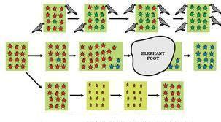

9) Observe the diagram properly. Mention the ratio of round, yellow seeds and wrinkled, green seeds.

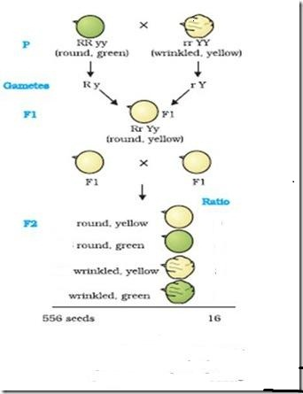

- From the figures given below, make a pair of homologous and analogous organs .Also justify the answer.
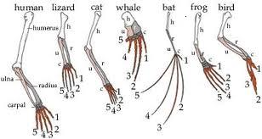

FORMATIVE ASSESSMENT - III

Very short type of questions:
Note: Each question carries one mark.

TICK THE CORRECT OPTION

- The number of chromosomes in human ovum is
- 21 b) 22 c) 23 d) 24

- An example of homologous organs is
a) Our arm and a dog’s foreleg b) Our teeth and an elephant’s tusk
c) Potato and runners of glass d) All of these.

- The hereditary units are
- Segments of RNA b) Genes
c) Chromosomes d) Chromatin

- The science dealing with Biotechnology is called
a) Heredity and variation b) Paleontology c) Genetics d) Phylogeny

- Which of the following are analogous organs?
- Wings of insect and bird b) Forelimb of man and bird
c) Nictitating membrane and vermiform appendix d) None of the above

- The father of genetics is
- Aristotle b) Darwin c) Lamarck d) Mendel

Short answer questions:
NOTE: Each question carries two marks:-

- Define variation in relation to a species. Why is variation beneficial to the species?

- Describe briefly four ways in which individual with a particular trait may increase in population?

- Can evolution be equated with progress? Discuss.

- Who proposed the theory of natural selection? Why was this theory criticized?

- Can the wing of a butterfly and the wing of a bat be considered homologous organs? Justify the answer.

ANSWER THE FOLLOWING QUESTIONS:

EACH QUESTION CARRIES THREE MARKS:

1) Is natural selection the only reason for a trait to remain and increase in a population?
Justify your answer.

- Suppose a pure yellow seeded plant and a pure green seeded pea plant are hybridized, work out F1 and F2 generations of this trait. Write down their ratios.

- State any six features of the mechanism of inheritance.

ANSWER IN DETAIL THE FOLLOWING:
(FIVE MARKS)
1) Discuss the points given below:
a) How is sex of a new borne determined in human?
b) Why do all gametes in human females have X chromosome?
c) A woman has daughter.Analyse the situation genetically.
(2, 2, 1 marks)
FORMATIVE ASSESSMENT - IV

- Quiz :
a) Decomposers are also called ------.
b) Producers prepare their -------.
c) Ozone layer is destroyed by ---------.
d) Ecology is the study of the interaction of ------ with each other and
their surroundings.

2) Seminar:
- Mendel’s work
- Sex determination in organism

3) Role play: Students enact as Aristotle, Darwin, Lamark and Mendel and
present the work done by these great people.

- Debate:
- Use of biotechnology in human welfare
- Organic farming versus GM crops

5) Group Discussion:
If Mendel and Darwin had met.
6) Projects:
- Save Tiger --- Children collect the information about the tigers from various national parks and wild life sanctuaries. Perform the stage shows to develop the awareness about the forests and wild life.
- To collect information on artificial selection carried out in some crops & animals. Visit to veterinary college.
- Visit to an agricultural research institute to understand various techniques involved in hybridization.

7) Activity: To study vestigial organs in human beings.
Students define vestigial organs and discuss the use of every part of the body. Then come to the conclusion.

Topic 5: Light – Reflection and Refraction

Key concepts and terms:

- Light: Light is a form of energy. It brings the sensation of sight. It is a form of electromagnetic radiation. It also provides us means of communication (fibre-optics).

- Light wave: Light wave travels with a speed of 3 x 10⁸ ms-1 in free space. Its speed depends on the medium.

- Ray and beam: The straight line indicating the path of the light (arrow-direction is called a ray. A bundle of rays originating from the same source of light in a particular direction is called a beam of light.

- Reflection: When light falls on a surface and gets back the same medium, it is called reflection.

- Image: The point of convergence or the point from where the light appears to diverge after reflection or refraction is called Image.

- Angle of Incidence: The angle between the incident ray and the normal at the point of incidence is called angle of incidence.

- Angle of Reflection: The angle between the reflected ray and the normal at the point of reflection is called angle of reflection.

- Laws of Reflection :
- The incident ray, the reflected ray and the normal at the point of incidence, all lie in the same plane.
- The angle of reflection and the angle of incidence are equal.

- Aperture: The width of the reflecting surface is called aperture (AB).

- Focus: The point on the principal axis where all parallel rays meet after reflection is called principal focus.

- Focal Length : The length or separation between the pole and the focus is called focal length (PF = f)

- In order to draw ray diagrams, two rules are used :
- The rays of light passing parallel to the principal axis will converge at the focus after reflection.
- The rays of light passing through the focus will emerge parallel to the principal axis after reflection.
- The rays of light passing through the Centre of curvature will all retrace their both after reflection.
- The rays of light falling at the pole get reflected at the same angle on the other side of Principal Axis.

- Relation between Radius of Curvature and Focal Length. It is two times the focal length i.e. R=2f.

- Mirror formula: 1/f = 1/v + 1/ u where f, v and u are the focal length, image distance and object distance.

- Lens formula : If u, v and f are the object distance, image distance and focal length respectively, then 1/f = 1/v - 1/u

- Magnification of a Lens :
M = size of image (h₁) / size of object (h₀) also m = (h₁) / (h₀) = v/u

---

Topic 5 : Light – Reflection and Refraction

FA - III
(Paper Pen Test)
(Model Paper)

Max marks : 20
Time: 1 hr

1. A ray of light PQ is incident on a mirror as shown in figure. Redraw the diagram and show the path of the ray after reflection from the mirror. (1 mk)

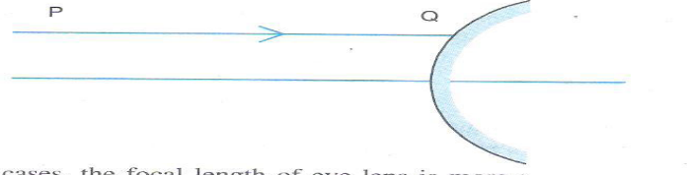

2. If the speed of light in a medium is 2 x 10⁸ m/s. its refractive index is : (1 mk)
a) 1 b) 10 cm c) 1.5 d) 0.5

3. The power of Sun glasses is
(1 mk)
a) 0 b) 10 cm c) 25 cm d) zero

4. The refractive index of diamond is 2.42. What is the meaning of this (2 mks)
Statement in relation to the speed of light?

5. Draw a ray diagram and show the image formed by a concave mirror (2 mks)
When the object is kept on focus?

6. An object is placed at a distance of 10 cm in front of convex mirror of focal (2 mks)
Length 15 cm. Find the nature and position of image.

7. a) Two thin lenses of power + 3.5 D and – 2.5 D are placed in contact. (1 mk)
Find the power and focal length of lens combination?

b) Define: i) Snell’s law of refraction of light. (2 mks)
ii) Pole of a concave mirror.

8. A object of size 4 cm is kept at a distance of 20 cm from the optical Centre (3 mks)
of a converging lens of focal length of 10 cm. Calculate the distance of the
Image from the lens and size of the image.

9. a) Define magnification? Write the sign convention used for expressing it. (2 mks)

b) Using lens formula, find the position of image its nature and magnification (3 mks)
Formed by a concave lens of focal lens is 20 cm and object is at 15 cm.
---
Topic 5 : Light – Reflection and Refraction

FA - 4

- Oral questions :

- What is a ray?
- A lemon placed in water appears larger in size due to _____________
- What does the negative sign of magnification of a mirror indicate?
- What is relation between focal length and radius of curvature of a spherical mirror?
- What is the range of vision of normal human eye?
- What do you mean by lateral displacement?
- Magnification produced by convex mirror for object of size 5 cm is ½.
What is the size of image?
- What is a real image?
- A ray of light strikes at 45 degree on a mirror. What is angle of incidence and reflection?
- What is power of accommodation?

- PUZZLE :

Solve the Puzzle:
- Across :
2. I take everyone diminished to the virtual world. (12)
3. Due to the shape of my surface, I converge the light. (7)
4. The effect of refraction in my surfaces always leads to a virtual image. (11)

 |  |  |  |  |  | 1 | C
 |  |  |  |  | 3 | c
 |  |  | 5 | p
2
c
 |  |  |  |  | 4 | c

- Down :
1. I act the same for all objects. (12)
5. My shape gives a magnification of unity. (5)

- Class Work / Home assignment :

- What is the lens formula?
- What do you mean by power of a lens?
- Using sign conventions indicate the sign for the following :
1) u in concave mirror
2) v for real image by convex lens.

- Name the lens / mirror in the following situations :
- Rear view mirror
- Magnifying glass
- Mirror with dentist
- Correction of myopia
- The power of lens is -2D. What is the focal length and nature of the lens?

4) Project work:

- To find the focal length of the given concave mirror using candle light.
- Study the phenomena of refraction of light in different medium
(Hint: glass slab, plastic etc.)
- Find the focal length of the given lens (Concave or Convex) using candle light
Hint (u = Candle lens separation
v = lens screen separation
Lens formula f = vu cm
u + v

5) Quiz:

- What is the focal length of a plane mirror?
- Which of the two has a great power, a lens of short focal length or a lens of large
Length?
- What does m= +1 stand for?
- What is the power of a lens if its focal length is 50 cm?
- What is nature of image at retina?
- Name the point inside the lens through which a ray of light goes deviated?
- What is the S.I. unit of power of a lens?

---

Topic 6 : The Human Eye and the colorful world

Key concepts and terms:

1) Eye: The natural optical device using which man could see objects around him. It forms an inverted, real image on a light sensitive surface called the retina.

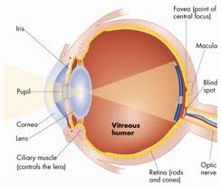

2) Power of Accommodation: The maximum variation in power of the lens so that the far-off and nearby objects are viewed is called power of accommodation.

3) Near point of Eye: The minimum distance between the object and the eye (lens) so that a clear image is formed on the retina. This distance is 25 cm.

4) Far point of Eye: The farthest point up to which the eye can see objects clearly is called the far point of eye. It is infinity (normal eye).

5) Persistence of vision: The time for which the impression or sensation continues in the eye is called the persistence of vision. It is about 1/16th of the second.

6) Myopia or Short-sightedness: Inability of the eye in viewing long distance objects. It is caused due to i) excessive curvature in cornea or ii) elongation of eye- ball. It is corrected by using concave lens.

7) Hypermetropia or Long – sightedness: The inability of the eye in viewing the nearby objects. It is caused due to i) Greater focal length of lens ii) Eye ball becoming smaller. It is corrected by using convex lens.

8) Presbyopia: In human eye, with age, the near point recedes and the far point get reduced. The eye becomes both myopic and hypermetric. This is caused due to i) weakening of ciliary muscles and ii) reducing ability of the lens to change the curvature. It can be corrected by using bi-focal lens.

---

Topic 6: The Human Eye and Colorful World
FA - III
(PAPER Pen Test)
(Model Paper)

Max marks: 20
Time: 1 hr.

I) Red light is used for danger signal as (1mk)
a) It has higher wave length
b) It can travel long distance
c) It scatters least
d) It scatters the longest

II) Acts as lens in the eye (1mk)

III) Colour blindness is caused by (1mk)
A: Vitamin A deficiency
B: Defective rod cells

Then the correct answer is / are
i) A only ii) B only iii) A & B Both iv) None of these.

4. A person with a myopia eye cannot see objects beyond a distance of 1.5m.
What would be the power of corrective lens? Which type of lens is used? (2 mks)

5. What do you understand by myopia? Write two causes of it? (2 mks)

6. What do you mean by far point and near point of eye? (2 mks)

7. What is presbyopia? State the causes of it and How is it corrected? (3 mks)

8. Explain: 1) Why does sky look blue on a clear day (3 mks)
2) Twinkling of stars.

9. What is Hypermetropia? State two causes of Hypermetropia with help (5 mks)
of ray diagrams show :
i) The eye defect hypermetropia.
ii) Correction of Hypermetropic by using a lens.

---

Topic 6: The Human Eye and Colourful World
FA - IV

- Quiz :
- Name the place where image is formed in the eye?
- Name the muscular diaphragm that controls the size of the pupil?
- What is the cause of dispersion of light?
- Give the cause of cataract of eye?
- Which colour has got more wave length?
- How many colours evolve when white light disperses?
- What is the reason for the different deviation?
- Who discovered that white light consists of seven colours?
- What makes bees respond to ultraviolet light?

- Home Assignment :
- Name the photographic film equivalent of our eye?
- Why does a glass slab not disperse while light?
- Why do we not perceive the depth of a lake?
- Name two causes of myopia.
- Name the liquids that keep our eye soft.
- Does the speed of light vary with medium?
- With Diagram illustrate the defective and corrective hypermetric eye ?
- The far point of a near sighted person is 1.5 m. Find the nature and power of lens.
- What causes rainbow formation?
- What is mirage?

- Project Work :
- To understand the dispersion of light with help of activity?
(Hint: Materials, An irregularly shaped glass, white screen)
- List, observe, reason and explain three cases of nature where dispersion happens.
- (Hint : i) Sun rise and sun set
ii) Formation of Rainbow
iii) Twinkling of stars)

- Draw a labeled diagram of Human eye and explain the functions of Retina, Cornea, Iris, Pupil, Rods and Cons)

- Seminar : (Students will be divided into groups & they will present papers on the topic)

Topic - Problems of Vision:
- Means to overcome
- Corrective measure
---

Topic 7: Management of Natural Resources

Key concepts and terms:

- Natural Resource: It is stock of the nature such as air, water, soil, minerals, coal, petroleum, forest and wildlife that are useful to mankind in many ways.

- Pollution: It is defined as the undesirable change in physical, chemical or biological characteristics of our soil, air or water, which harmfully affect human lives or the lives of other species.

- pH of water: pH stands for ‘potential of hydrogen’. The acidic and basic character of aqueous solutions can be described in terms of hydrogen ion and hydroxyl ion concentration. A pH below 7 indicates an acid solution and above 7 indicates an alkaline solution.

- Three R’s to save the Environment: We can reduce pressure on the environment by applying the maxim of ‘Reduce, Recycle and Reuse’ in our lives.

- Sustainable Development: It is the development which can be maintained for a long time without undue damage to the environment.

- Need to manage our Resources :
Our natural resources are limited. With the rapid increase in human population, due to improvement in health care, the demand for all resources is also increasing.

- Biodiversity: It is the existence of a wide variety of species of plants, animals and microorganisms in a natural habitat within a particular environment or of genetic variation within a species.

- Wildlife: It means all those naturally occurring animals, plants and their species which are not cultivated, domesticated and tamed.

- Water Harvesting: It means capturing rainwater where it falls or capturing the run off in a local area and taking measures to keep the water clean by not allowing polluting activities to take place.

- Fossil fuels: These fuels are obtained from the remains of plants and animals, which got buried beneath the earth millions of years ago, changed into coal, petroleum and natural gas due to excessive heat and high pressure inside the earth.

- Coal: It contains chiefly carbon and its compounds mainly nitrogen, oxygen, sulphur and hydrogen. It also contains inorganic matter.

- Non-renewable Energy Sources: These are energy sources which cannot be replaced easily when they get exhausted and are also called conventional sources of energy. Ex: Fossil fuels.

- Uses of Fossil Fuels
Coal: Thermal power plants and steam engines.
Petroleum: Petroleum products like petrol and diesel are used as means of transport.

- Management of Fossil Fuels: the natural gas is a good alternative to fossil fuels like coal and petroleum. The use of alternative source of non-conventional energy such as solar energy, wind energy, biomass energy, etc. should be promoted to save the reserves of fossil fuels. Biogas can also be used for various purposes.

---

Topic 7: Management of Natural Resources
FA – III
(Paper pen test)
(Model Paper)

Max: 20 marks
Time: 1 hr.

Q.1) i) Which one of the following started chipko movement? (1)

a) A.K. Banerjee b) Amrita Devi Bishnoi
c) Sunder Lal Bahuguna d) Medha Patkar

ii) From the list given pick the item that is not a natural resource? (1)
- Soil b) water c) air d) electricity

iii) The pH range most Conductive for life of freshwater plants and animals is (1)
- 6.5 – 7.5 b) 2.0 – 3.5 c) 3.5 – 5.0 d) 9.0 – 10.5

Q.2) what are renewable resources? How are they different from non newable (2)
Resources?

Q.3) what would be the advantage of exploiting resources with long term aim? (2)

Q.4) why should there be equitable distribution of resources? (2)

Q.5) why are coal and petroleum known as fossil fuels? Why do we need to (3)
Conserve them?

Q.6) Name the three ‘R’ to save the environment? Explain how each of them is
Beneficial for mankind? (3)

Q.7) who are the stakeholders in forest? Why do you think so? (5)

--

Topic 7 – Management of Natural Resources
FA – IV

Q.1) Home Assignment :

- What is water harvesting? Mention any two water harvesting structures?
- What are the reasons of destruction of forests?
- Name two categories of natural resources?
- What are Coliform bacteria?
- Why is the underground water getting depleted?
- What is the best method to conserve the environment?
- What is the best way to get rid of non-biodegradable waste?
- What does wildlife include?
- What is the objective of Ganga action plane?
- What is the best method to conserve the environment?

Q.2) Quiz:

- Chipako Andolan originated in
- Kerala b) Rajasthan c) Uttarakhand d) Karnataka

- Kulhs are irrigation Canals of
- Rajasthan b) Karantaka c) Himachal Pradesh d) Assam

- Which of the following is a green house gas?
- Sulphurdioxide b) Carbon monoxide c) Carbondioxide
d) Nitrogen dioxide

- Which of the following bacteria is found in Garga water?
- Coliform bacteria b) Streptococcus bacteria
c) Staphylococcus bacteria d) Diplococcus bacteria

- Stake holders of forest resources in India are
- Local people and Industrials b) NGO c) Forest enthusiasts
d) All of these

6) Arabari forest of Bengal is dominated by
a) Teak b) Sal c) Bamboo d) Mangrove

7) Which of the following are to be managed for sustainable developments?

- Industries b) Forests c) crops d) Resources

8) Red Data book provides a list of
a) Protect animals b) Rear animals for milk
c) Entrap animal d) both a & b

9) Sardar Sarovar Dam is situated on river
a) Ganga b) Narmada c) Yamuna d) Godavari

10) Pynes System of irrigation is common in:
a) Bihar b) Madhya Pradesh c) Rajasthan
d) Himachal Pradesh

Q.3) Debate:

Topic: “Money spent on protection of wild life should actually be spent for the welfare of poor people”

Q.4) Seminar:
Reading papers by the students on the following topics:

- “River water pollution – Source and solution”
- “Sustainable development”

Q.5) Symposium:
i) “Global warming and melting Himalaya – a controversy”
ii) “Save the tiger”

---

TOPIC 8: OUR ENVIRONMENT
POINTS TO REMEMBER:
- ECOLOGY – The study of the interaction of living organisms with each other and their surroundings is called ecology.

- ENVIRONMENT – Everything that surrounds organisms and influences its life.
- Biotic components of environment --- The living organisms .e.g. Plants and animals.
- Abiotic components of environment --- The nonliving components like water, air, light, etc.

- ECOSYSTEM – All interacting organisms in an area together with the nonliving constituents of environment. (Functional unit of an environment)

- PRODUCERS --- They make the energy from sunlight available to the rest of the ecosystem.

- CONSUMERS --- Animals can not manufacture their own food. They are called consumers.

- BIODEGRABLE ---- Substances that are broken down by the action of bacteria or other saprophytes. e. g. – Paper.

- NONBIODEGRABLE --- Substances that are not broken down by the action of bacteria or saprophytes. e. g. Plastic.

- FOOD CHAIN ---- The process of one organism eating the other.
GRASS → GRASSHOPPER → FROG → SNAKE

- FOODWEB ----- It is a network of food links between populations in a community.

- 10% LAW OF ENERGY FLOW --- The energy available at any trophic level in a food chain is 10% of the previous one.

- BIOLOGICAL MAGNIFICATION --- Progressive accumulation of non- biodegradable waste at various trophic levels of food chain.

HIGHER ORDER THINKIN SKILLS (HOTS) QUESTIONS

- Write any two ways of energy flow through an ecosystem.

- Differentiate between biodegradable and non biodegradable with respect to the effect of biological processes on them and the way they affect our environment.

- Which level shows the maximum biological magnification? Why?
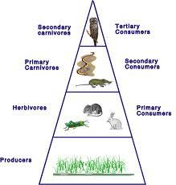

- Why is a pond self sustaining unit while an aquarium may not be? Justify the answer.

- Arrange grasshopper, frog, grass, eagle and snake in the form of food chain.

- If 1000 KJ energy is available at producer level, how much energy will be available at first carnival level?

- Why do most food chains have 3-5 steps only?

- Select the biodegradable items from the list given below-
Polythene bags, old clothes, wilted flowers, pencil shavings, glass bangles, bronze statue, vegetable peels.

- What will be impact on ecosystem if bacteria and fungi are removed from the
Environment?

10) Express your feelings on the picture given down below. What will happen if all?
Carnivores are eliminated from the environment? What measures will you take to save?
Tiger?

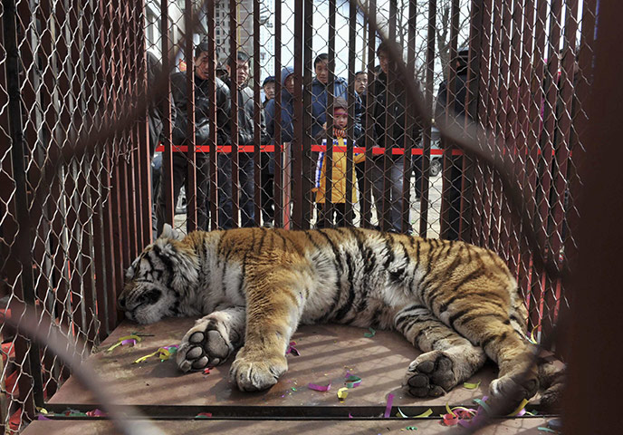

FORMATIVE ASSIGNMENT - III

Very short answer questions:
NOTE: Each question carries one mark.
TICK THE CORRECT OPTIONS:-

- Ozone layer is destroyed by
- SO₂ b) Smog c) CFC d) CO₂

- Which of the following is biodegradable?
- Cow dung b) Plastic c) DDT d) Radioactive wastes

- Vegetable peels, waste paper, wood carvings and egg shells can be used to make
- Bricks b) Compost c) Urea d) None of these

- Which of the following is constituent of a food chain?
- Grass, wheat and mango b) Grass, goat and human
c) Goat, cow and elephant d) Grass, fish and goat

- Acid rain is caused by precipitation of
- Oxides of sulphur b) CFCs c) Ozone d) CO₂

SHORT ANSER QUESTIONS:
EACH QUESTION CARRIES TWO MARKS:
- Classify the following as decomposers and producers
Green plants, bacteria, fungi, algae, blue green algae.
- Distinguish between producers and consumers.
- Name two environment friendly practices.

ANSWER THE FOLLOWING QUESTIONS:
EACH QUESTION CARRIES THREE MARKS:

- How is ozone depletion caused? Name the compounds causing it.
- What is meant by biodegradable waste? Which of the following are biodegradable? Agriculture residue, plastic, insecticides, sewage.
- What is being done to avoid ozone depletion? ( Three steps)
- What is meant by a trophic level? Why do we have a greater number of organisms at lower levels?
Long answer (5 marks):
- Describe any five modes of disposal of wastes.

FORMATIVE ASSESSMENT - IV

    - Quiz:
- Ozone layer is destroyed by ____________.
- Ecology is the study of the interaction of _______ with each other and their surroundings.
- Decomposers are also called ___________.
- Water, air, light and temperature are the examples of ____ components.
- Consumers ______manufacture their own food and depend on plants and other animals for their feed.

      - Seminar: Children discuss ways and means to reduce the problems given below:
a) Ozone depletion b) Garbage disposal

      - Symposium:
Environmental problems: Groups mention the problems they are facing in day today life.

      - Group discussion
Role of students in bringing awareness among community members on ill effects of polythene bags.

      - Activities:
a) To study the ill effects of using some chemicals like CFCS, nitrogenous fertilizers, DDT etc.
b) Field trips: Visit to a botanical garden.

      - Debate -Plastic, a friend or a foe?

      - Collect some more pictures like this. Think over it. How will you prevent this
From happening?
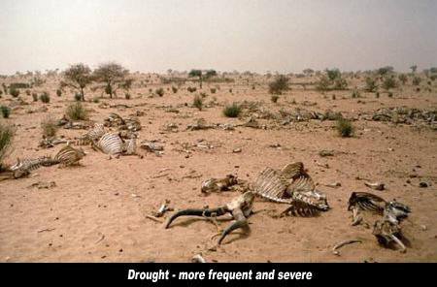

S. A. - II
PAPER
CLASS-X
SUBJECT – SCIENCE
Time: 3Hrs. M.M. :80
General Instructions:
1. All questions are compulsory.
2. Question no. 1 to 4 in section A are one mark questions.
3. Question no. 5 to 13 are two marks questions.
4. Question no. 14 to 22 are three marks questions.
5. Question no. 23 to 25 are five marks questions.
6. Question no. 26 to 41 in section B are multiple choice questions based on practical skills. Each question carries one mark.

Section – A

1. What are chlorofluorocarbons?
2. Why does carbon form compound mainly by covalent bonding?
3. Give a chemical test to distinguish ethanol from ethnic acid?
4. A person is advised to wear .spectacles with convex lenses. What type of defect of
Vision is he suffering from?
5. What is biodiversity? Why is it important to conserve biodiversity?
6. What is astigmatism? How is it caused? How is it corrected?
7. (a) Where are genes located?
(b) What is gene?
(c) What is the nature of genes?
8. State the laws of reflection.

9. (a) What is the fermentation process?
(b) List the two products formed when the enzyme invertace act on sugar present in molasses.
(c) Name the gas evolved during the fermentation process.
10. How do homologous organs differ from analogous organs?
11. An object 5 cm high is placed at 20 cm away in front of a concave mirror of focal
length 15 cm. At what distance from the mirror, should a screen be placed to obtain
a sharp image? Calculate the size of the image formed.
12. Who are the stakeholders in respect of forests? Which one of these causes
Maximum damage of forest and why?
13. (a) how do you calculate the valency of an element from its electronic
Configuration?
(b) What is the valency of magnesium with atomic number 12 and chlorine with?
Atomic number 17?
(c) What is different in number of shells in magnesium and sulphur?
14. State the reason for the following observations recorded from the surface of moon:
(a) Sky appears dark
15. What is the function of genes in an organism?
16. What are synthetic detergents? Give two advantages over soap.
17. State any three practice which can help in protecting our environment.
18. With respect to air, the refractive index of ice is 1.31 and that of rock salt is 1. 54.
Calculate the refractive index of rock salt with respect of ice.
19. (i). Give the name of functional groups.
(a) – CHO (b) – C = O
(ii) Write the IUPAC name of the next homologue of CH3OHCH2CH3.
20. An element M is in the third group of the periodic table. Write the formula of its
oxide, its electronic configuration and identify the element also.
21. An organic compound ‘A’ is a constituent of antifreeze. The compound on heating
With oxygen forms another compound B which has a molecular formula C2H4O2.
Identify the compound ‘A’ and ‘B’ writes the chemical equation of the reaction that
Takes place to from the compound ‘B’.
22. ‘X’ is an element with atomic number 20.
(a) What will be its valency?
(b) Is it a metal or non – metal?
23. (a). Give an example of a bisexual flower. What is its female reproductive part
Known as?
(b). Draw a diagram of its longitudinal section showing the process of germination of
Pollen on stigma and level the following on it:
(i). male germ cell (ii). Female germ cell
(iii). Ovary (iv) pollen tube
(c) Pollination may occur without fertilization but fertilization will not take place without pollination .give reason.
24. (a) Name the type of mirrors that should be used to obtain:
(i) A magnified and virtual.
(ii). A diminished and virtual image of an image.
(b) Draw labelled ray diagrams to show the formation of the required image in each of the above two cases. Which of these mirrors could also form a magnified and real image of the objects? State the position of object for which this could happen.
25. (a) Complete the following equations:
(i) CH₄ +O₂ -----------------------------
(ii) CH₃COOH +C₂H₅OH--------------------------
(iii)CH₃CH₂OH +H₂SO₄-------------------------
(b) Explain the cleansing action of soap.

Section – B
26. A reproduction by single organism without the production of gametes is known as:
(a) Asexual reproduction (b) Both
(c) Bisexual reproduction (d) none of these
27. Semi – permeable membrane in Osmosis is a:
(a) Selective membrane (b) Porous membrane
(c) Non – porous membrane (d) none of these
28. Which one of the following gives a colourless solution in water?
(a) NaCl (b) ZnSO₄ (c) Al₂(SO₄)₃ (d) All
29. The colour of copper sulphate solution is:
(a) Yellow (b) Orange (c) Blue (d) Colourless
30. Which one of the following metals will decolorize blue solution of copper sulphate?
(a) Al (b) Fe (c) Zn (d) All
31. Which of the following solutions of acetic acid in water can be used as vinegar used in pickles?
(a) 10 – 15% (b) 20 – 30% (c) 100% (d) 5 – 10%
32. When copper wire is dipped in a solution of ferrous sulphate?
(a) Blue colour of copper sulphate is formed
(b) No reaction takes place
(c) Iron metal gets deposited on copper wire
(d) Light green colour of ferrous sulphate turns colourless
33. 2 ml of ethanoic acid was taken in each of the three test tubes A, B and C, and 2 ml,
4 ml and 8 ml water was added to them, respectively.
A clear solution is obtained in:
(a) Test tubes A and B only (b) test tubes B and C only
(c) Test tube A only (d) All the test tubes

34. Which one of the following reagents gives brisk effervescence with ethanoic acid?
(a) Sodium bicarbonate (b) Sodium chloride
(c) Calcium hydroxide (d) Ammonium chloride
35. Each of the three beakers A, B and C contained 50 ml distilled water. A student
Placed five raisins in raisins in each beaker. The raisins for each beaker weighted
the same. The beakers were kept at room temperature. The raisins were removed
36. The nature of image is not affected by the position of the object is:
(a) Concave mirror (b) Plane mirror
(c) Convex mirror (d) Both (A) and (B)
37. The angle to which an incident ray at an angle ‘ѳ’ deviates on getting reflected from
a surface is:
(a) θ (b) 180 – 2 θ (c) 180 – θ (d) 2 θ
38. A ray passing through the focus and falling on a convex lens will:
(a) Will emerge parallel to principal axis
(b) Will emerge through focus on other side
(c) Retrace its path
(d) None of these
39. While positioning the pins, it is arranged such that:
(a) The foots are in straight line (b) The mid points are in straight line
(c) The heads are in straight line (d) none of these
40. A lens of focal length ‘f’ is cut into two equal parts without affecting its curvature.
The two pieces will have equal focal length of:
(a) f/2 (b) f/3 (c) f (d) 2f
41. To determine the percentage of water absorbed by raisins before weighing, gently
Dry the raisins with:
(a) Cotton (b) By air (c) Filter paper (d) Cloths

----

